
Welcome to Year 5!

Dear Parents and Carers,

We are writing to you to introduce ourselves and to outline some of the plans we have for teaching and learning in Year 5. We are very much looking forward to working with the children, and with you, in what we are certain will be a successful year.

We are always here to help:
Year 5 is made up of a lovely team of people who are always ready to listen to any worries or concerns you, or your child, may have. We are: Miss Wilson and Mr Pugh. We are supported by Mrs Wilson, Mrs Simpson, Mrs Preece and Miss Sawyer. Mrs Yates will continue to be the assistant head teacher for years 4,5 and 6.

Keeping in touch:
The Home School diary is an ideal way to contact us on a daily basis. These are collected every morning, checked and signed ready for the children to use during the day. Please feel free to use the diary to give feedback regarding homework tasks, ask any questions or queries and inform us of appointments etc.
The children will write their homework tasks in their Home School diary every Monday. Alongside the task, there will always be the date it has been given out and the date it must be handed in.

You may also like to contact us via email. Please see our email addresses below:
Miss Wilson: mwilson@st-pauls.hereford.sch.uk
Mr Pugh: dpugh@st-pauls.hereford.sch.uk
Mrs Yates: jyates@st-pauls.hereford.sch.uk

What do the children need to bring to school?:
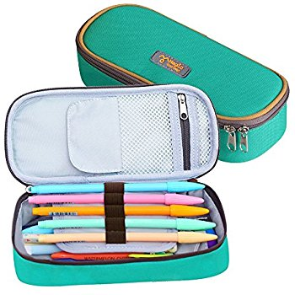
Each pupil should have a reading book of their own choosing and their PE kit in school each day.
Children should ensure that their PE kits are in school from Monday to Friday (our PE lessons are on Tuesdays and Thursdays, but there are times when timetables change at short notice).

Swimming
Year 5 will be swimming during the first half term. Each class will have 6 weeks of lessons, for 30 minutes each week.
Swimming will begin on Tuesday 12th September until Tuesday 17th October.
Children must ensure they have their swimming kit with them upon their arrival to school.
If you have any questions or concerns about swimming, please get in touch.

Homework:
Homework is set weekly and we greatly appreciate your support at home.
We ask that the children read daily and record this in their home-school diary, learn their spellings and practice times tables.
The children are set one piece of Maths and English homework each week. We believe this steady increase of homework helps the children become more independent and prepares them for Year 6 and High School.

To support teaching and learning spellings, the children will have a spelling booklet to complete weekly which will provide good practise for their weekly test.


Autumn Term History Topic:
We begin the Autumn Term with our World War II topic. We will explore how the war started, what it was like to be a child in the war, what it was like to live with food rationing and the contribution made by women to the war effort.

RAF Cosford School Trip
We have provisionally booked this trip for Thursday 19th October. We are hoping to visit the RAF Cosford Museum to bring our World War Two topic to life.
The children will experience a tour of the museum learning about the history of the RAF and take part in the ‘Spirit of the Blitz’ workshop, where the children will learn about the Blitz and life on the Home Front. Further details and information will be sent out to parents in the early Autumn term.

Summer Homework:
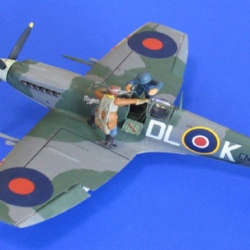
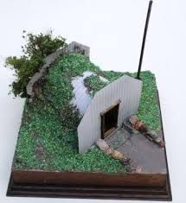
To kick start our World War II topic, we would love for the children to create a model related to WWII over the summer holidays. This model could be anything from a tank, plane, ship, air raid shelter, helmet, a city, evacuee suitcase, gas mask, gas mask box to name just a few! We would request that the model is no bigger than a shoe box as we would like to display the models in school. We would also like the children to create a piece of writing to go along with their model. This could be in the form of a diary, story, information poster or even a letter or newspaper article.

Key dates:
Parent workshop
We look forward to welcoming you to our Year 5 parent day on the Thursday 14th December- more information to follow in the Autumn term.
Class assembly dates.
5W – 9th November.
5TP – 22nd February.

We hope you have a wonderful summer and we look forward to seeing you all soon.

Yours sincerely,

Miss Wilson and Mr Pugh.

Key performance indicators:



