Pupil Leadership Team Minutes
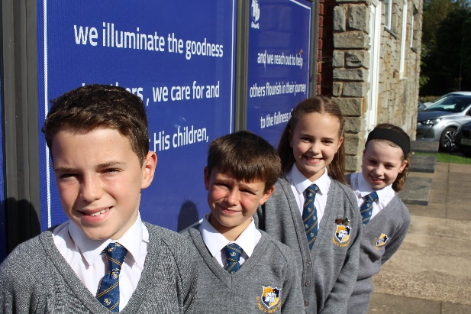
Date of Meeting: 2.10.23
Present: Evie Hughes, Thomas Taylor, Rio Warner, Isla Dunsford
Our first meeting of the year began with Mrs Vautier-Thomas explaining what the role of the Pupil Leadership Team entails. We discussed the need for the children at St Paul’s to feel able to chat about their learning and the PLT will help with this.
We then discussed why the children have been chosen. Reasons included being excellent role models for others, smartly dressed, kind, caring attitudes and empathetic natures.
I asked the team to create an all about me poster and paragraph for the website so that we can introduce the children to the classes and so that we are able to know more about our leaders in school. The poster will be completed ready for display by 13th October.
I finished the meeting by discussing the Open morning and inviting the Pupil Leadership Team to join the hosting group that will tour the school with parents and an SLT member. The group seemed very excited about this idea and all were up for the challenge.
The meeting closed at 11.00am

Next meeting: 10th November 2023 in the Meeting Room at 9.00am
Focus: Quality of Education
Are our classrooms engaging and inspirational?
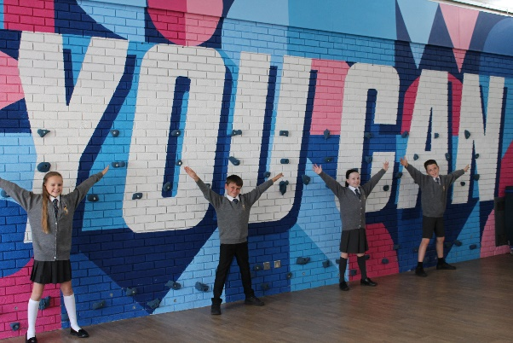
Can the children talk with excitement about something they have enjoyed learning this term?

