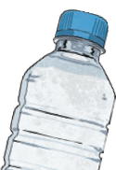
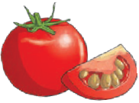
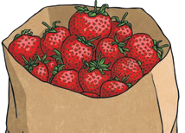
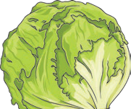
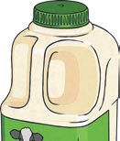
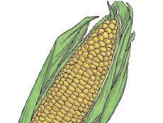
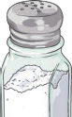
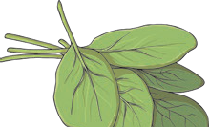
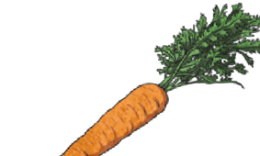
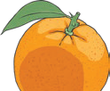
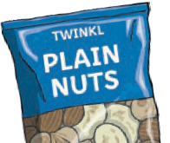
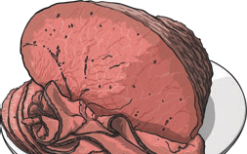
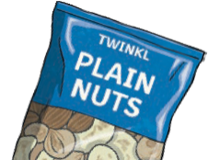
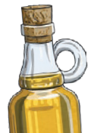
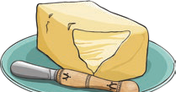
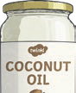
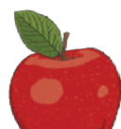
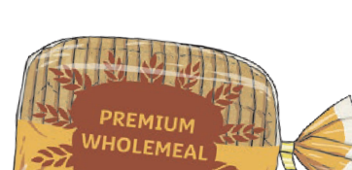
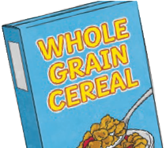
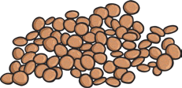
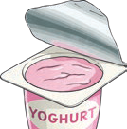
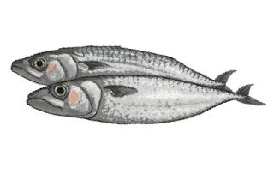
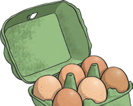
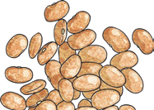
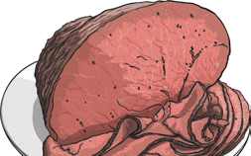
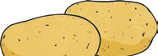
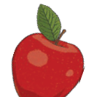
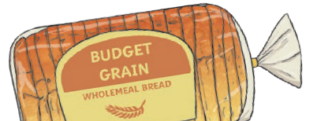
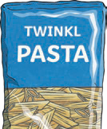
Animals Including Humans
Year 3

- Living things need food to grow and to be strong and healthy.
- Plants can make their own food, but animals cannot.
- To stay healthy, humans need to exercise, eat a healthy diet and be hygienic.
- Animals, including humans, need food, water and air to stay alive.
Nutrient
Found in... (examples)
What it does/they do

carbohydrates

provide energy

protein

helps growth and repair

fibre

helps you to digest the food that you have eaten

fats

provide energy

vitamins

keep you healthy

minerals

keep you healthy

water

moves nutrients around your body and helps to get rid of waste

Key Vocabulary

healthy

in a good physical and mental condition

nutrients

substances that animals need to stay alive and healthy

energy

strength to be able to move and grow

saturated fats

types of fats, considered to be less healthy, that should only be eaten in small amounts

unsaturated fats

fats that give you energy, vitamins and minerals

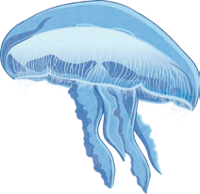
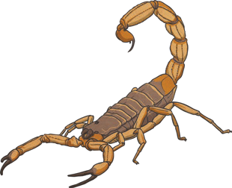
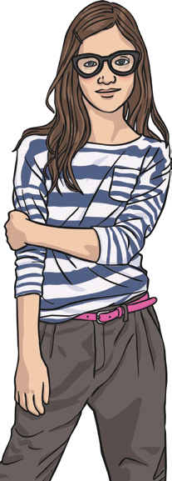
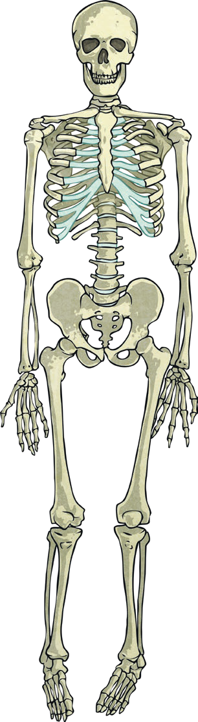
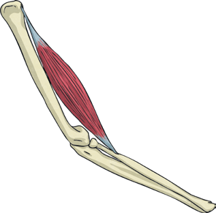
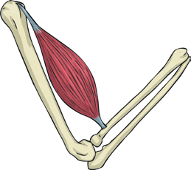
hydrostatic skeleton
– a skeleton made up of a fluid-filled compartment in the body called a coelom, mainly found in soft-bodied animals
– a skeleton on the outside of the body that supports and protects it
exoskeleton
vertebrate

endoskeleton
– a skeleton on the
inside of the body that supports and protects it
invertebrate

Animals Including Humans
Year 3

Skeletal muscles work in pairs to move the bones they are attached to by taking turns to contract (get shorter) and relax (get longer).

contract relax

skull

clavicle
scapula

ribcage
vertebral humerus column

ulna pelvis
radius

femur

tibia fibula

Skeletons do three important jobs:
- protect organs inside the body;
- allow movement;
- support the body and stop it
from falling on the floor.
Key Vocabulary
vertebrate
animals with backbones
invertebrate
animals without backbones

muscles

soft tissues in the body that contract and relax to cause movement

tendons

cords that join muscles to bones

joints

areas where two or more bones are fitted together

