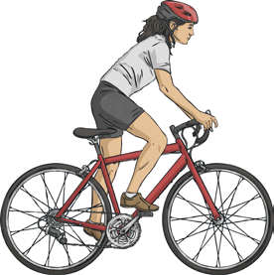
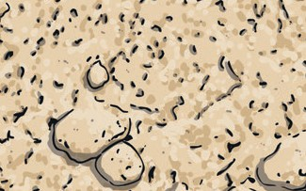
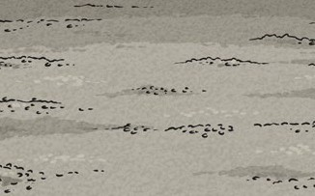
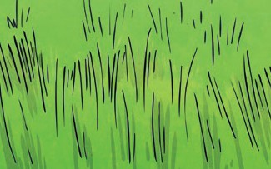
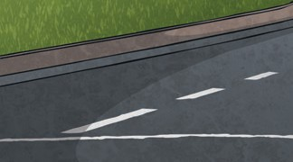
Forces and Magnets
Year 3
Key Vocabulary
forces | Pushes or pulls.
friction | A force that acts between two surfaces or objects that are moving, or trying to move, across each other.
surface | The top layer of something.

Key Knowledge
Different surfaces create different amounts of friction. The amount of friction created by an object moving over a surface depends on the roughness of the surface and the object, and the force between them.
The driving force Friction pushes on
pushes the bicycle, the bicycle, slowing making it move. it down.
Grass | Gravel | Sand | Road

Forces will change the motion of an object.
They will either make it start to move, speed up, slow it down or even make it stop.
Pushes
Pulls

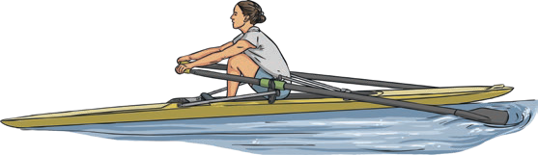
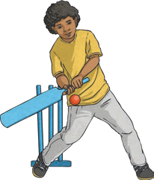
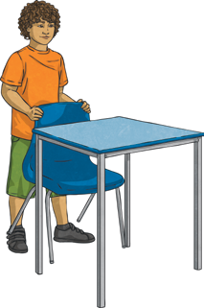

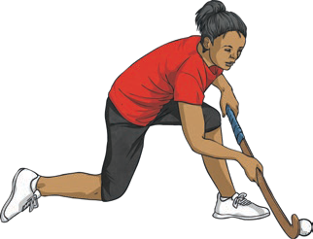
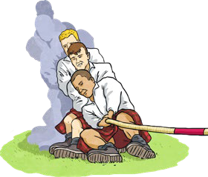
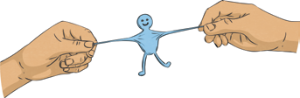



To look at all the planning resources linked to the Forces and Magnets unit, click here.

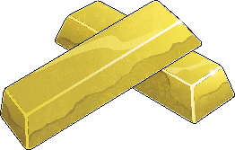
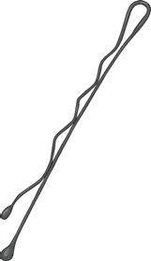
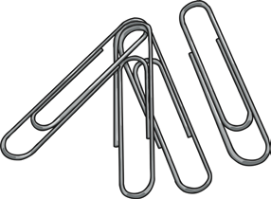
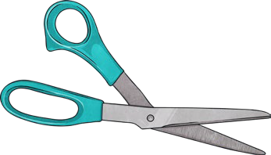

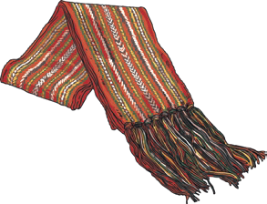
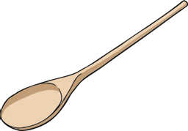
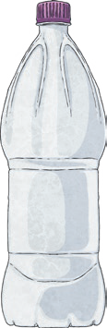
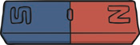
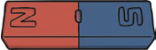
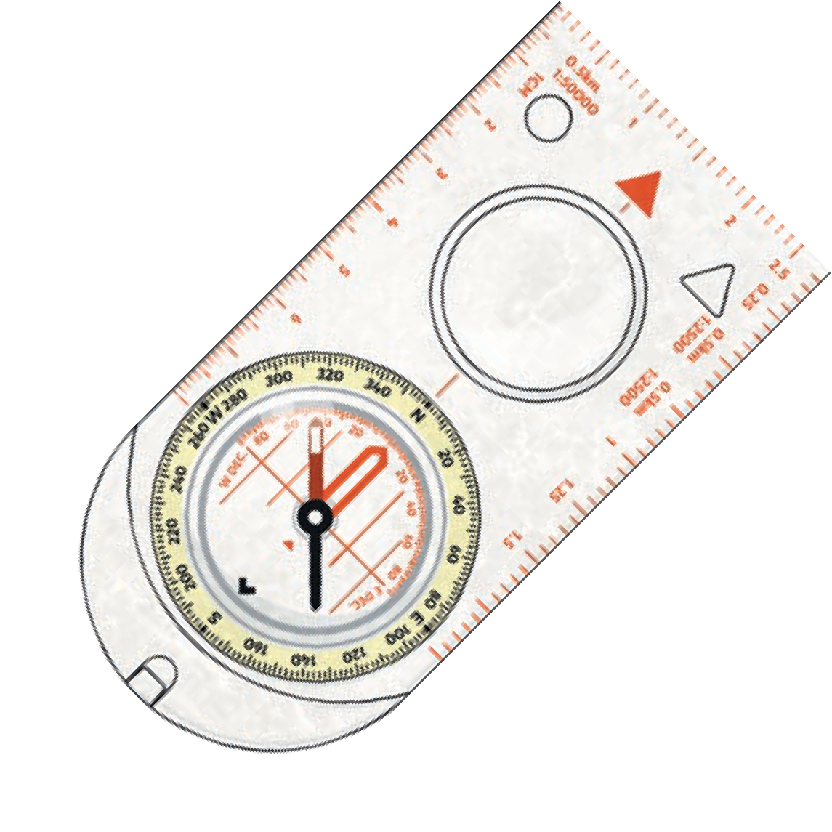
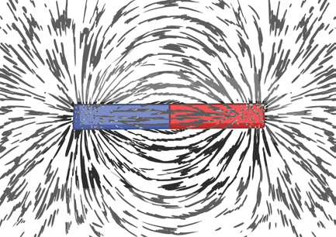
Year 3
Forces and Magnets
Non-magnetic×
Magnetic

These objects contain iron, nickel or cobalt. Not all metals are magnetic.
These objects do not contain iron, nickel or cobalt.
Key Vocabulary
magnet | An object which produces a magnetic force that pulls certain objects towards it.
magnetic | Objects which are attracted to a magnet are magnetic. Objects containing iron, nickel or cobalt metals are magnetic.
magnetic field | The area around a magnet where there is a magnetic force which will pull magnetic objects towards the magnet.
poles | North and south poles are found at different ends of a magnet.
repel | Repulsion is a force that pushes objects away. For example, when a north pole is placed near the north pole of another magnet, the two poles repel (push away from each other).
attract | Attraction is a force that pulls objects together. For example, when a north pole is placed near the south pole of another magnet, the two poles attract (pull together).

Key Knowledge
Like poles repel.
Opposite poles attract.
A magnetic field is invisible. You can see the magnetic field here though. This is what happens when iron filings are placed on top of a piece of paper with a magnet underneath. |  | The needle in a compass is a magnet. A compass always points north-south on Earth.

