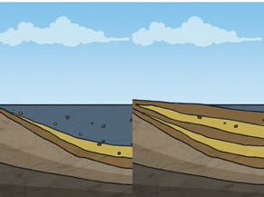
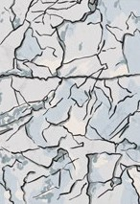
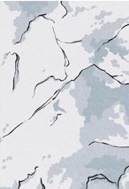
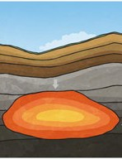
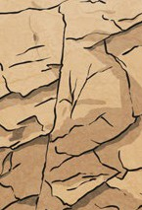
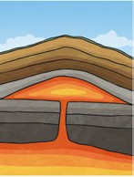
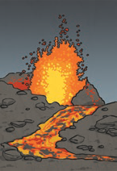
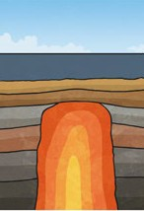
Sedimentary
Igneous
Metamorphic
There are three types of naturally occurring rock.
Key Knowledge

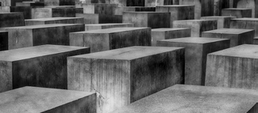
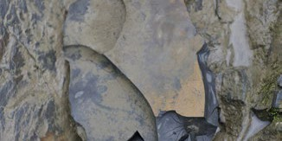
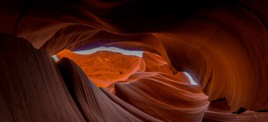
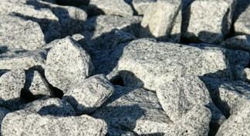
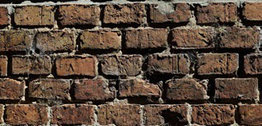
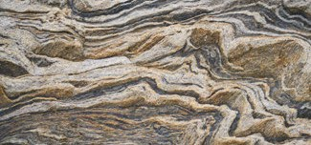
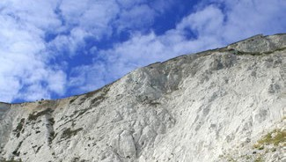
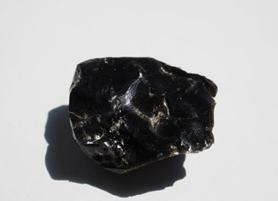
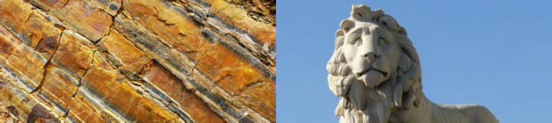
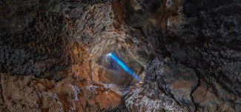
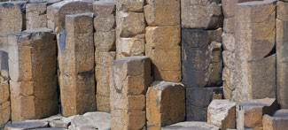
To look at all the planning resources linked to the Rocks unit, click here.
Key Vocabulary
igneous rock | Rock that has been formed from magma  or lava.
sedimentary rock | Rock that has been formed by layers of sediment being pressed down hard and sticking together. You can see the layers of sediment in the rock.
metamorphic rock | Rock that started out as igneous or sedimentary rock but changed due to being exposed to extreme heat or pressure.
magma | Molten rock that remains underground.
lava | Molten rock that comes out of the ground is called lava.
sediment | Natural solid material that is moved and dropped off in a new place by water or wind, e.g. sand.
permeable | Allows liquids to pass through it.
impermeable | Does not allow liquids to pass through it.

Natural Rocks |  |  | Human-Made Rocks
Igneous | Sedimentary | Metamorphic | Human-Made Rocks
Obsidian | Chalk | Marble | Brick
Granite | Sandstone | Quartzite | Concrete
Basalt | Limestone | Slate | Coade Stone

Some words you might use to discuss the properties of a rock:
hard, soft, permeable, impermeable, durable (meaning resistant to weathering), high density, low density. Density measures how ‘bulky’ the rock is (how tightly packed the molecules are).

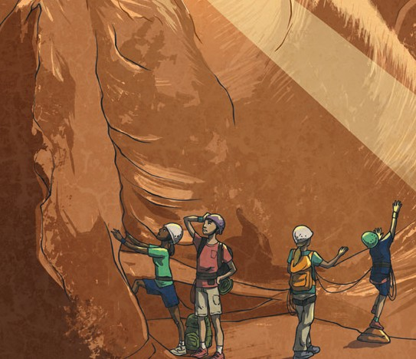
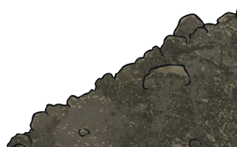

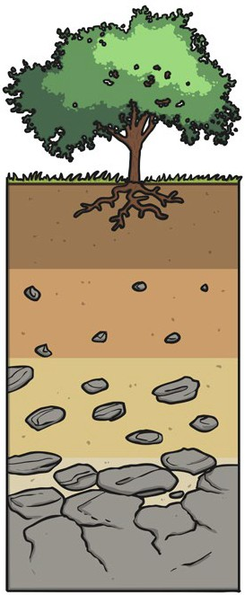

Caves are formed when water permeates through the base rock and erodes some of the rock away. Over thousands of years these caves can become very large.
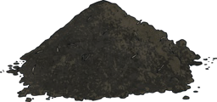

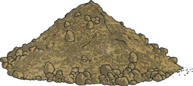

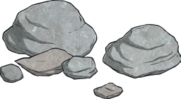

Key Vocabulary
fossilisation | The process by which fossils are made.
palaeontology | The study of fossils.
erosion | When water, wind or ice wears away land.

Key Knowledge
Soil
Soil is the uppermost layer of the Earth. It is a mixture of different things:
- minerals
(the minerals in soil come from finely broken-down rock);
- air;
- water;
- organic matter (including living and dead plants and animals).

topsoil

subsoil

baserock

Fossilisation
An animal dies. It gets covered with sediments which eventually become rock. | More layers of rock cover it. Only hard parts of the creature remain, e.g. bones, shells and teeth. | Over thousands of years, sediment might enter the mould to make a cast fossil. Bones may change to mineral but will stay the same shape. | Changes in sea level take place over a long period. | As erosion and weathering take place, eventually the fossil becomes exposed.
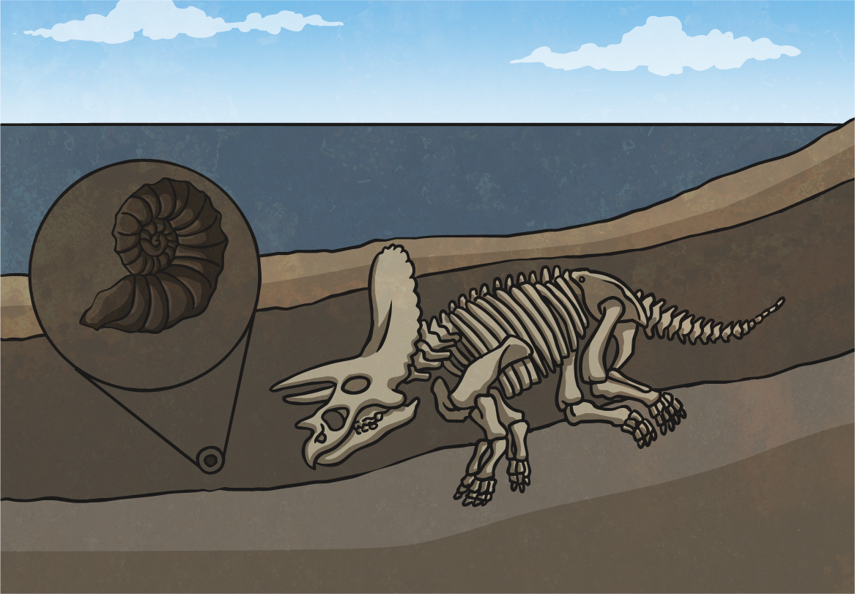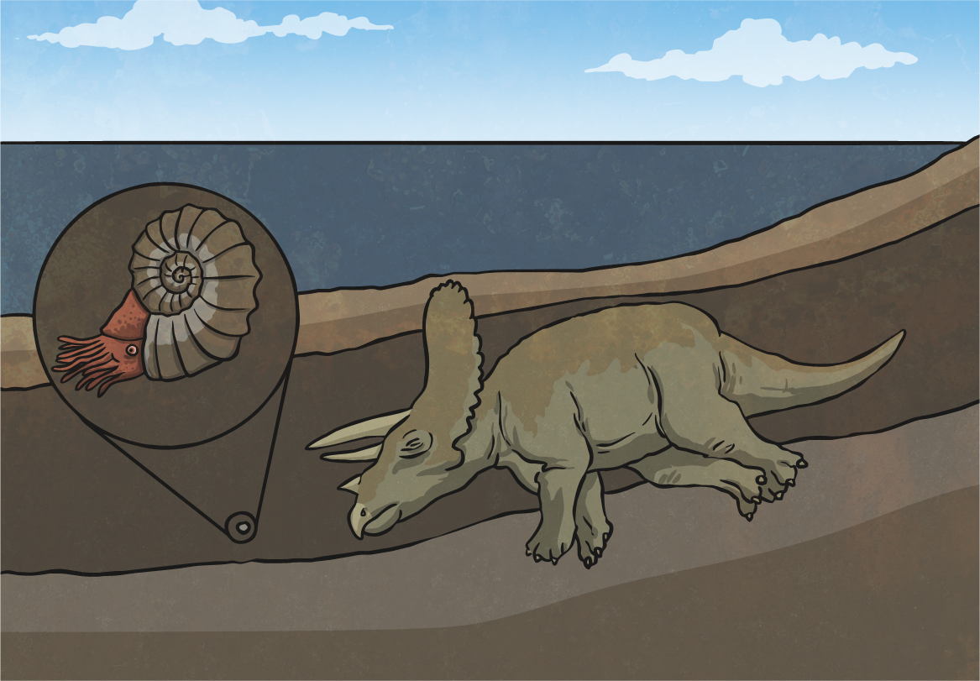 | 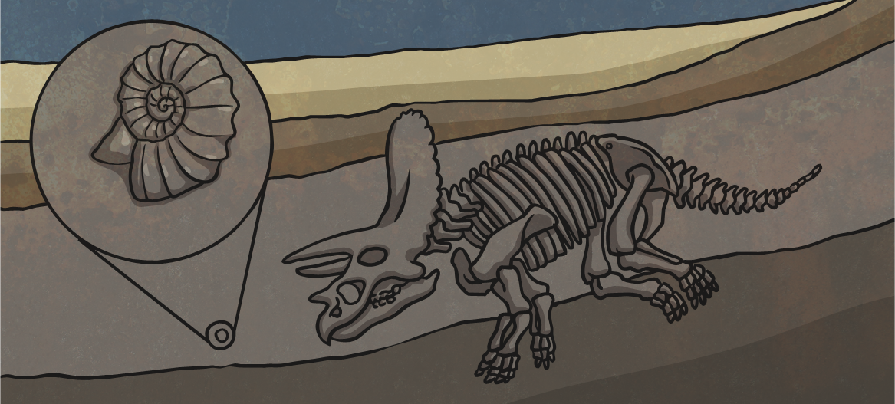 |  | 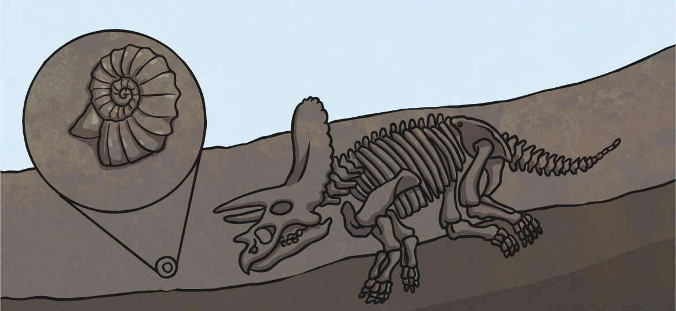 | 

