Year 5
Forces
Key Vocabulary
forces | Pushes or pulls.
gravity | A pulling force exerted by the Earth (or anything else which has mass).
Earth’s gravitational pull | The pull that Earth exerts on an object, pulling it towards Earth’s centre. It is the Earth’s gravitational pull which keeps us on the ground.
weight | The measure of the force of gravity on an object.
mass | A measure of how much matter (or ‘stuff’) is inside an object.

Key Knowledge
Forces |  |  | Isaac Newton
start to move. stop moving.
change direction. | Forces can make an object… | move faster.
change its shape. move more slowly.
Mass is how much matter is inside an object.  It is measured in kilograms (kg).  Weight is how strongly  gravity is pulling an object down. It is measured in newtons (N). |  |  | Isaac Newton is famously thought to have developed his theory of gravity when he saw an apple fall to the ground from an apple tree.  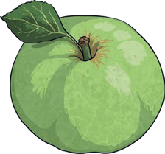

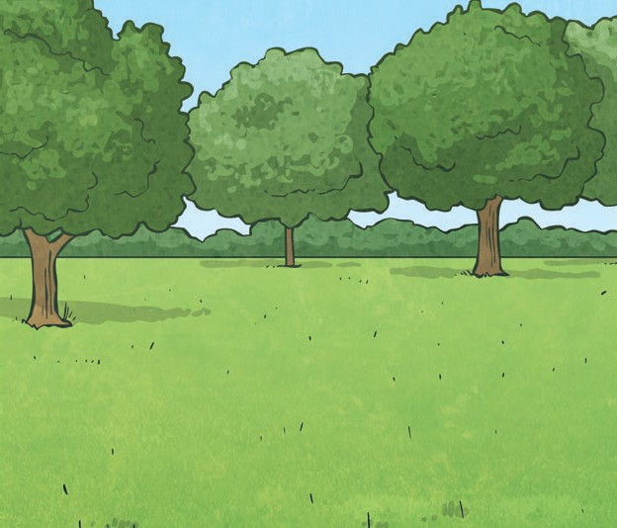
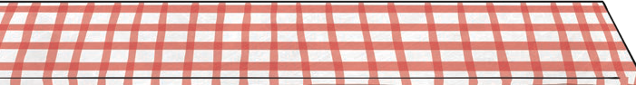
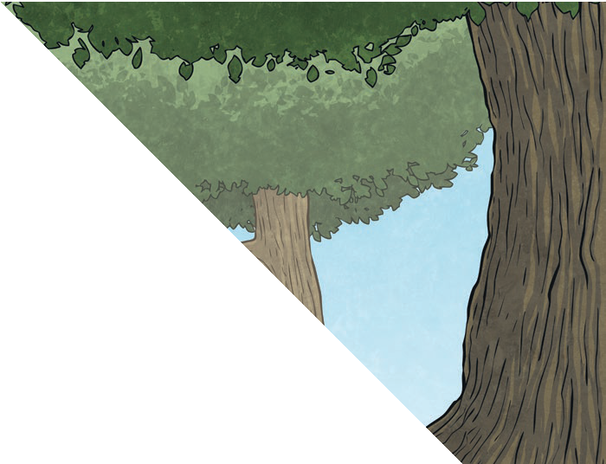
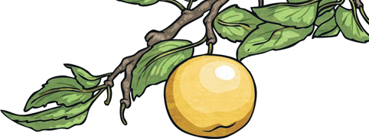
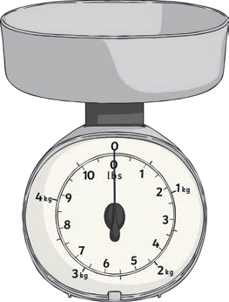
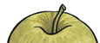
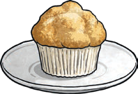
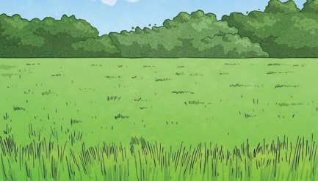
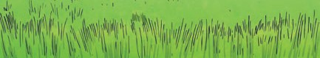
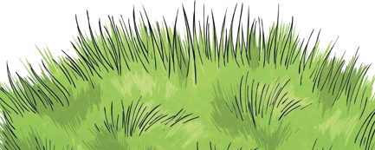
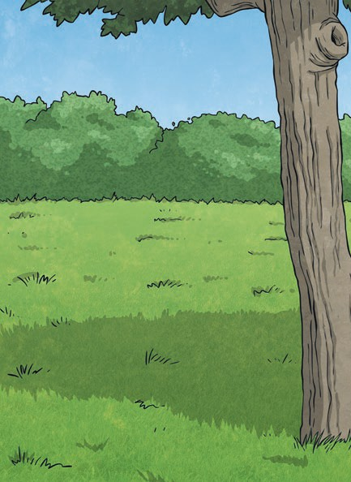
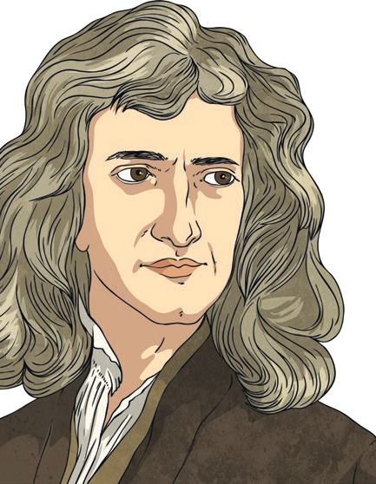
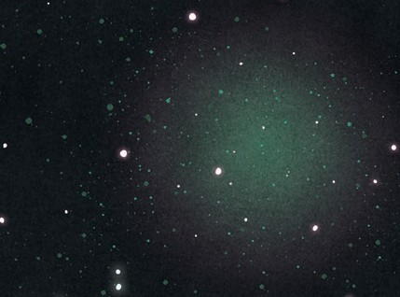
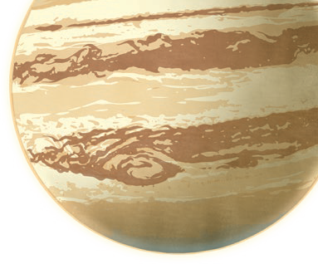

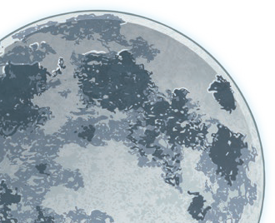
To look at all the planning resources linked to the Forces unit, click here.

Jupiter has
a greater mass than Earth so the gravitational pull on Jupiter is stronger than on Earth.
The Moon has a smaller mass than Earth so the gravitational pull on the Moon is smaller than it is on Earth.

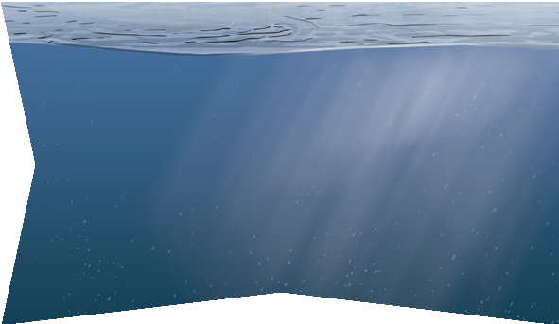
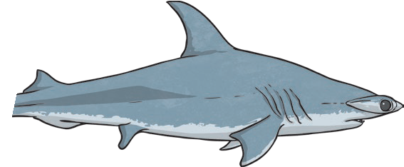

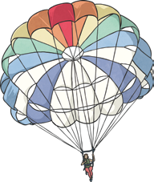
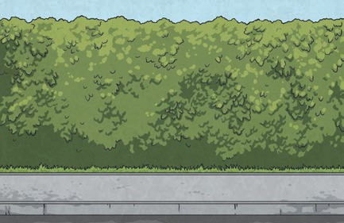
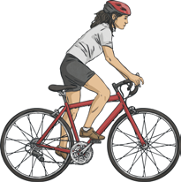

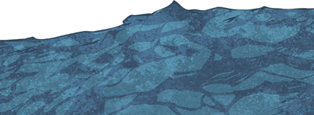
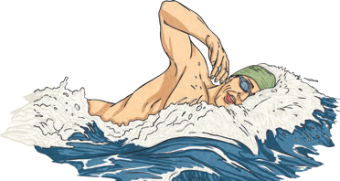
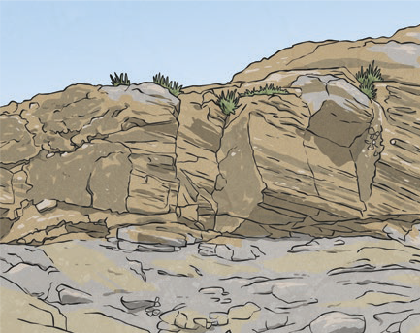
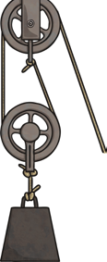
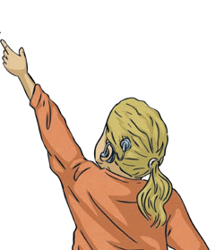
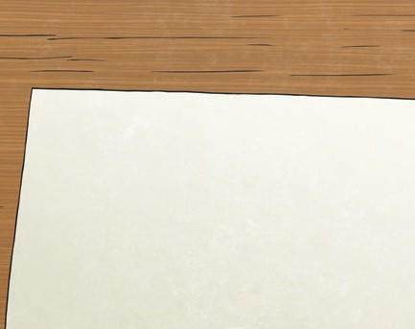
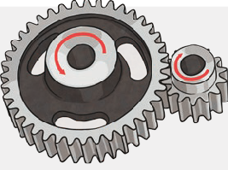
It
has a
pointed nose to cut through the water, and a smooth, low, curved back to allow the water to flow over and around it.
This shark is streamlined.
It does not create much water resistance so it can move through the water quickly.
Year 5
Forces
Pulleys | Gears/Cogs | Levers
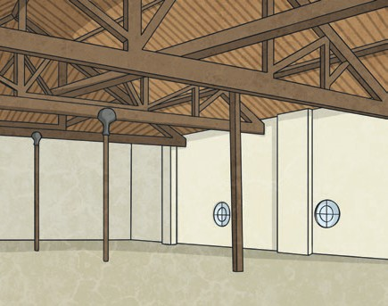 |  | 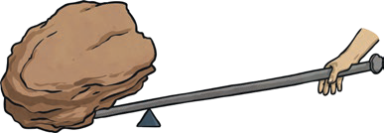
Pulleys can be used to make a small force lift a heavier load. The more wheels in a pulley, the less force is needed to lift a weight. | Gears or cogs can be used to change the speed, force or direction of a motion. When two gears are connected, they always turn in the opposite direction to each other. | Levers can be used to make a small force lift a heavier load. A lever always rests on a pivot.

Key Vocabulary
friction | A force that acts between two surfaces or objects that are moving, or trying to move, across each other.
air resistance | A type of friction caused by air pushing against any moving object.
water resistance | A type of friction caused by water pushing against any moving object.
buoyancy | An object is buoyant if it floats. This is because the weight of the object is equal to the upthrust.
streamlined | When an object is shaped to minimise the effects of air or water resistance.
mechanism | Mechanisms are simple machines with moving parts that change input forces and movement into a set of useful output forces. Examples of mechanisms are pulleys, gears and levers.
upthrust | A force that pushes objects up, usually in water.

Key Knowledge
Examples of forces in action:
swimmer’s water force resistance | gravity  air resistance | cyclist’s  driving force friction
Water resistance and air resistance are forms of friction. Friction is sometimes helpful and sometimes unhelpful. For example, air resistance is helpful as it stops the skydiver hitting the ground at high speed. Friction on a bike chain can make the bike harder to pedal so it is unhelpful.

