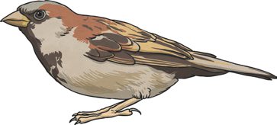
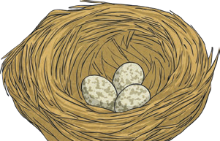
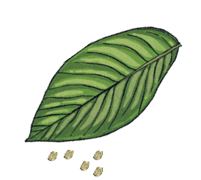
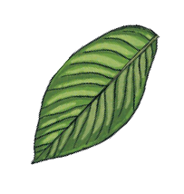
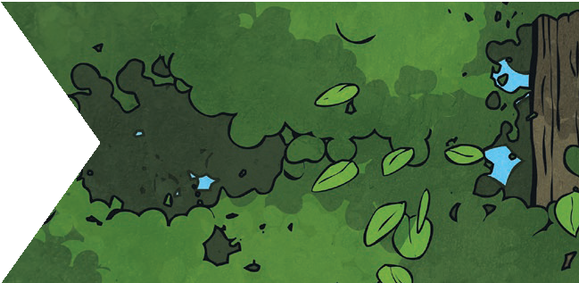
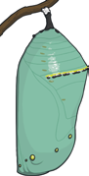
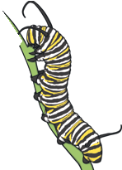
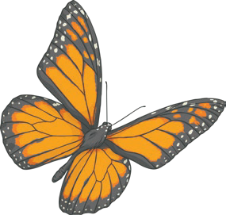
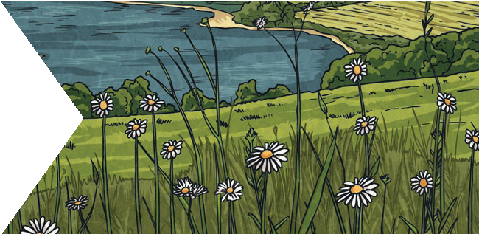
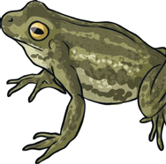
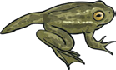

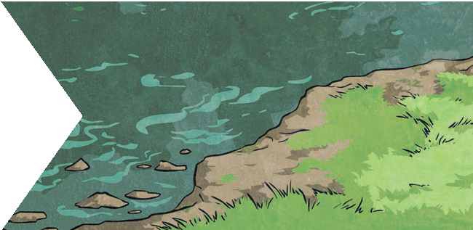
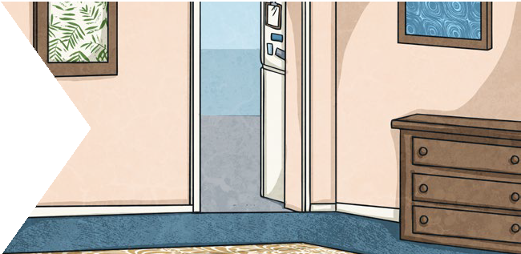
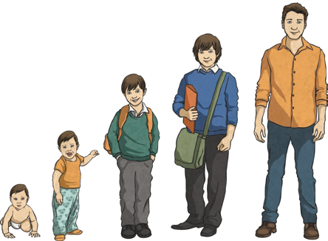
Humans develop inside their mothers and are dependent on their parents for many years until they are old enough to look after themselves.
Living Things and Their Habitats
Year 5
Amphibians such as frogs are laid in eggs then, once hatched, go through many changes until they become an adult.
Birds are hatched from eggs and are looked after by their parents until they are able to live independently.
View more Living Things and Their Habitats planning resources.

Key Vocabulary
asexual  reproduction | One parent is needed to create an offspring, which is an exact copy of  the parent.
fertilise | The action of fusing the male  and female sex cells in order to develop an egg.
gestation | The length of a pregnancy.
life cycle | The journey of changes that take place throughout the life of a living thing including birth, growing up and reproduction.
metamorphosis | An abrupt and obvious change in the structure of an animal’s body and their behaviour.
pollination | The transfer of pollen to a stigma to allow fertilisation.
reproduction | The process of new living things being made.
sexual  reproduction | Two parents are needed to make offspring which are similar but not identical to either parent.
Some animals, such as butterflies, go through metamorphosis to become an adult.
Plants
Most plants contain both the male
sex cell (pollen) and female sex cell
(ovules), but most plants can’t fertilise
themselves. Wind and insects help to
transfer pollen to a different plant.
The pollen from the stamen of one plant
is transferred to the stigma of another.
The pollen then travels down a tube through
the style and fuses with an ovule.
Some plants, such as strawberry plants, potatoes, spider plants and daffodils use asexual reproduction to create a new plant. They are identical to the parent plant.

Reproduction in mammals
Mammals use sexual reproduction to produce their offspring.
- The male sex cell, called the sperm, fertilises the female
sex cells.
- The fertilised cell divides into different cells and
will form a baby with a beating heart.
- The baby will grow inside the female until the end of the gestation period when the baby is born.
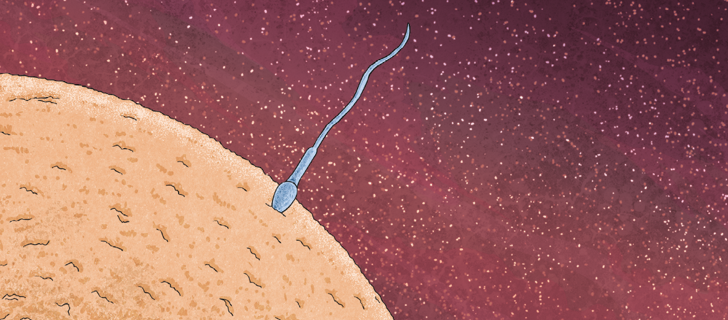
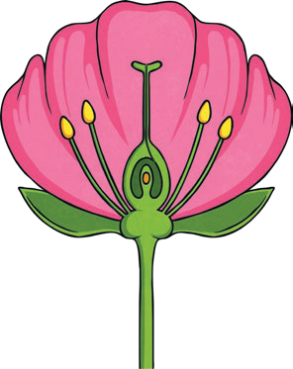
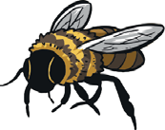
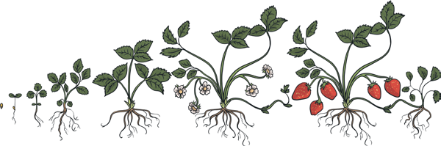
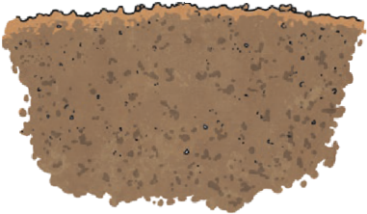
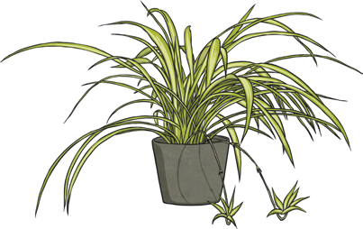
Echidnas and platypus are mammals but they lay eggs rather than giving birth to live young.
ovule
style
stamen
Some living things, such as plants, contain both the male and female sex cells. In others, such as humans, they contain either the male or female sex cell.
Living Things and Their Habitats
Year 5
View more Living Things and Their Habitats planning resources.

