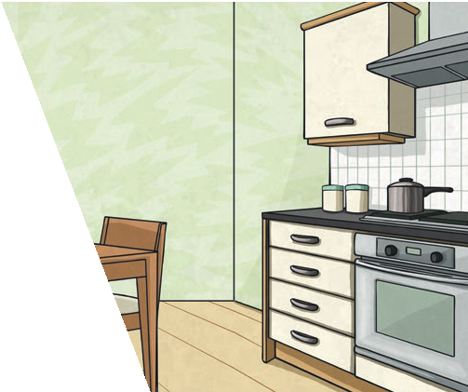
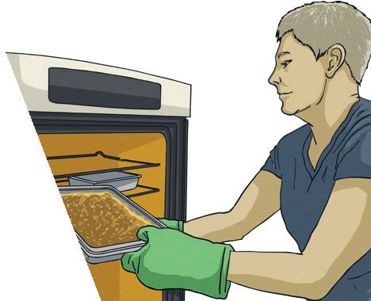
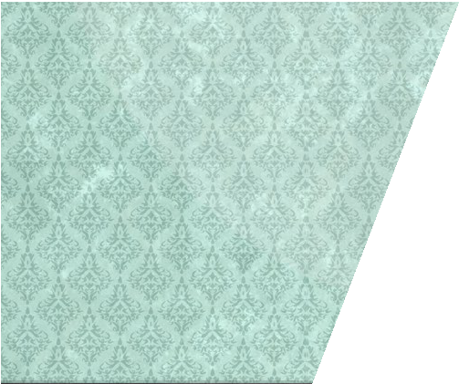
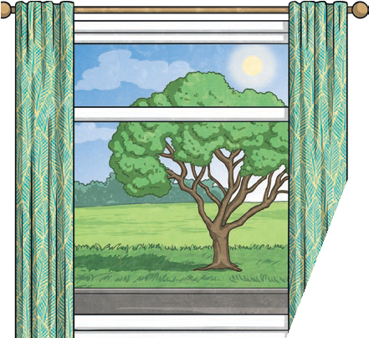
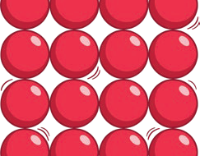
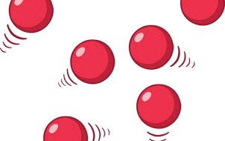
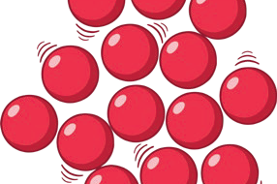
Year 5
Properties and Changes of Materials
For example, glass is used
for windows
because it is hard and transparent. Oven gloves are made from a thermal insulator
to keep the heat from burning your hand.
Changes of State
Key Vocabulary
materials | The substance that something is made out of, e.g. wood, plastic, metal.
solids | One of the three states of matter. Solid particles are very close together, meaning solids, such as wood and glass, hold their shape.
liquids | This state of matter can flow and take the shape of the container because the particles are more loosely packed than solids and can move around each other. Examples of liquids include water and milk.
gases | One of the three states of matter. Gas particles are further apart than solid or liquid particles and they are free to move around. Examples of gases are oxygen and helium.
melting | The process of heating a solid until it changes into a liquid.
freezing | When a liquid cools and turns into a solid.
evaporating | When a liquid turns into a gas or vapour.
condensing | When a gas, such as water vapour, cools and turns into a liquid.

Key Knowledge
Different materials are used for particular jobs based on their properties: electrical conductivity, flexibility, hardness, insulators, magnetism, solubility, thermal conductivity, transparency.

solid particles | liquid particles | gas particles

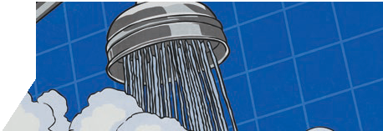

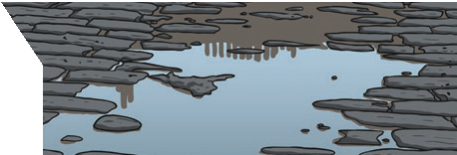
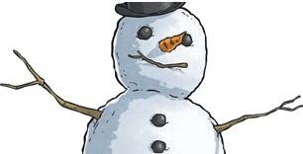
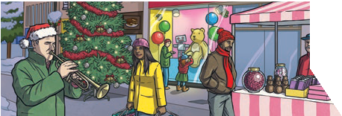
gas
The liquid evaporates.
liquid
The gas condenses.
liquid
The liquid freezes.
solid
The solid melts.
Properties and Changes of Materials
Year 5
Key Vocabulary
conductor | A conductor is a material that heat or electricity can easily travel through. Most metals are both thermal conductors (they conduct heat) and electrical conductors (they conduct electricity).
insulator | An insulator is a material that does not let heat or electricity travel through them. Wood and plastic are both thermal and electrical insulators.
transparency | A transparent object lets light through so the object can be looked through, for example glass or some plastics.

Key Knowledge
Reversible changes, such as mixing and dissolving solids and liquids together, can be reversed by:
Sieving | Filtering | Evaporating
Smaller materials are able to fall through the holes in the sieve, separating them from larger particles. | The solid particles will get caught in the filter paper but the liquid will be able to get through. | The liquid changes into a gas, leaving the solid particles behind.

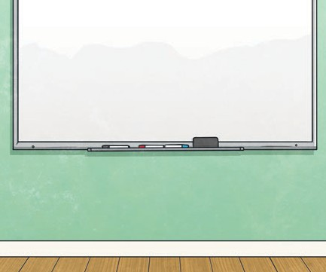
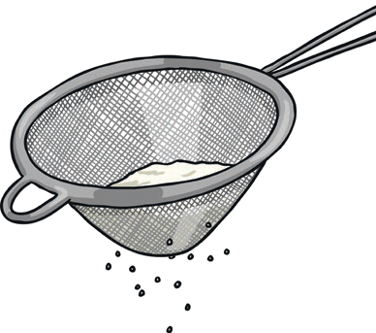
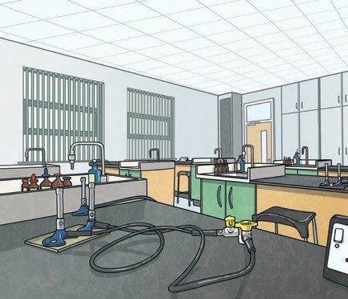
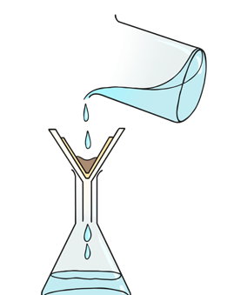

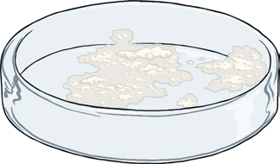
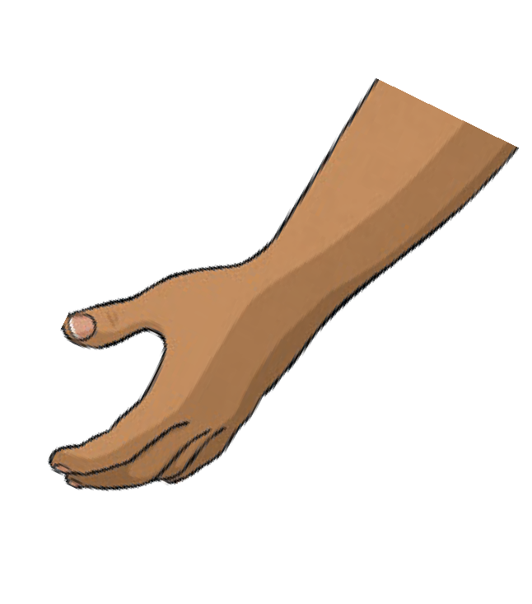
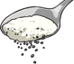
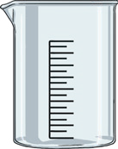
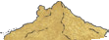
Dissolving
A solution is made when
solid particles are mixed with liquid particles. Materials that will dissolve are known as soluble. Materials that won’t dissolve are known as insoluble. A suspension is when the particles don’t dissolve.

Sugar is a soluble
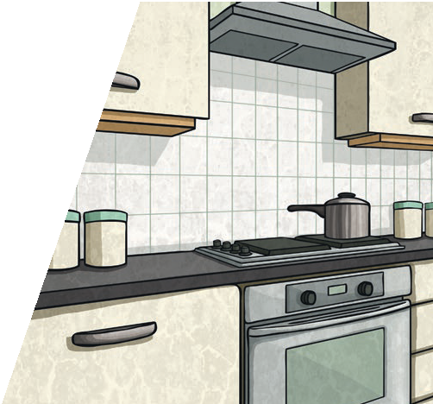
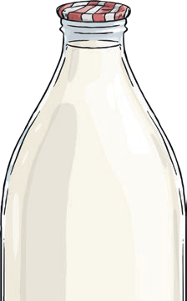
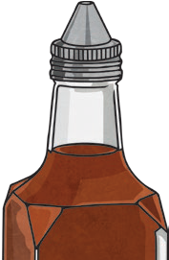
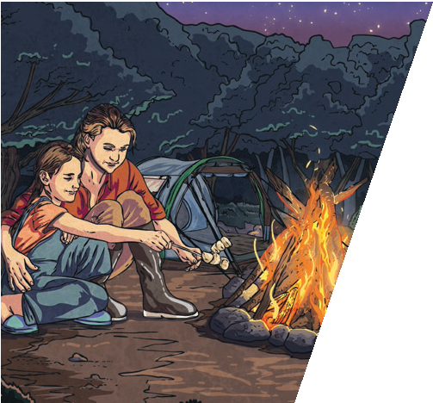
material.
Irreversible changes often result in a new product being made from the old materials (reactants).
For example, burning wood produces ash. Mixing vinegar and milk produces casein plastic.

Sand is an
insoluble material.

To look at all the planning resources linked to the Properties and Changes of Materials unit, click here.

