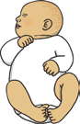
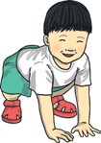
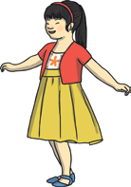
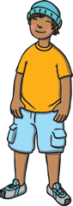
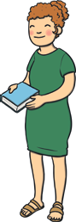
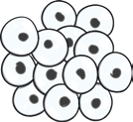
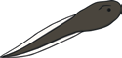
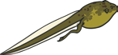
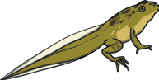
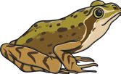
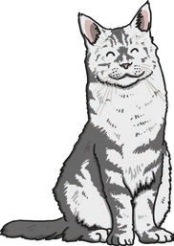
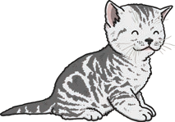
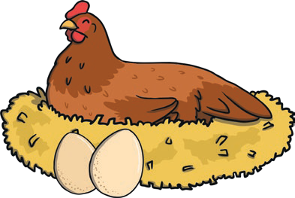
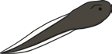
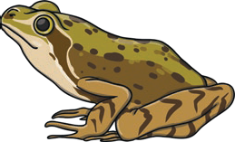
Some animals lay eggs which hatch into live young. This young then develops into an adult.
When these eggs hatch, some animals look like their adult, e.g. birds and reptiles.
Animals Including Humans
Year 2
All living things reproduce and have offspring.
Some animals give birth to live young. Their offspring normally look
like them when they are born.
Other animals have offspring which do not look like
them, e.g. fish and amphibians.
spawn
baby
frog
adult
toddler
tadpole
All young animals change at different stages as they grow into adults.
froglet
tadpole with legs
child
teenager

Key Vocabulary
adult

A fully grown up animal or plant.
develop

To grow and become stronger.
life cycle

The changes living things go through to become an adult.
offspring
The child of an animal.
reproduce

When living things make a new living thing of the same kind.
young

Offspring that has not reached adulthood.
live young

Offspring that has not hatched from an egg.

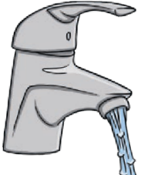
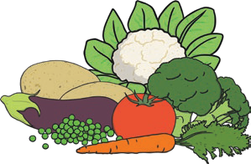
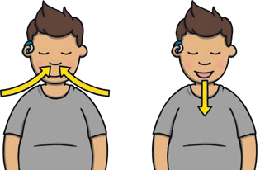
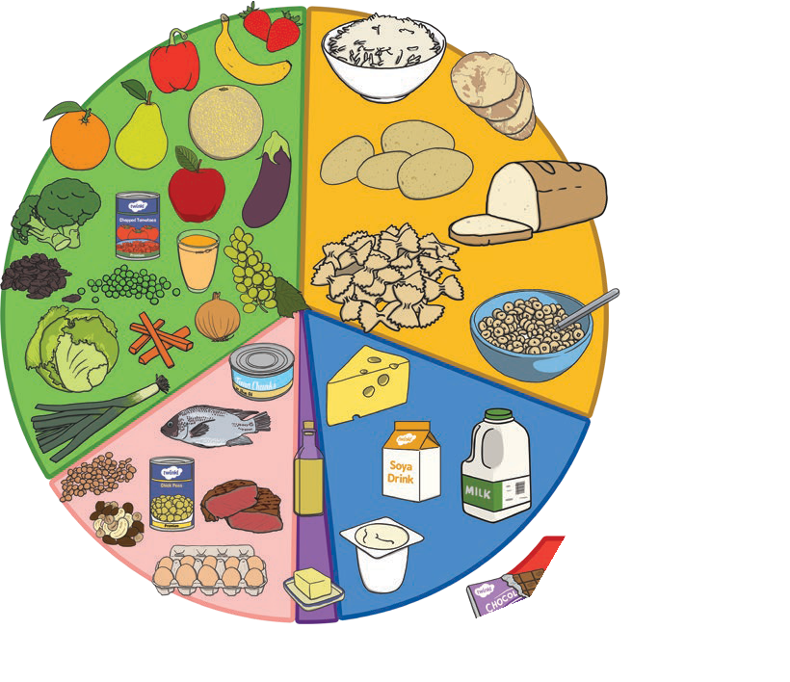
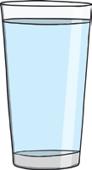

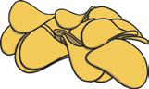
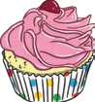
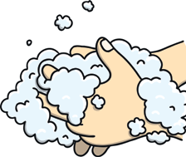
Water,
lower fat milk,
sugar-free drinks including tea and coffee all count.
To grow into a healthy adult, we must eat the right types of food in the right amount and exercise.
Animals Including Humans
Year 2
To stay alive, all animals have 3 basic needs:
air
water
food
Eatwell Guide
6-8
a day
Eat less often and in small amounts.
oils and spreads Choose unsaturated oils and use in small amounts.
To stop illness and infections spreading, we must be hygienic and keep ourselves clean.

c
a
r
b
o
h
y
d
r
a
t
e
s
d
a
i
r
y
a
n
d
a
l
t
e
r
n
a
t
i
v
e
s
p
r
o
t
e
i
n
s
f
r
u
i
t
a
n
d
v
e
g
e
t
a
b
l
e
s

Key Vocabulary
dehydrate
To lose water (dry out).
diet

The food and water that an animal needs.
disease
Illness or sickness.
energy

The power needed to carry out a task.
exercise

A physical activity to keep your body fit.
germs

Bugs that cause disease and illness.
heart rate

The number of times a heart beats in
one minute.
hygiene

How clean something is (to stay healthy and stop disease and illness spreading).
nutrition
Food needed to live.
pulse

The beating of the heart that can be felt in your neck and wrist.

