Key Vocabulary
Seed or Bean
germination | When the conditions are right, the seed soaks up water and swells, and the tiny new plant bursts out of its shell. This is called germination.
sprout | When a plant sprouts, it grows new shoots.
shoot | A shoot grows upwards from the seed or plant to find sunlight.
seed dispersal | Seed dispersal is when the seeds move away from the parent plant. They can be moved by the wind or animals.

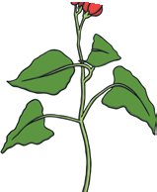
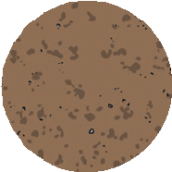

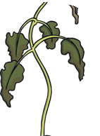

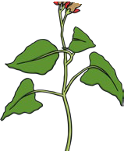

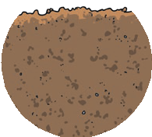
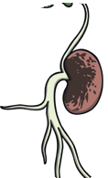

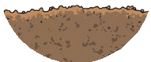
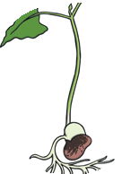

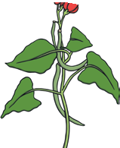
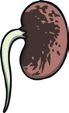
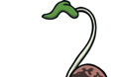
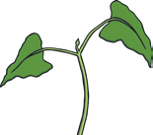
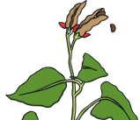

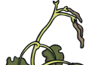
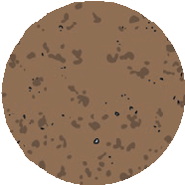
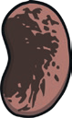
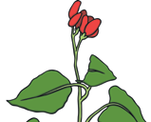
Dies
Seed Dispersal
Roots
Germination
Seed or Bean
4
5
6
3
Life Cycle of a Plant
7
2
1
8

Fruit

Leaves

Flowers

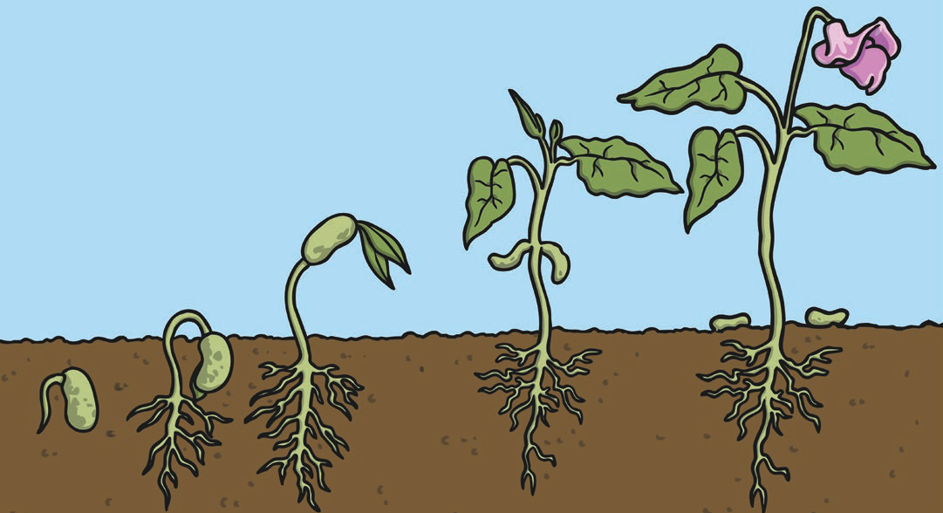

Key Vocabulary
What do plants need to grow well?
sunlight | All plants need light from the sun to grow well. Some plants need lots of sunlight. Some plants only need a little sunlight.
water | All plants need water to grow. Without  water, seeds and bulbs will not germinate.
temperature | Temperature is how warm or cold something or somewhere is. Some plants like cooler temperatures and some like warmer temperatures.
nutrition | Food or nourishment. Plants make their own food in their leaves using sunlight.


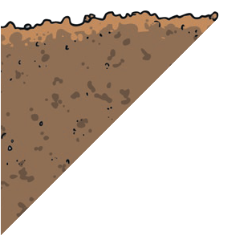
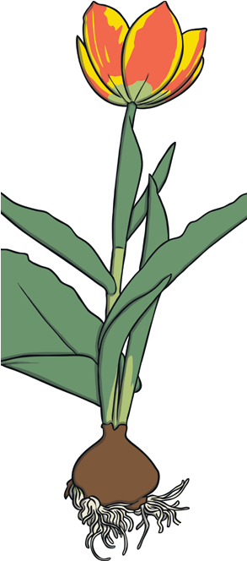

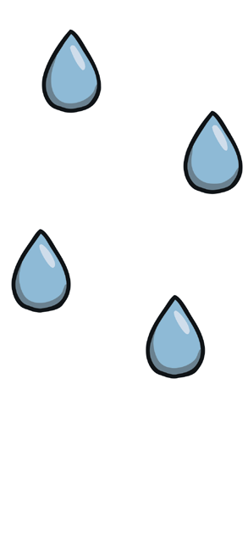
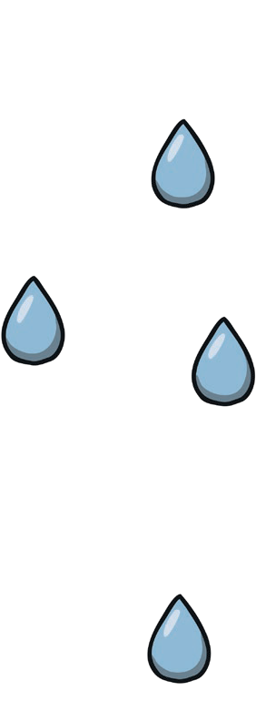

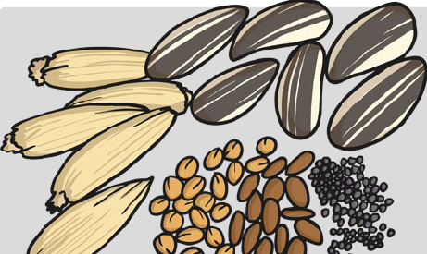
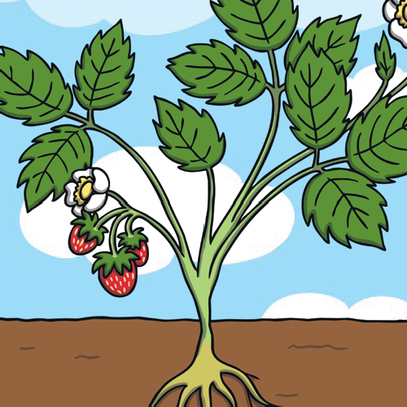
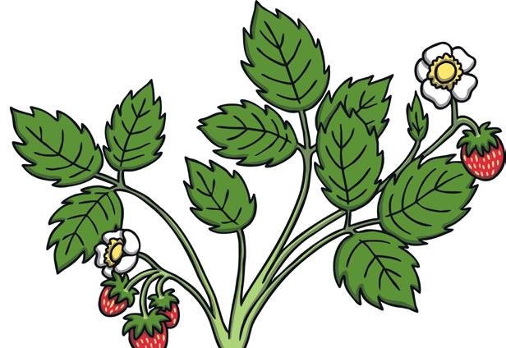
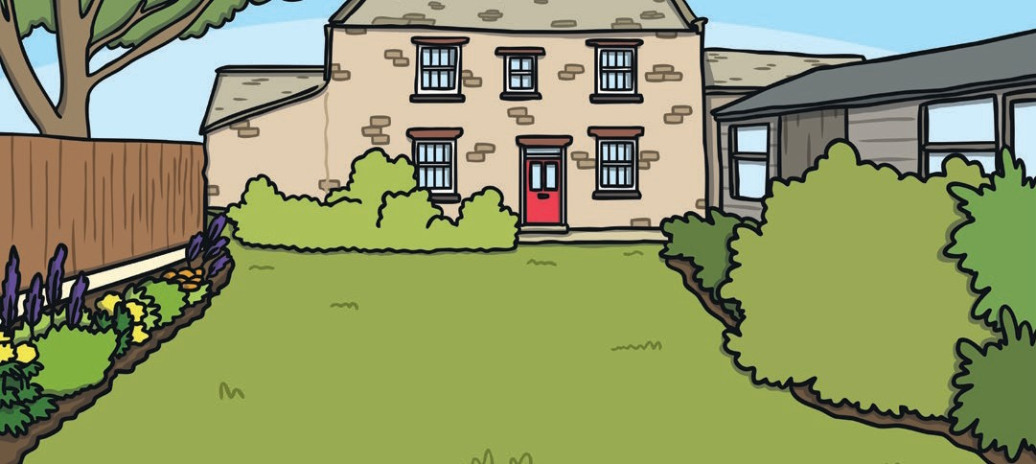
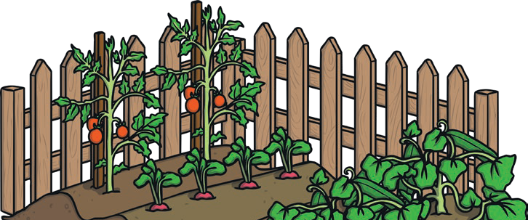
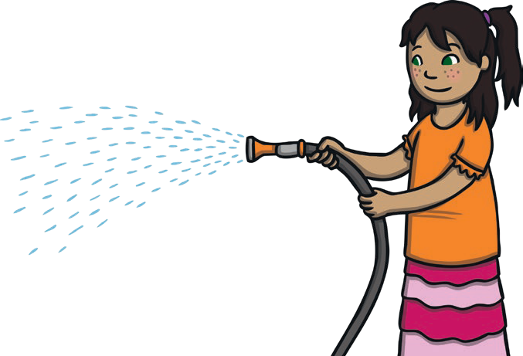
seeds
bulb
water
sun

