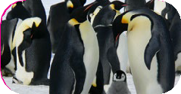
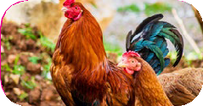
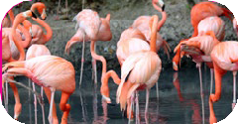
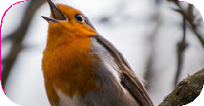
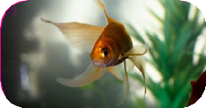
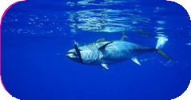
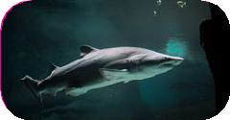
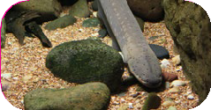
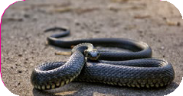
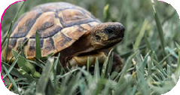
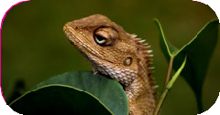
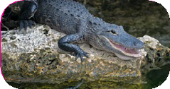
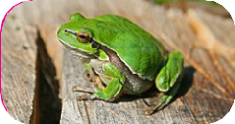
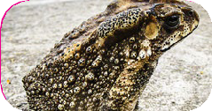
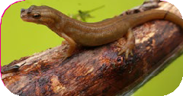
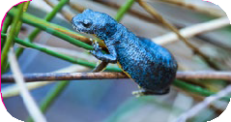

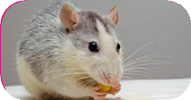

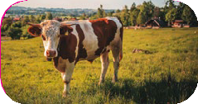
Animals Including Humans
Year 1
Mammals
human
mouse
dog
cow
Birds
penguin
chicken
flamingo
robin
Fish
goldfish
tuna
shark
eel
Reptiles
snake
tortoise
lizard
alligator
Amphibians

frog
toad
newt
salamander

Key Vocabulary
amphibians

Amphibians live in the water as babies and on land as they grow older. They have smooth, slimy skin.
birds

All birds have a beak, two legs, feathers and wings.
fish

Fish live and breathe under water. They have scaly skin, fins to help them swim and they breathe through gills.
mammals

Mammals are animals that breathe air, grow hair or fur and feed on their mother’s milk as a baby.
reptiles

All reptiles breathe air. They have scales on their skin.
carnivore

Animals that mostly eat other animals (meat) are carnivores.
herbivore

Animals that only eat plants are herbivores.
omnivore

Animals that eat both plants and other animals are omnivores.

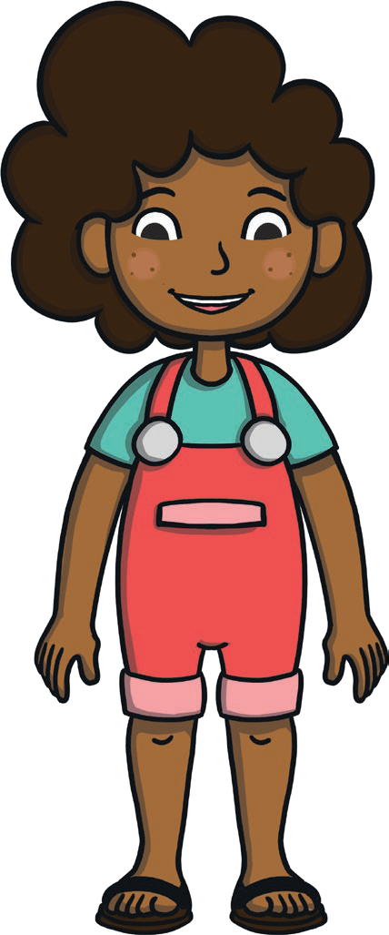
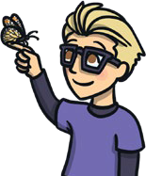
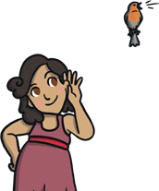
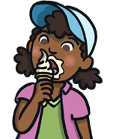
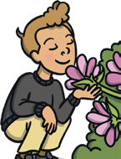
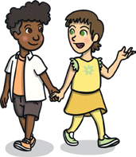
Animals Including Humans
Year 1
Senses
Parts of the Body
head
sight
eye
ear
nose
hearing
mouth
shoulder
teeth
elbow
touch
hand
thumb
fingers
knee
taste
leg
toes
foot
smell

Key Vocabulary
sight

Your eyes let you see all the things around you.

hearing

Your ears let you listen to all the things around you. Your brain
is able to tell what different sounds are.
touch

Your skin gives you the sense of touch. You can tell if something is warm, cold, smooth or rough without even looking at it!
taste

Your sense of taste comes from your tongue. You can tell if something tastes bitter or sweet. You might have some tastes you like and some you don’t.
smell

You smell using your nose. Your nose can tell if things smell nice or not nice.

