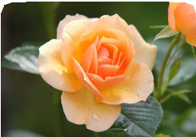
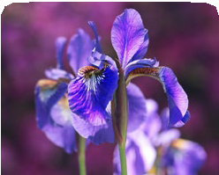
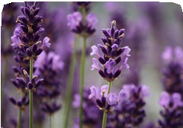
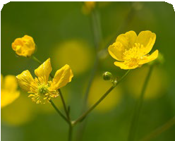
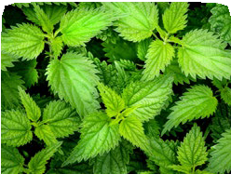
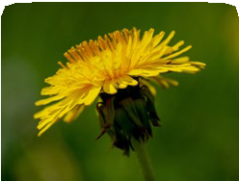
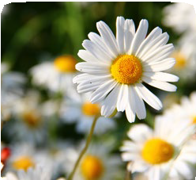
Year 1
Plants
rose
iris

lavender

buttercup

nettles

dandelion

daisy
Key Knowledge
Wild Plants

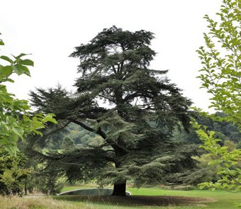
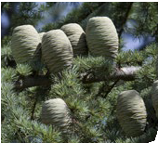
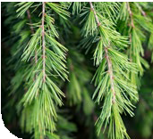
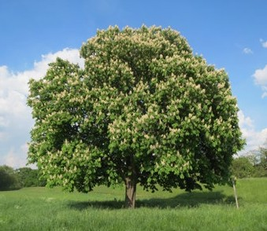
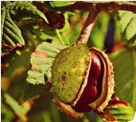
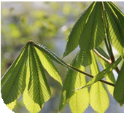
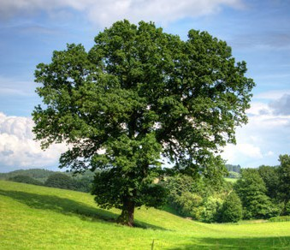
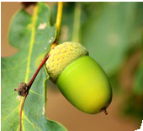
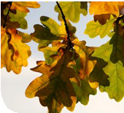
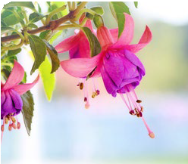
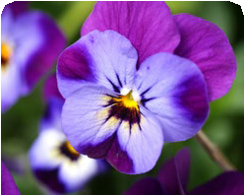
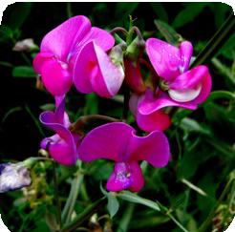
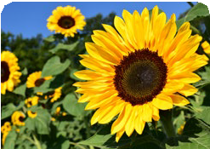
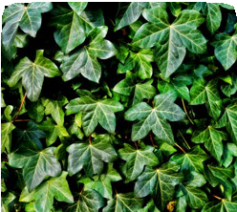
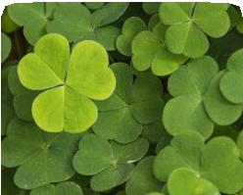
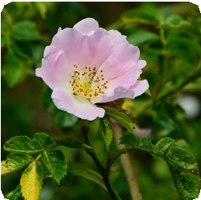
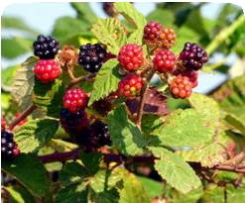
Trees Garden Plants
cedar
horse chestnut
oak

fuchsia

pansy

sweet pea

sunflower
ivy

clover

dog rose

brambles
Key Vocabulary
wild plants | A wild plant seed grows where it falls. It doesn’t need to be planted or cared for as it grows.
garden plants | Garden plants are plants that people choose to grow in their gardens.
weed | Weeds are wild plants that grow in places where people don’t want them.
deciduous | A deciduous tree loses its leaves each year.
evergreen | An evergreen tree keeps its green leaves all year round, even in the winter.

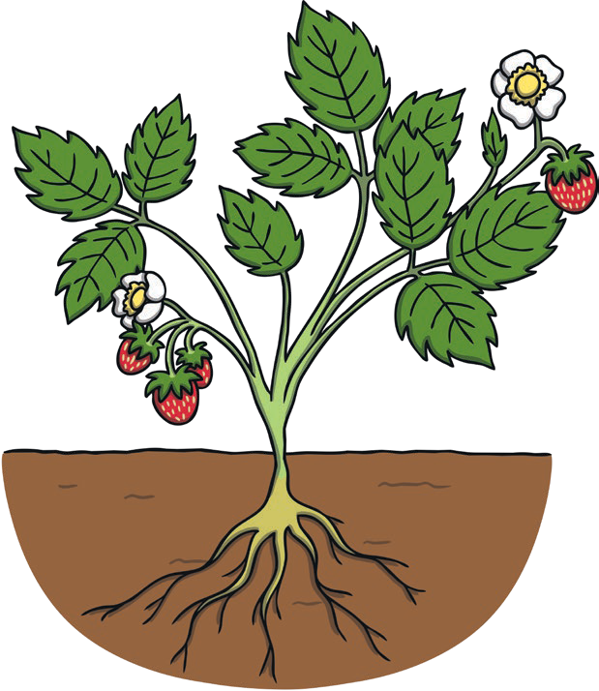
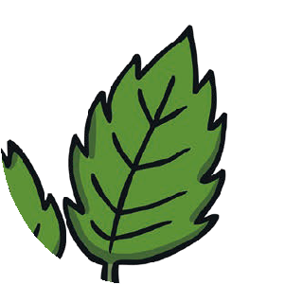
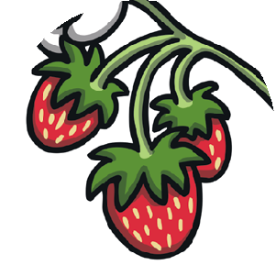
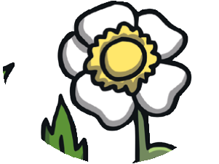
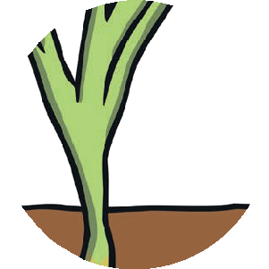
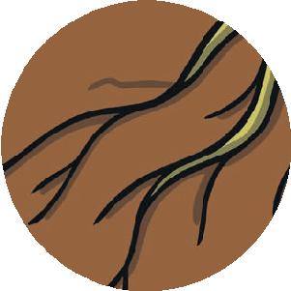
Year 1
Plants
Key Knowledge
f
l
s
o
t
w
e
e
m
r
r
o
s
o
t
s
l
e
f
r
a
u
v
i
e
t
s
Key Vocabulary
roots | Roots take in water and nutrients from the soil and keep the plant in the ground.
stem | The stem holds the plant up and carries the water and nutrients from the roots to the leaves and flowers.
leaves | Leaves catch sunlight to help the plant to make its own food.
flowers | Flowers attract insects and birds.
petals | Petals are the colourful part of the flower.
fruit | Fruit contains the plant’s seeds. Sometimes humans try to grow fruit without seeds because it’s easier to eat.
seed | Seeds grow into new plants.
bulb | Bulbs grow into new plants.
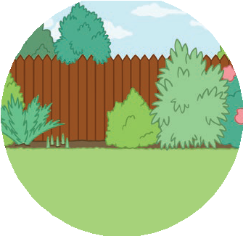

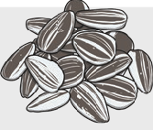
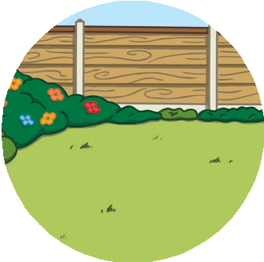
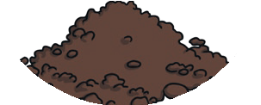
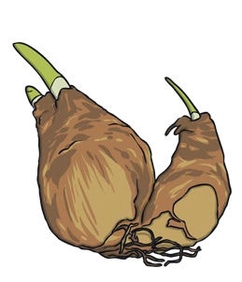
d
s
s
e
e
u
l
b
b
s

