Mammals have hearts with four chambers. Notice how the blood that has come from the body is deoxygenated, and the blood that has come from
Key Vocabulary
circulatory system | A system which includes the heart, veins, arteries and blood transporting substances around the body.
heart | An organ which constantly pumps blood around the circulatory system.
blood vessels | The tube-like structures that carry blood through the tissues and organs. Veins, arteries and capillaries are the three types of blood vessels.
oxygenated blood | Oxygenated blood has more oxygen. It is pumped from the heart to the rest of the body.
deoxygenated blood | Deoxygenated blood is blood where most of the oxygen has already been transferred to the rest of the body.

the lungs is oxygenated

from body
to body
Year 6
Animals Including Humans

to lungs
from lungs

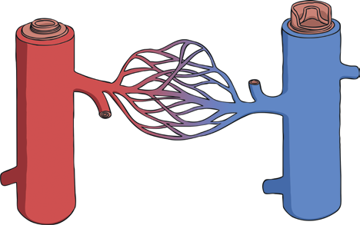
again. The blood isn’t actually red and blue: we just show it like
that on a diagram.
Capillaries are the smallest blood vessels in the body and it is here that the exchange of water, nutrients, oxygen and carbon dioxide
takes place.
Arteries carry
oxy g e n at ed
Veins
carry
blood
from
heart.
away
the
deoxygenated blood toward
the heart.
capillaries
veins
arteries
from body

deoxygenated blood

oxygenated blood

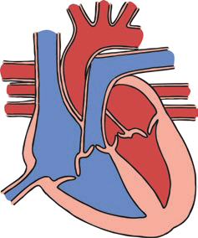







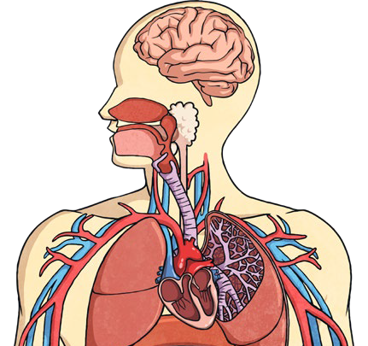
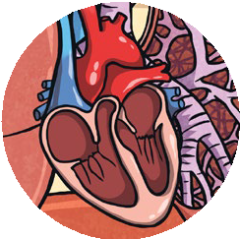
The heart pumps blood to the lungs to get oxygen.
It then pumps this oxygenated blood around the body.
If you linked up all of the body’s blood vessels, including arteries,
capillaries, and veins, they would measure over 60,000 miles.

Year 6
Animals Including Humans

The liquid part of blood
Key Vocabulary
drug | A substance containing natural or man-made chemicals that has an effect on your body when it enters your system.
alcohol | A drug produced from grains, fruits or vegetables when they are put through a process called fermentation.
nutrients | Substances that animals need to stay alive and healthy.

Blood transports:
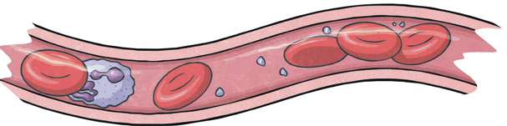
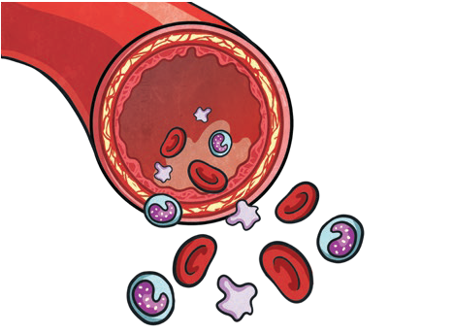
- gases (mostly oxygen and carbon dioxide);
  - nutrients (including water);

Plasma is liquid. The other

Platelets help you stop bleeding when
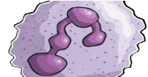
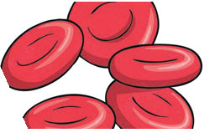
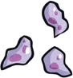
you get hurt.
contains water and protein. This is called plasma.

- waste products.

parts of your blood are solid.
Red blood cells carry oxygen through your body.
White blood cells fight infection


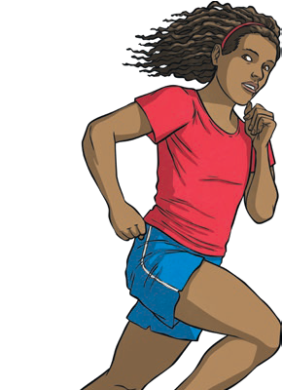
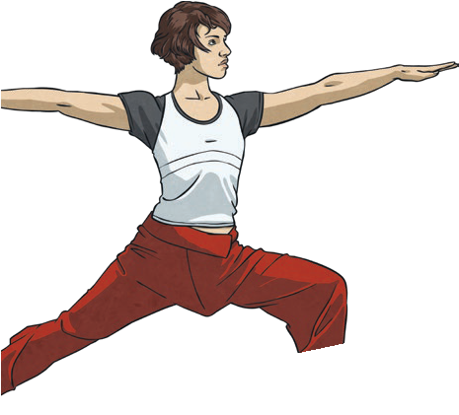
when you’re sick.
Regular exercise:
- strengthens muscles including the heart muscle;
- improves circulation;
- increases the amount of oxygen around the body;
- releases brain chemicals which help you feel calm and relaxed;
- helps you sleep more easily;
- strengthens bones.
It can even help to stop us from getting ill.

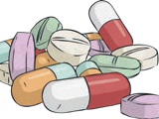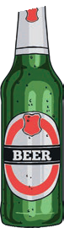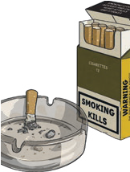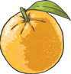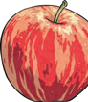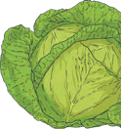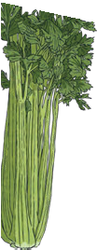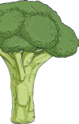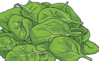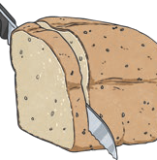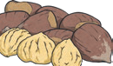
Drugs, alcohol and smoking have negative effects on the body.
A healthy diet involves eating the right types of nutrients in
the right amounts.

