



These symbols can be used to create electrical circuit diagrams.
Key Knowledge
M
battery
Components of a Circuit and Their Symbols
Electricity
Year 6
lamp/bulb (indicator)
wire
lamp/bulb (lighting)
switch (open)
motor
buzzer
switch (closed)
cell
To look at all the planning resources linked to the Electricity unit, click here.
Key Vocabulary
circuit

A path that an electrical current
can flow around.
symbol

A visual picture that stands for something else.
cell/battery

A device that stores energy as a chemical until it is needed. A cell is a single unit. A battery is a collection of cells.
current

The flow of electrons, measured in amps.
amps
How electric current is measured.
voltage

The force that makes the electric current move through the wires. The greater the voltage, the more current will flow.
resistance

The difficulty that the electric current has when flowing around a circuit.
electrons

Very small particles that travel around an electrical circuit.

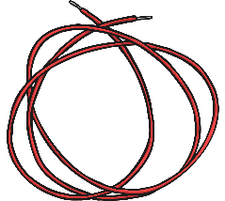


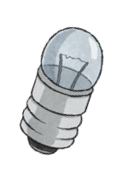


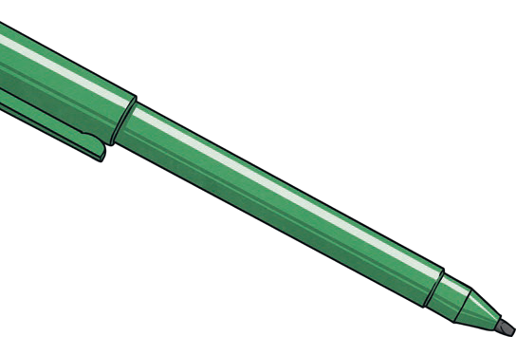
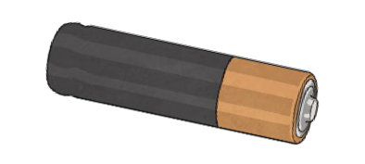


A broken circuit with no electrical current.
More components sharing less power.
- More batteries or a higher voltage create more
power to flow through the circuit.
- Shortening the wires means the electrons have
less resistance to
flow through.
Key Knowledge
What will make a bulb brighter or a buzzer louder?
Electricity
Year 6
Series Circuit
A circuit that has only one route for the current to take. If more bulbs or buzzers are added, the power has to be shared and so they will be dimmer or quieter. If just one part of this series circuit breaks, the circuit is broken and
the flow of current stops.
What will make a bulb dimmer or a buzzer quieter?
- Fewer batteries or a lower voltage
give less power to the circuit.
- More buzzers or bulbs mean the power is shared by more components.
- Lengthening the wires means the electrons have to travel through more resistance.

