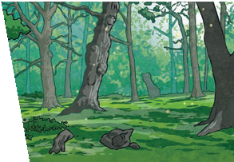
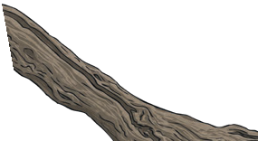
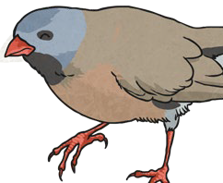
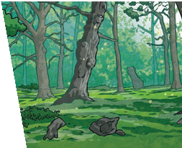
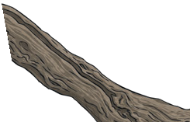
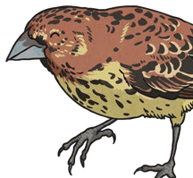

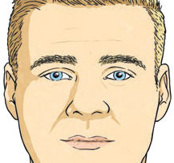

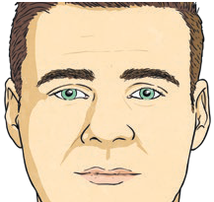
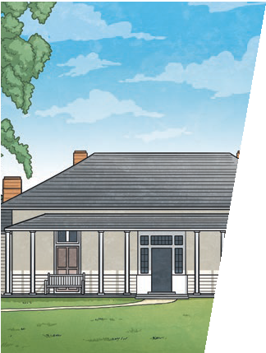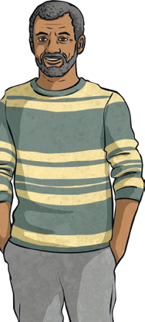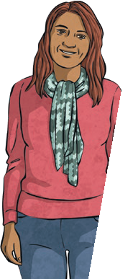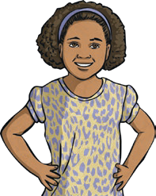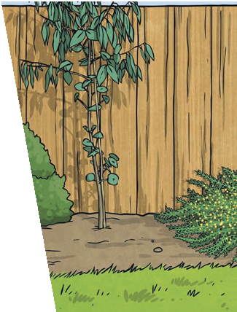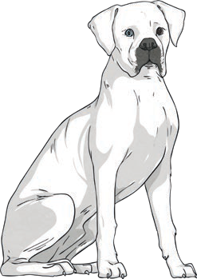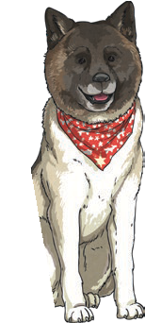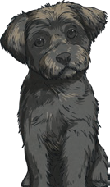
Year 6
Evolution and Inheritance
Year 6
Evolution and Inheritance
Adaptive Traits Characteristics that are influenced by
the environment the living things live in. These adaptations can develop as a result of many things, such as food and climate.
Inherited Traits Eye colour is an example of an
inherited trait, but so are things
like hair colour, the shape of your
earlobes and whether or not you can smell certain flowers.
Key Vocabulary
offspring | The young animal or plant that is produced by the reproduction of that species.
inheritance | This is when characteristics are passed on to offspring from their parents.
variations | The differences between individuals within a species.
characteristics | The distinguishing features or qualities that are specific to a species.
adaptation | An adaptation is a trait (or characteristic) changing to increase a living thing’s chances of surviving and reproducing.
habitat | Refers to a specific area or place in which particular animals and plants can live.
environment | An environment contains many habitats and includes areas where there are both living and non- living things.

Offspring Animals
and
plants produce offspring that are similar but not identical to them. Offspring often look like their parents because features
are passed on.
Variation
In the same way that there is variation between parents and their offspring, you can see variation within any species, even plants.

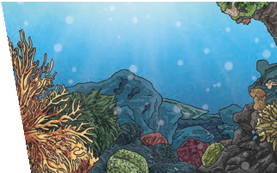
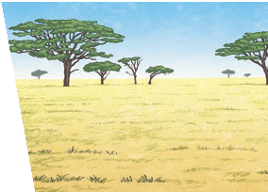
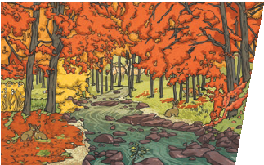
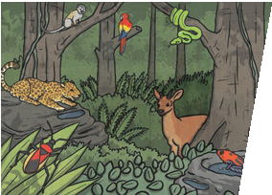
To look at all the planning resources linked to the Evolution and Inheritance unit, click here.
Environments There are many types of
environment around the world. Polar regions, deserts, rainforests, oceans, rivers, and grasslands are all environments.
Habitats
A good habitat should provide
shelter, water, enough space and plenty of food.

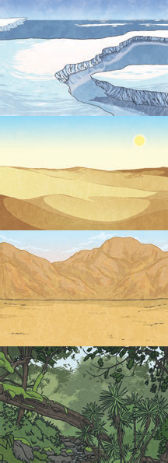
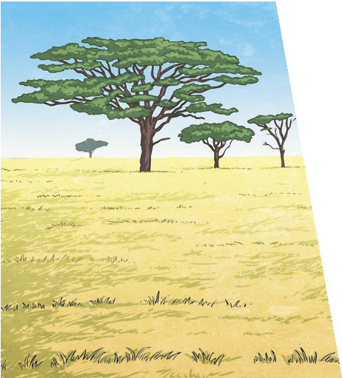
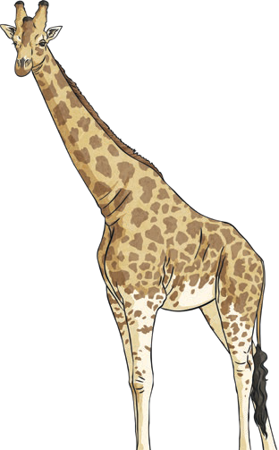
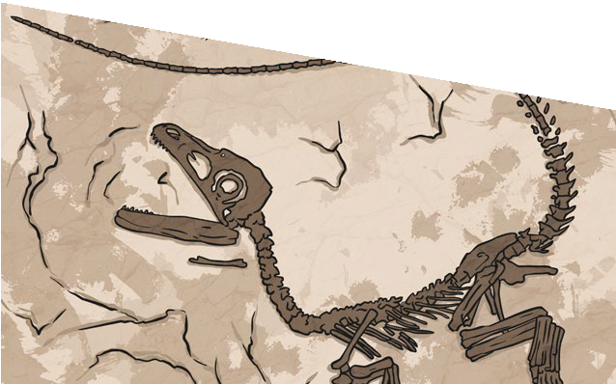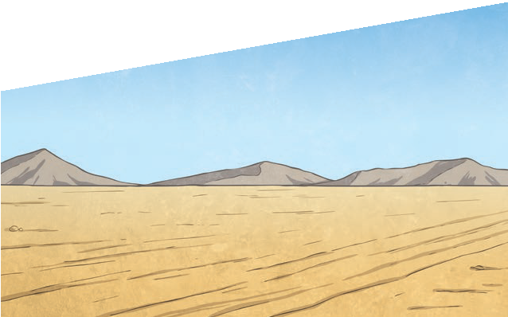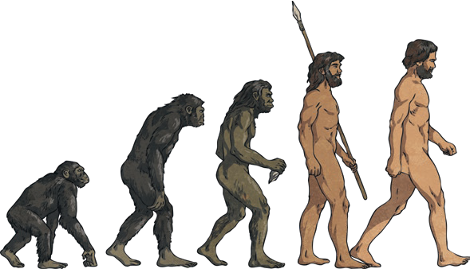
Evolution and Inheritance
Year 6
Natural Selection
Fossils of giraffes from millions of years ago show that they used to have shorter necks. They have gradually evolved through natural selection to have longer necks so that they can reach the top leaves on taller trees.
Living Things |  | Habitat |  | Adaptive Traits
polar bear | 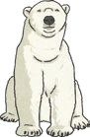 | arctic |  | Its white fur enables it to camouflage in the snow.
camel | 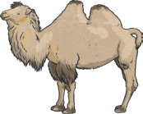 | desert |  | It has wide feet to make it easier to walk in the sand.
cactus | 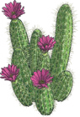 | desert |  | It stores water in its stem.
toucan | 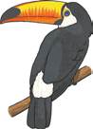 | rainforest |  | Its narrow tongue allows it to eat small fruit and insects.

Key Vocabulary
evolution | Adaptation over a very long time.
natural selection | The process where organisms that are better adapted to their environment tend to survive and produce more offspring.
fossil | The remains or imprint of a prehistoric plant or animal, embedded in rock and preserved.
adaptive traits | Genetic features that help a living thing to survive.
inherited traits | These are traits you get from your parents. Within a family, you will often see similar traits, e.g. curly hair.

Fossils are the preserved remains, or partial remains, of ancient animals and plants. Fossils let scientists know how plants and animals used to look millions of years ago. This is proof that living things have
evolved over time.
Evolution is the gradual process by which different kinds of living organism have developed from earlier forms over millions of years. Scientists have proof that living things are continuously evolving - even today!

