Key Knowledge
Lightning and static electricity are examples of electricity occurring naturally but for us to use electricity to power appliances, we need to make it.
Electricity Year 4
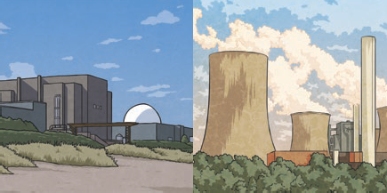
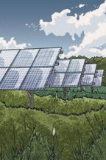
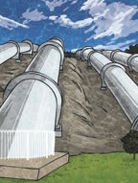
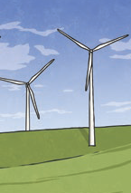
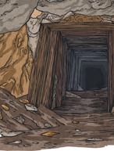
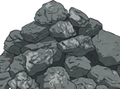
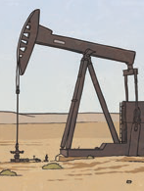
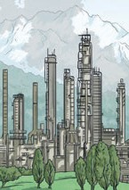


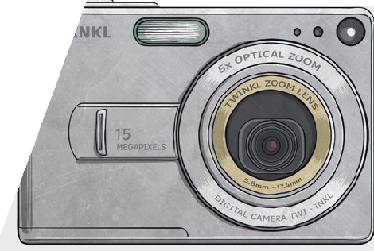
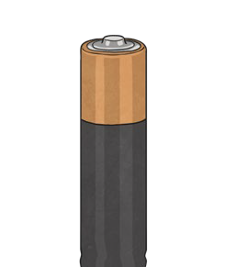
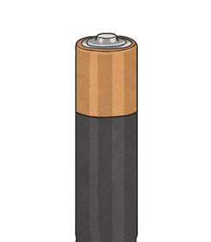
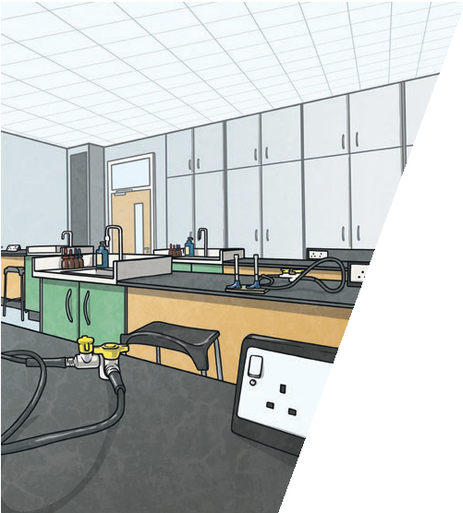
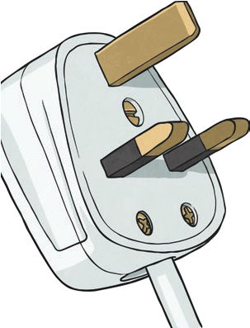

Many everyday appliances rely on electricity for
them to work. Some appliances use mains
electricity (are plugged into a
socket) and others have a battery to make them work.
Key Vocabulary
electricity | The flow of an electric current through a material, e.g. from a power source through wires to an appliance.
generate | To make or produce.
renewable | A source of electricity that will not run out. These include solar, nuclear, geothermal, hydro and wind.
non-renewable | This source of energy will eventually run out and so will no longer be able to be used to make electricity. These include fossil fuels – coal, oil and natural gas.
appliances | A piece of equipment or a device designed to perform a particular job, such as a washing machine or mobile phone.
battery | A device that stores electrical energy as a chemical.

Coal, oil
and natural gases are fossil fuels which, when burnt, produce heat which can be used to generate electricity.
Electricity can be generated from wind power used to turn windmills and hydroelectric power from water used in dams. The Sun’s rays can be converted into electricity by solar panels.

Nuclear energy
is created when atoms are split. This creates heat which can be used to generate electricity. Geothermal energy is heat from the Earth that is converted into electricity.


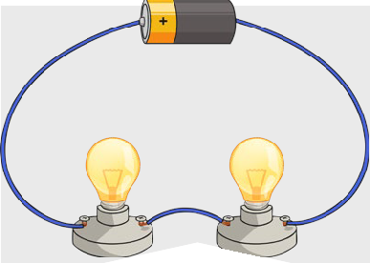


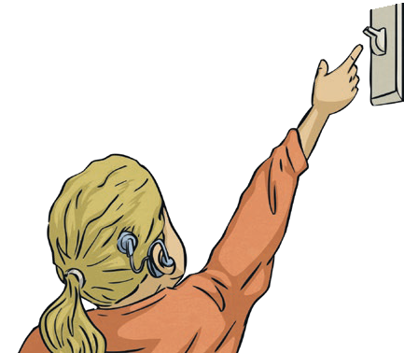


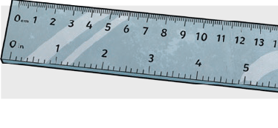



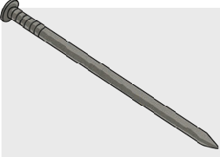
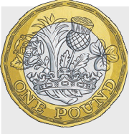




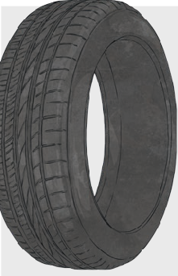
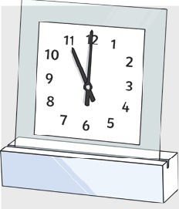

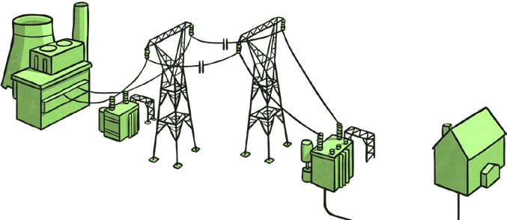
Electricity Year 4

Electricity can
only flow around a complete circuit that has no gaps. There must be wires connected to both the positive and negative end of the power supply/battery.
Key Knowledge
Switches can be used to open or close a circuit. When off, a switch ‘breaks’ the circuit to stop the flow of electricity. When on, a switch ‘completes’ the circuit and allows the electricity to flow.
A conductor of electricity is a material that will allow electricity to flow through it. Metals are good conductors. Materials that are electrical insulators do not allow electricity to flow through them. Wood, plastic and glass are good insulators
Electrical Conductors
Electrical Insulators
Key Vocabulary
circuit | A pathway that electricity can flow around. It includes wires and a power supply and may include bulbs, switches or buzzers.

There are two types of electric current.
Mains electricity: power stations send an electric charge through wires to transformers and pylons. Then, underground wires carry the electricity into our homes via wires in the walls and out through plug sockets.

Battery electricity: batteries store chemicals which produce an electric current. Eventually, even rechargeable batteries will stop producing an electric current.
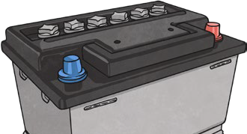 | 

