Year 4
Sound

slower vibrations = lower pitch

The size of the vibration is called the amplitude.
Louder sounds have a larger amplitude, and quieter sounds
loud
Pitch is a measure of how high or low a sound is. A whistle being blown creates a high-pitched sound. A rumble of thunder is an example of a low-pitched sound.

have a smaller amplitude. quiet
Faster vibrations
= higher pitch

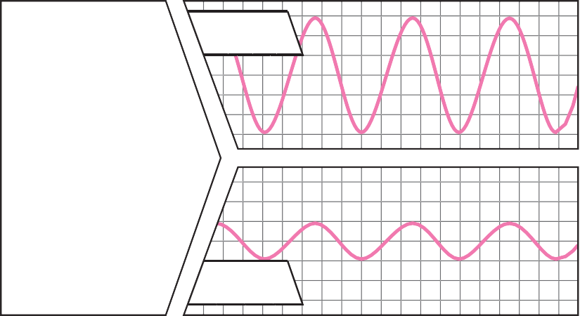
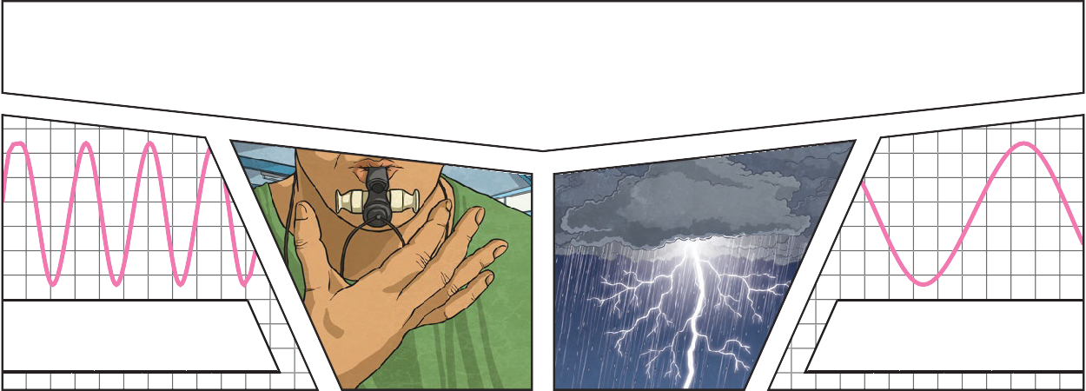

You can change the pitch of a sound in different ways depending on the type of instrument
For example, if you are playing a
xylophone, striking the smaller bars with the beater causes faster vibrations and so a higher pitched note. Striking
the larger bars causes slower vibrations

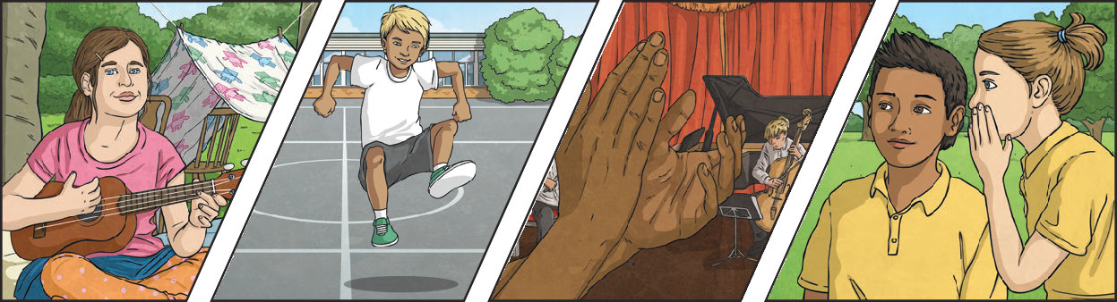
you are playing. and produces a lower note.
Key Vocabulary
vibration | A movement backwards and forwards.
sound wave | Vibrations travelling from a sound source.
volume | The loudness of a sound.
amplitude | The size of a vibration. A larger amplitude = a louder sound.
pitch | How low or high a sound is.

Key Knowledge
Sound is a type of energy. Sounds are created by vibrations. The louder the sound, the bigger the vibration.


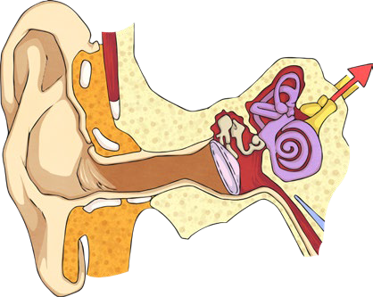






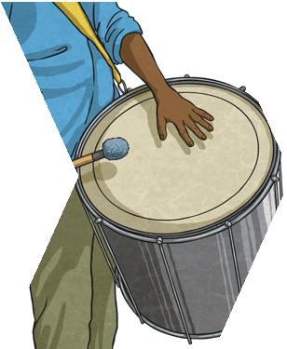








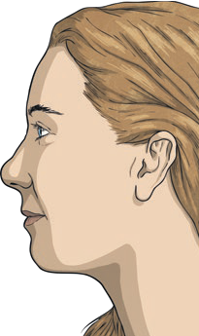
Year 4
Sound

Inside your ear, the vibrations hit the eardrum and are then passed to the middle and then the inner ear. They are then changed into electrical signals and sent to your brain. Your brain tells you that you are hearing a sound.
When
you
hit the drum, the drum skin vibrates. This makes the air particles closest to the drum start to vibrate as well.
The vibrations then pass to the next air particle, then the next, then the
next. This carries on until the air particles closest to your ear vibrate, passing the vibrations
into your ear.
Key Vocabulary
ear | An organ used for hearing.
particles | Solids, liquids and gases are made of particles. They are so small we are unable to see them.
distance | A measurement of length between two points.
soundproof | To prevent sound from passing.
absorb sound | To take in sound energy. Absorbent materials have the effect of muffling sound.
vacuum | A space where there is nothing. There are no particles in a vacuum.
eardrum | A part of the ear which is a thin, tough layer of tissue that is stretched out like a drum skin. It separates the outer ear from the middle and inner ear. Sound waves make the eardrum vibrate.

Key Knowledge
Sound can travel through solids, liquids and gases. Sound travels as a wave, vibrating the particles in the medium it is travelling in. Sound cannot travel through a vacuum.

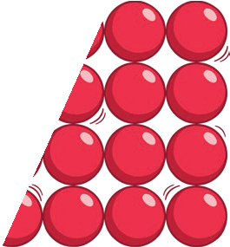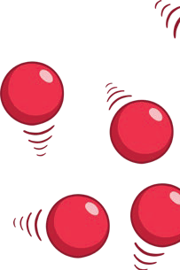
Sound energy can travel from particle to particle far easier in a solid because the vibrating particles
are closer together than in other states of matter.
solid
particles
gas particles
If you throw a stone in a pond, it will produce ripples. As the ripples spread out across the pond, they become smaller.
When sound vibrations spread out over a distance, the sound becomes quieter, just like ripples in a pond.

