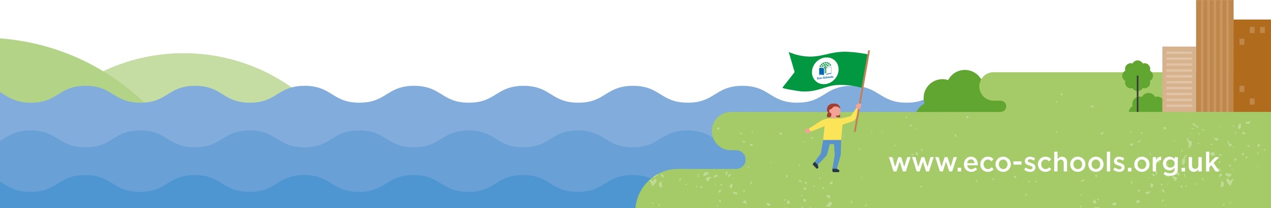
What was discussed?
- The vote for the recycled products for the project were counted and announced.
- Crisp packets, cheese wrappers, plastic bottle tops and pens and pencils.
- Each rep confirmed they have organised a scrap paper drawer and recycling paper bin in their own classrooms. Also that they had asked their peers to help in reducing energy costs and wastage following simple recommended steps.
- ECO school photo was taken for newsletter and ECO display board.

Meeting Minutes
Time and date of the meeting:
29/04/21
Eco-Committee members present:
ECO reps Years R-6

Eco-Committee members not present:

Next steps: monitor the recycled products regularly.

Year 6 child and myself to finish off the ECO council rep badges (made out of recycled green milk bottle tops.)

Set a date for the environmental review completion for action plan.

When and where is the next meeting?

06/05/21- Hall

