What’s happening this term: |  | Year 1 Spring Term 1 English |  |  | Year 1 National Curriculum content
Three Little Pigs  - Story writing  - Suffixes: tall, taller, tallest  - Sequencing sentences  Poem about toys  - Poem  - Singular and plural –s –es  - Simple adjectives  Teddy Bears’ Picnic  - Instructions  - Imperative verbs  - Sequencing sentences  Simple information text about Spring  - Information text  - Suffix – er: warmer, brighter  Spring List Poem  List Poem  - Adding adjectives to nouns: yellow flowers  - A journey to another continent and back again.  - Home-Away Home story  - Suffix –ed  - Capital letters for people, places and days of the week. |  | 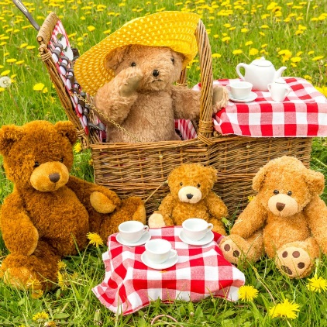 |  |  | Word | - Regular suffixes –er, -est, -ed  - Simple adjectives
 |  |  |  |  | Sentence | - How words can combine to make sentences.  - Joining words and clauses using and.
 |  |  |  |  | Text | - Sequencing sentences to form short narratives.  - Using side-headings in information texts.  - Writing list poems, line by line.  - Laying out instructions correctly.
 |  | Some words to learn to spell this half term: |  |  | Punctuation | - Separation of words with spaces.  - Question marks and exclamation marks.  - Capital letters for names of people, places and days of the week.
 |  | Her | I | these | Punctuation
 |  | was | Monday | friend | Punctuation
 |  | you | Tuesday | ask | Punctuation
 |  | into | Wednesday | only | Punctuation
 |  | people | Thursday | would | Key vocabulary:
 |  | their | Friday | should | Letter | Continue to show the difference between a small letter and a capital letters; join digraphs.
 |  | Mr | Saturday | could | Letter
 |  | Mrs | Sunday | half | Word | Singular and plural
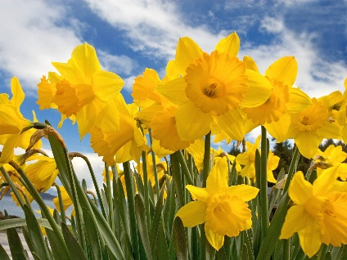 |  | Ideas for reading this half-term: |  | 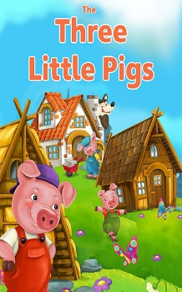 | Word | Singular and plural
 |  | - Cinnamon by Gaiman, King of the Classroom by Barnes and Brantley-Newton, Yokki and the Parno Gry by O'Neill, The Bad-tempered Ladybird by Carle, Owl Babies by Waddell, My Friend Bear by Alborough, I Want My Hat Back by Klassen. |  |  | Sentence | Know when a simple sentence makes sense.
 |  |  |  |  | Punctuation | Full stop, question mark, exclamation mark.
 |  |  |  |  | Adjective | A describing word
Examples of sentences taught this term, including ‘Alan Peat’ sentences: | Simple sentences: | Questions and exclamations: “Do you like red?” “How Kind!”
 | Sentences with short noun phrases: | Single clause with an adjective: “The brown rabbit jumped on the green grass.”
 | Compound sentences | Two clauses joined with and: I like to play with my new toys and I like to read lots of books.

