What’s happening this half term: |  | Year 3 Autumn Term 1 English |  |  |  | National Curriculum Content
Cave Challenge by Jo Franklin (Narrative- A Paleolithic Story)  -Create characters, setting and plot to write an original Cave Painting story.  -Use direct speech and noun phrases formed in different ways.  -Propose changes to grammar and vocabulary to improve their work.  Why should I visit Skara Brae? (Persuasive- promotional text about a historical site)  -Plan and write a promotional leaflet about Skara Brae or another historical location well-known to the children.  - To organise paragraphs around a theme, e.g. tools, food, homes  -Propose changes to grammar and vocabulary.  How to build an Iron Age roundhouse by Loretta Schauer (Instructions)  -Make an Iron Age roundhouse from craft materials. Write up how to do this as a set of instructions for other children to follow.  -Proofread for spelling and punctuation errors. |  | 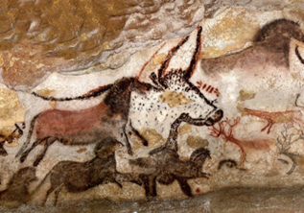 |  |  |  | Word | - Investigate words with -er and -or suffixes to determine word class (nouns) and that they denote a profession or the place of origin. e.g. hunter  - Identify word families based on common words e.g. know, knowing, knowledge, knowledgeable  - To use the correct form of a or an
 |  |  |  |  |  | Sentence | - Subordination (using when, if that, because)  - Co-ordination (using or, and, but)  - Expanded noun phrases e.g. the dark cave  - Grammatical patterns in different types of sentence: statement, question, exclamation or command.
 |  |  |  |  |  | Text | - Correct choice and consistent use of present tense and past tense throughout writing.  - Use of the progressive form of verbs in the present and past tense to show verbs in progress
 |  | Some words to learn to spell this half term: |  |  |  | Punctuation |  | - Use of capital letters, full stops, question marks and exclamation marks to demarcate sentences  - Commas to separate items in a list  - Apostrophes to mark where letters are missing in spelling and to mark singular possession in nouns (e.g. the girl’s name).  - Direct speech “” NSNL (New Speaker, New Line)
 |  | special | history |  | circle/circular
 |  | although | island |  | strength
 |  | ordinary | knowledge |  | material/s
 |  | learn | community |  | naturally
 |  | hunters | destination |  | thatch | Key vocabulary this half term:
 |  | gatherers | prehistoric |  | weave | sentence |  | A sentence is an idea in words that makes sense, separated from other ideas using capital letters and punctuation.
 |  | cave dweller | Neolithic |  | wattle
 |  | painting | archaeology |  | daub | statement |  | A statement is a factual sentence giving information: They built a model roundhouse.
Ideas for reading this half-term: |  | 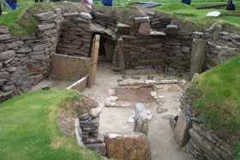 |  | 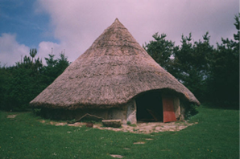
 |  |  |  |  |  | question |  | A question uses wh-words or modal verbs e.g. Where are you? Did you see it? Might you come?
We would recommend reading any books relating to the Stone Age and/or the Iron Age with your child. Stone Age Boy by Satoshi Kitamuraa is a fantastic book. Stig of the Dump by Clive King is a firm favourite too!
 |  |  |  |  |  | exclamation |  | An exclamation uses ‘how’ or ‘what’ but is not a question e.g. What a lovely day it is!
 |  |  |  |  |  | command |  | A sentence that is a command begins with an imperative verb e.g. Fetch the building materials.
Examples of sentences taught this half-term, including ‘Alan Peat’ sentences: | Writing sentences in the past tense: | The elder led the way to the cave entrance. Finch followed, his legs quaking beneath him. He clutched the doe skin pouch tied to his waist. He had everything he needed.
 | To use the conjunction ‘because’: | Finch didn’t dare breathe because the bull seemed so real.
 | Expanded noun phrases: | the cold, dark cave / the stunning, remarkable paintings on the cave wall / the large painting in charcoal

Key Vocabulary: (choose 5 each half term from this list)
Concepts in Red have been taught in previous year groups but should still be included in Key Vocabulary list where they are relevant, and where understanding them is a vital step in the children’s next learning journey.
noun: the name of an object, place, time.
proper noun: nouns that are names of people and places need capital letters.
upper case: capital letters of the alphabet e.g. A B C
lower case: the ‘little letters’ of the handwritten alphabet e.g. a b c
compound noun: a noun made of two words joined together e.g. lawnmower, saucepan
noun phrase: a short clause that uses adjectives to describe a noun
adjective: a word that describes a noun, including colours and sizes
sentence: an idea in words that makes sense, separated from other ideas using capital letters and punctuation.
statement: a statement is a factual sentence giving information: Jamie caught the ball.
question: a question uses wh-words or modal verbs e.g. where are you ? Did you see it?
exclamation: an exclamation uses ‘how’ or ‘what’ but is not a question e.g. What a lovely day it is!
command: a sentence that is a command begins with an imperative verb e.g. Fetch the ball.
verb: a word for an action. Changing the verb can change the tense of the writing
suffix: an ending that is added to a root word to change its meaning
prefix: a starter that is added to the beginning a root word to change its meaning
adverb: a word that describes how a verb is done – often ending in -ly
past tense: describing things that have happened in the past
present tense: describing things that happen now, or are happening now
progressive: using the verb ‘to be’ with the –ing form of the verb in the present or past tense
conjunction: a word that joins ideas together in a sentence e.g. and
co-ordinating conjunction: when, if, that, because
subordinating conjunction: or, but, and
punctuation: marks made in writing to help the reader understand what is written
apostrophe: a punctuation mark to show 1) letters are missing from a contracted word 2) something belongs to someone
possession: the apostrophe of possession shows something belongs to someone e.g. David’s pencil case
contraction: the apostrophe of contraction shows a letter or letters are missing e.g. don’t, I’ve, we’re
comma: a punctuation mark used to separate items in a list

