What’s happening this half term: |  | Year 3 Spring Term 2 English |  |  |  | National Curriculum Content
How to make a healthy fruit salad (Instruction writing)  -Plan and write a set of instructions for making a fruit salad (as if they were monarchs, presidents or media stars with their own chefs to do it for the,)  - Propose changes to grammar using the suffix –ly to change adjectives into adverbs.  -Compose and rehearse sentences orally before writing them, especially command sentences.  -Organise writing using subheadings.  Letter to a pen pal (by Loretta Schaeur)  -Identify features and layout of a letter.  -Write about a landscape using figurative language and expanded noun phrases.  -Plan and write an informal letter to a pen pal.  -Proofread and edit their work looking at grammar and punctuation. |  | 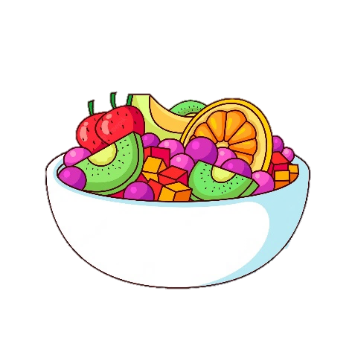  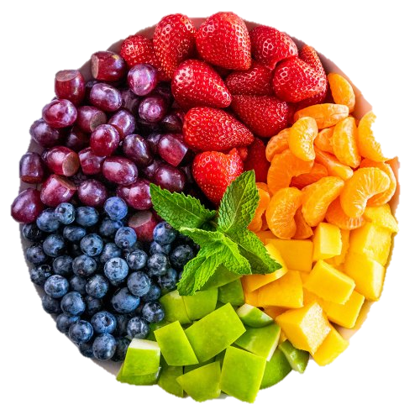 |  |  |  | Word | - Investigate words with -ly suffixes to determine word class.  - Identify word families based on common words e.g. The struct family (instruction, construct, instruct)  - To use the correct form of a or an.
 |  |  |  |  |  | Sentence | - Subordination (using when, if that, because)  - Co-ordination (using or, and, but)  - Expanded noun phrases e.g. The tall, heroic soldier).  - Grammatical patterns in different types of sentence: statement, question, exclamation or command.
 |  |  |  |  |  | Text | - Correct choice and consistent use of present tense and past tense throughout writing.  - Use of the progressive form of verbs in the present and past tense to show verbs in progress
 |  | Some words to learn to spell this half term: |  |  |  | Punctuation | - Use of capital letters, full stops, question marks and exclamation marks to demarcate sentences  - Commas to separate items in a list  - Apostrophes to mark where letters are missing in spelling and to mark singular possession in nouns (e.g. the girl’s name).
 |  | fruit | taste |  | United Kingdom | Punctuation
 |  | sieve | instructions |  | reign | Punctuation
 |  | colander | letter |  | special | Punctuation
 |  | salad | custom |  | favourite | Punctuation
 |  | ingredients | culture |  | various | Key vocabulary this half term:
 |  | important | address |  | carefully | Contraction | The apostrophe of contraction shows a letter or letters are missing e.g. don’t, I’ve, we’re
Ideas for reading this half-term: |  | 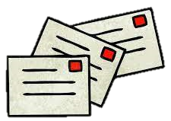 |  |  |  | Contraction
 |  |  |  |  |  | Possession | The apostrophe of possession shows something belongs to someone e.g. David’s pencil case.
Oliver’s fruit salad – By Vivian French
Pen Pals – By Katie Dale
I will always write back – By Liz Welch
Same, same but different – By Jenny Sue Kostecki-Shaw

 |  |  |  |  |  | Apostrophe | A punctuation mark to show a contraction or possession.
 |  |  |  |  |  | Comma | A punctuation mark used to separate items in a list.
Examples of sentences taught this half-term, including ‘Alan Peat’ sentences: | If, if, if, then sentence | If I hadn’t found that watch, if the alarm hadn’t gone off, if it hadn’t scared those burglars, then I wouldn’t be sitting here today.
 | Double –ly sentences | Carefully, but efficiently slice the bananas.
 | Compound sentences | Bananas are good for you, but so are apples.

Key Vocabulary: (choose 5 each half term from this list)
Concepts in Red have been taught in previous year groups but should still be included in Key Vocabulary list where they are relevant, and where understanding them is a vital step in the children’s next learning journey.
noun: the name of an object, place, time.
proper noun: nouns that are names of people and places need capital letters.
upper case: capital letters of the alphabet e.g. A B C
lower case: the ‘little letters’ of the handwritten alphabet e.g. a b c
compound noun: a noun made of two words joined together e.g. lawnmower, saucepan
noun phrase: a short clause that uses adjectives to describe a noun
adjective: a word that describes a noun, including colours and sizes
sentence: an idea in words that makes sense, separated from other ideas using capital letters and punctuation.
statement: a statement is a factual sentence giving information: Jamie caught the ball.
question: a question uses wh-words or modal verbs e.g. where are you ? Did you see it?
exclamation: an exclamation uses ‘how’ or ‘what’ but is not a question e.g. What a lovely day it is!
command: a sentence that is a command begins with an imperative verb e.g. Fetch the ball.
verb: a word for an action. Changing the verb can change the tense of the writing
suffix: an ending that is added to a root word to change its meaning
prefix: a starter that is added to the beginning a root word to change its meaning
adverb: a word that describes how a verb is done – often ending in -ly
past tense: describing things that have happened in the past
present tense: describing things that happen now, or are happening now
progressive: using the verb ‘to be’ with the –ing form of the verb in the present or past tense
conjunction: a word that joins ideas together in a sentence e.g. and
co-ordinating conjunction: when, if, that, because
subordinating conjunction: or, but, and
punctuation: marks made in writing to help the reader understand what is written
apostrophe: a punctuation mark to show 1) letters are missing from a contracted word 2) something belongs to someone
possession: the apostrophe of possession shows something belongs to someone e.g. David’s pencil case
contraction: the apostrophe of contraction shows a letter or letters are missing e.g. don’t, I’ve, we’re
comma: a punctuation mark used to separate items in a list

