What’s happening this half term: |  | Year 3 Summer Term 1 English |  |  |  | National Curriculum Content
The Mystery Rucksack by Ross Montgomery – A narrative involving orienteering.  -Use a range of tenses, both past for storytelling and present for dialogue.  -To write in chronological order using sequential words.  -To use a range of descriptive techniques.  -To write in paragraphs.  -To plan and write individual mystery stories.  What time is it? By Jo Franklin - Explanatory text.  -Explore tenses including present perfect.  -Write dialogue as if communicating with someone living within another time zone.  -To plan and write their own informative poster  The beautiful game by Ross Montgomery – Non-Chronological report.  -Explore idiomatic phrases  - Write a pen portrait of their favourite sports person.  -Use expanded noun phrases for description  -Plan and write their individual non-chronological reports on a chosen sport.  -Edit and improve work looking at grammar, spelling, vocabulary and punctuation. |  | 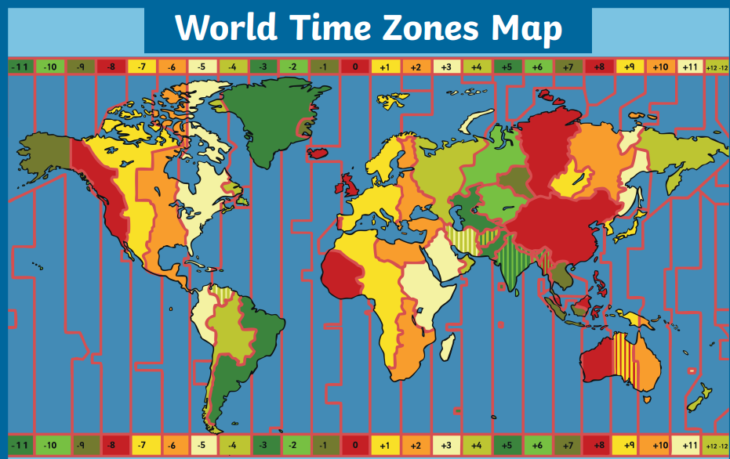 |  |  |  | Word | - Investigate words with -ly suffixes to determine word class.  - Identify word families based on common words e.g. The struct family (instruction, construct, instruct)  - To use the correct form of a or an.
 |  |  |  |  |  | Sentence | - Subordination (using when, if that, because)  - Co-ordination (using or, and, but)  - Expanded noun phrases e.g. The tall, athletic footballer  - Grammatical patterns in different types of sentence: statement, question, exclamation or command.
 |  |  |  |  |  | Text | - Correct choice and consistent use of present tense and past tense throughout writing.  - Use of the progressive form of verbs in the present and past tense to show verbs in progress
 |  | Some words to learn to spell this half term: |  |  |  | Punctuation | - Use of capital letters, full stops, question marks and exclamation marks to demarcate sentences  - Commas to separate items in a list  - Apostrophes to mark where letters are missing in spelling and to mark singular possession in nouns (e.g. the girl’s name).
 |  | mystery | orienteering |  | swimming | Punctuation
 |  | sequence | portrait |  | breath | Punctuation
 |  | idioms | sport |  | unknown | Punctuation
 |  | time | football |  | compass | Punctuation
 |  | zone | dance |  | direction | Key vocabulary this half term:
 |  | wandering | gymnastics |  | navigate | Compound noun | A noun made of two words joined together e.g. lawnmower, saucepan.
Ideas for reading this half-term: |  |  |  |  |  | Compound noun
 |  |  |  |  |  | Suffix | An ending that is added to a root word to change its meaning.
The sports timeline wall book – Christopher Lloyd  Sportopedia – Adam Skinner  The Creakers – Tom Fletcher  Mystery short stories for kids – Johnny Nelson |  |  |  |  |  | Prefix | A starter that is added to the beginning a root word to change its meaning.
 |  |  |  |  |  | Punctuation | Marks made in writing to help the reader understand what is written.
 |  |  |  |  |  | Upper case/Lower case | -Capital letters of the alphabet e.g. A B C  -The ‘little letters’ of the handwritten alphabet e.g. a b c
Examples of sentences taught this half-term, including ‘Alan Peat’ sentences: | Idiomatic phases | Then, out of the blue she asked me if I would like to start taking the lead.
 | Personification | The grass tickled my feet.
 | Verb, person Alan Peat sentence | Trembling, he fled the woods.

Key Vocabulary: (choose 5 each half term from this list)
Concepts in Red have been taught in previous year groups but should still be included in Key Vocabulary list where they are relevant, and where understanding them is a vital step in the children’s next learning journey.
Highlighted = Looked at so far this year.
/noun: the name of an object, place, time.
/proper noun: nouns that are names of people and places need capital letters.
upper case: capital letters of the alphabet e.g. A B C
lower case: the ‘little letters’ of the handwritten alphabet e.g. a b c
/compound noun: a noun made of two words joined together e.g. lawnmower, saucepan
noun phrase: a short clause that uses adjectives to describe a noun
/adjective: a word that describes a noun, including colours and sizes
/sentence: an idea in words that makes sense, separated from other ideas using capital letters and punctuation.
/statement: a statement is a factual sentence giving information: Jamie caught the ball.
/question: a question uses wh-words or modal verbs e.g. where are you ? Did you see it?
/exclamation: an exclamation uses ‘how’ or ‘what’ but is not a question e.g. What a lovely day it is!
/command: a sentence that is a command begins with an imperative verb e.g. Fetch the ball.
verb: a word for an action. Changing the verb can change the tense of the writing
/suffix: an ending that is added to a root word to change its meaning
/prefix: a starter that is added to the beginning a root word to change its meaning
/adverb: a word that describes how a verb is done – often ending in -ly
/past tense: describing things that have happened in the past
/present tense: describing things that happen now, or are happening now
progressive: using the verb ‘to be’ with the –ing form of the verb in the present or past tense
conjunction: a word that joins ideas together in a sentence e.g. and
/co-ordinating conjunction: when, if, that, because
/subordinating conjunction: or, but, and
/punctuation: marks made in writing to help the reader understand what is written
/apostrophe: a punctuation mark to show 1) letters are missing from a contracted word 2) something belongs to someone
/possession: the apostrophe of possession shows something belongs to someone e.g. David’s pencil case
/contraction: the apostrophe of contraction shows a letter or letters are missing e.g. don’t, I’ve, we’re
/comma: a punctuation mark used to separate items in a list

