What’s happening this half term: |  | Year 4 Autumn Term 1 English |  |  | Year 4 National Curriculum content
How to build a Roman road – Instructional  -Use imperative verbs  -Use of commas for fronted adverbials  -Use command sentences  -Use prepositions  -Use bullet points in a list  -Write in the present tense.  Discovering Sutton Hoo – Report  -Organising paragraphs around a theme  -Write a letter from the perspective of Basil Brown.  -use various forms of research to inform writing.  -Write own informative report.  Who do you think you are? – Report  -Use topic sentences to introduce paragraphs  -Build vocabulary.  -Write own informative report.  Worth its weight in gold – Newspaper Report  -Use a dictionary to look-yp the spelling and meaning of words.  -Use the 5W’s in lead paragraphs to introduce the report.  -Write in the past tense.  -Write in chronological order.  -Write a diary recount from the perspective of Terry Herbert.  -Identify nouns and pronouns and their need for capital letters or not.  -Write newspaper article.  Pupils will be encouraged to proof-read and edit their own work as well as their peers, often. |  | 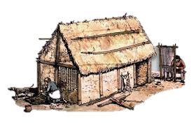 |  |  | Word | - The grammatical difference between plural and possessive –s;  - Standard English forms for verb inflections; (e.g. we were instead of we was)
 |  |  |  |  | Sentence | - Noun phrases expanded by the addition of modifying adjectives and preposition phrases (e.g. the woman expanded to the tall white-haired woman in the red tunic).  - Fronted adverbials (e.g. Later that day,)
 |  |  |  |  | Text | - Use of paragraphs to organise ideas around a theme.  - Appropriate choice of pronoun or noun within and across sentences to aid cohesion and avoid repetition.
 |  | Some words to learn to spell this half term: |  |  | Punctuation | - Use of inverted commas and other punctuation to indicate direct speech (e.g. a comma after the reporting clause; end punctuation within inverted comas.)  - Apostrophes to mark plural possession (e.g the girl’s name, the girls’ names)  - Use of commas after fronted adverbials.
 |  | archaeological | enough | location | Punctuation
 |  | artefact | evidence | material | Punctuation
 |  | believe | excavate | popular | Punctuation
 |  | build | foundation | pronunciation | Punctuation
 |  | century | history | settlement | Key vocabulary:
 |  | construction | imagine | straight | adverb | A word that describes how a verb is done – often (but not always) ending in –ly
 |  | derived | island | surface | adverb
 |  | early | knowledge | weight | Command | A sentence that is a command begins with an imperative verb.
Ideas for reading this half-term: |  | 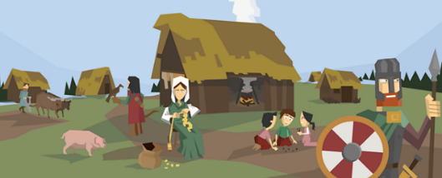 |  | 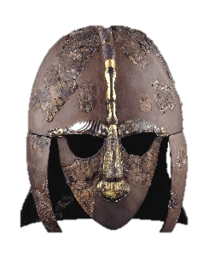 | Command | A sentence that is a command begins with an imperative verb.
  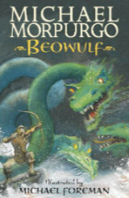  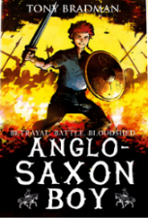 |  |  |  |  | Fronted Adverbial | A phrase that opens a sentence explaining how or why the verb was done e.g. Later that day,
 |  |  |  |  | Preposition | A word that describes the position of an object e.g. in, under, between, behind, through, outside.
 |  |  |  |  | Paragraph | A group of related sentences on a topic.
Examples of sentences taught this half-term, including ‘Alan Peat’ sentences: | Headlines | Worth its weight in Gold!
 | Emotion word, comma | Desperate, she screamed for help. (Alan Peat sentence)
 | 3 –ed sentence | Frightened, terrified, exhausted, the princess ran for home. (Alan Peat sentence)
adjective: a word that describes a noun, including colours and sizes  adverb: a word that describes how a verb is done – often ending in –ly  adverbial phrase: several words that do the job of an adverb, explaining how, why, where or how often a verb is done.  apostrophe: a punctuation mark to show 1) letters are missing from a contracted word 2) something belongs to someone  clause: part of a sentence that does not make sense on its own e.g. kicking the ball  comma: a punctuation mark used to separate items in a list, or to separate clauses in a sentence  command: a sentence that is a command begins with an imperative verb e.g. Fetch the ball.  conclusion: the final paragraph of a piece of non-fiction writing that sums up the key points and tells the reader what to do next.  conjunction: a word that joins ideas together in a sentence e.g. and  consonant: any letter of the alphabet that is not a vowel  contraction: the apostrophe of contraction shows a letter or letters are missing.  co-ordinating conjunction: when, if, that, because  definition: a statement in an introduction that explains the subject that is being written about  determiner: a word that introduces and defines a noun e.g. a, an, the, these, those, every, many, two.  dialect: local spoken forms of English that do not use the correct inflections e.g. you was  direct speech: speech that shows exactly the words that were spoken or thought  exclamation: an exclamation uses ‘how’ or ‘what’ but is not a question e.g. What a lovely day it is!  fronted adverbial: a phrase that opens a sentence explaining how or why the verb was done e.g. Later that day,  heading / subheading: titles for paragraphs to help the reader locate information quickly.  hyphen: a short line that joins two words e.g. twenty-three, ice-cream | introduction: the first paragraph of a piece of non-fiction writing that includes the definition and purpose  inverted commas: punctuation marks that go at the beginning and end of direct speech  metaphor:  noun phrase: a short clause that uses adjectives to describe a noun  noun: the name of an object, place, time.  paragraph: a group of related sentences on a topic  past tense: describing things that have happened in the past  personification:  plural: a plural noun (e.g. lions) shows that there is more than one of that object.  possession: the apostrophe of possession shows something belongs to someone  possessive pronoun: a pronoun that shows possession e.g. mine, ours, hers, his, theirs, and yours.  prefix: a starter that is added to the beginning a root word to change its meaning  preposition: a word that describes the position of an object e.g. in, under, between, behind, through, outside  present perfect tense: a recent past-tense verb form using has/have and the past participle  present tense: describing things that happen now, or are happening now  progressive tenses: using the verb ‘to be’ with the –ing form of the verb in the present or past tense  pronoun: a word such as ‘he’, ‘it’, ‘they’ that are used instead of a noun.  punctuation: marks made in writing to help the reader understand what is written  purpose: a reason for writing e.g. to inform, to persuade, to entertain, to request, to complain  question: a question uses wh-words or modal verbs e.g. where are you ? Did you see it?  reported speech: speech in which only the gist of what is spoken is conveyed.  reporting clause: a clause that explains who is speaking and how they spoke the words.  sentence: an idea in words that makes sense, separated from other ideas using capital letters and punctuation. | simile:  singular: a singular noun (e.g. lion) shows that there is only one object.  Standard English: the grammatically correct form of written and spoken English  statement: a statement is a factual sentence giving information: Jamie caught the ball.  subordinate clause: a clause that begins with a subordinating conjunction e.g. because it was raining  subordinating conjunction: or, but, and  suffix: an ending that is added to the end of root word to change its meaning  Verb inflections: how verbs change according to tense or subject e.g. I do, he does  verb: a word for an action. Changing the verb can change the tense of the writing  vowel: five letters of the alphabet are vowels – a, e, i, o, uproper noun: nouns that are names of people and places need capital letters.  word family: a group of words that share a common root word and are similar in meaning
Key Vocabulary: (choose 5 each half term from this list

