What’s happening this half term: |  | Year 4 Summer Term 1 English |  |  | Year 4 National Curriculum content
Banksy; An artist or Vandal? – Balanced argument  -Discuss and use key vocabulary  -Orally debate different viewpoints  -look at the use of formal vocabulary  -Use a dictionary to check the meaning and spelling of new vocabulary.  -Use the present perfect form  -Use conjunctions to extend sentences  -Write a balanced argument about a topical issue  Terrific teeth – Factfile  -Compare animal and human teeth  -Use and discuss new vocabulary  -Write a set of instructions of how to brush your teeth  -Investigate and spell irregular plurals  -Organise paragraphs to write own explanation text  -Use diagrams and captions to enhance explanation text.  Pupils will be encouraged to proof-read and edit their own work as well as their peers, often. |  | 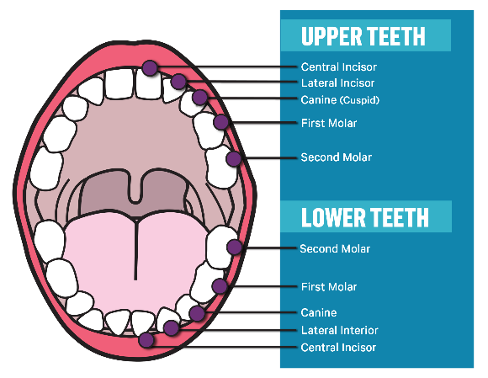 |  |  | Word | - The grammatical difference between plural and possessive –s;  - Standard English forms for verb inflections; (e.g. we were instead of we was)
 |  |  |  |  | Sentence | - Noun phrases expanded by the addition of modifying adjectives and preposition phrases (e.g. the woman expanded to the tall white-haired woman in the red tunic).  - Fronted adverbials (e.g. Later that day,)
 |  |  |  |  | Text | - Use of paragraphs to organise ideas around a theme.  - Appropriate choice of pronoun or noun within and across sentences to aid cohesion and avoid repetition.
 |  | Some words to learn to spell this half term: |  |  | Punctuation | - Use of inverted commas and other punctuation to indicate direct speech (e.g. a comma after the reporting clause; end punctuation within inverted comas.)  - Apostrophes to mark plural possession (e.g the girl’s name, the girls’ names)  - Use of commas after fronted adverbials.
 |  | Anonymous | Gallery | Naughty | Punctuation
 |  | Anonymously | Graffiti | Plaque | Punctuation
 |  | Controversial | Influential | Incisor | Punctuation
 |  | Outrage | Sculpture | Enamel | Punctuation
 |  | Unique | Often | Bacteria | Key vocabulary:
 |  | Vandalism | Pulp | Tissue | Subordinating Conjunction | or, but, and
 |  | Artist | Decide | Canines | Subordinating Conjunction | or, but, and
 |  | Deface | Dentine | Decay | Word Family | a group of words that share a common root word and are similar in meaning
Ideas for reading this half-term: |  | 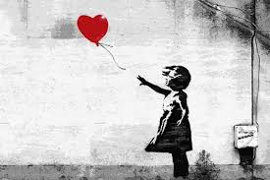 |  | 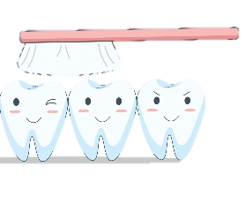 | Word Family
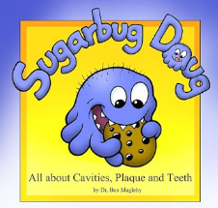  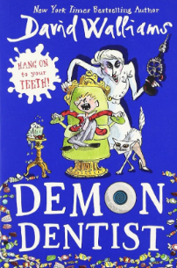  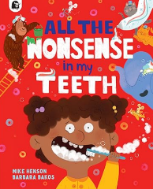 |  |  |  |  | Definition | a statement in an introduction that explains the subject that is being written about
 |  |  |  |  | Determiner | a word that introduces and defines a noun e.g. a, an, the, these, those, every, many, two.
 |  |  |  |  | Suffix | an ending that is added to the end of root word to change its meaning
Examples of sentences taught this half-term, including ‘Alan Peat’ sentences: | Definition statement | Floss is a waxy thread that you pull gently between your teeth to remove any bits of food left behind.
 | Subordinate clause | While his work is still popular, new artwork created by Banksy will probably still appear.
adjective: a word that describes a noun, including colours and sizes  adverb: a word that describes how a verb is done – often ending in –ly  adverbial phrase: several words that do the job of an adverb, explaining how, why, where or how often a verb is done.  apostrophe: a punctuation mark to show 1) letters are missing from a contracted word 2) something belongs to someone  clause: part of a sentence that does not make sense on its own e.g. kicking the ball  comma: a punctuation mark used to separate items in a list, or to separate clauses in a sentence  command: a sentence that is a command begins with an imperative verb e.g. Fetch the ball.  conclusion: the final paragraph of a piece of non-fiction writing that sums up the key points and tells the reader what to do next.  conjunction: a word that joins ideas together in a sentence e.g. and  consonant: any letter of the alphabet that is not a vowel  Contraction: the apostrophe of contraction shows a letter or letters are missing.  co-ordinating conjunction: when, if, that, because  definition: a statement in an introduction that explains the subject that is being written about  determiner: a word that introduces and defines a noun e.g. a, an, the, these, those, every, many, two.  dialect: local spoken forms of English that do not use the correct inflections e.g. you was  direct speech: speech that shows exactly the words that were spoken or thought  exclamation: an exclamation uses ‘how’ or ‘what’ but is not a question e.g. What a lovely day it is!  fronted adverbial: a phrase that opens a sentence explaining how or why the verb was done e.g. Later that day,  heading / subheading: titles for paragraphs to help the reader locate information quickly.  hyphen: a short line that joins two words e.g. twenty-three, ice-cream | introduction: the first paragraph of a piece of non-fiction writing that includes the definition and purpose  inverted commas: punctuation marks that go at the beginning and end of direct speech  metaphor:  noun phrase: a short clause that uses adjectives to describe a noun  noun: the name of an object, place, time.  paragraph: a group of related sentences on a topic  past tense: describing things that have happened in the past  personification: a poetic device, where inanimate objects are given human characteristics.  plural: a plural noun (e.g. lions) shows that there is more than one of that object.  possession: the apostrophe of possession shows something belongs to someone  possessive pronoun: a pronoun that shows possession e.g. mine, ours, hers, his, theirs, and yours.  prefix: a starter that is added to the beginning a root word to change its meaning  preposition: a word that describes the position of an object e.g. in, under, between, behind, through, outside  present perfect tense: a recent past-tense verb form using has/have and the past participle  present tense: describing things that happen now, or are happening now  progressive tenses: using the verb ‘to be’ with the –ing form of the verb in the present or past tense  pronoun: a word such as ‘he’, ‘it’, ‘they’ that are used instead of a noun.  punctuation: marks made in writing to help the reader understand what is written  purpose: a reason for writing e.g. to inform, to persuade, to entertain, to request, to complain  question: a question uses wh-words or modal verbs e.g. where are you ? Did you see it?  reported speech: speech in which only the gist of what is spoken is conveyed.  reporting clause: a clause that explains who is speaking and how they spoke the words. | sentence: an idea in words that makes sense, separated from other ideas using capital letters and punctuation.  simile:  singular: a singular noun (e.g. lion) shows that there is only one object.  Standard English: the grammatically correct form of written and spoken English  statement: a statement is a factual sentence giving information: Jamie caught the ball.  subordinate clause: a clause that begins with a subordinating conjunction e.g. because it was raining  subordinating conjunction: or, but, and  suffix: an ending that is added to the end of root word to change its meaning  Verb inflections: how verbs change according to tense or subject e.g. I do, he does  verb: a word for an action. Changing the verb can change the tense of the writing  vowel: five letters of the alphabet are vowels – a, e, i, o, proper noun: nouns that are names of people and places need capital letters.  word family: a group of words that share a common root word and are similar in meaning
Key Vocabulary: (choose 5 each half term from this list

