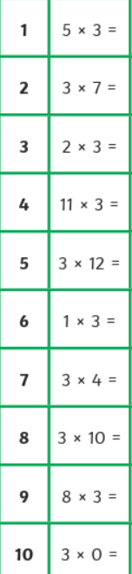
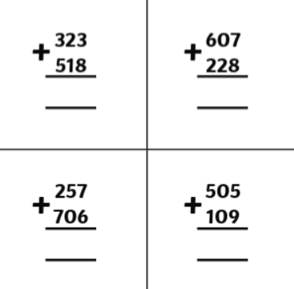
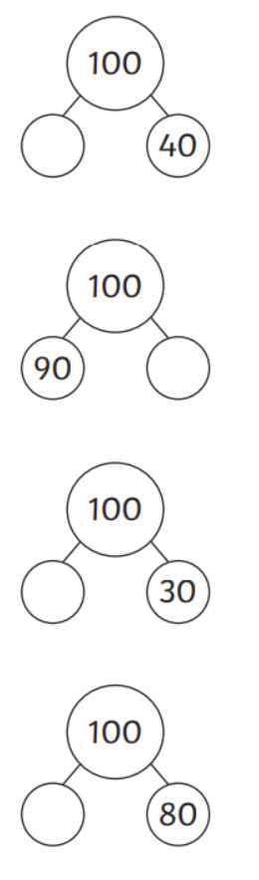

Homework
-

Year 3

Maths
Given: 7.11.2025 Due: 14.11.25

Arithmetic:

This week
’
s learning:

Practise makes perfect:

In your light shall we see light
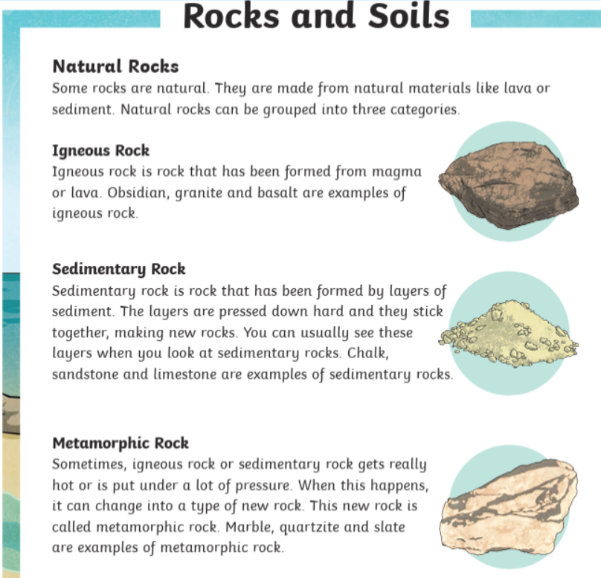
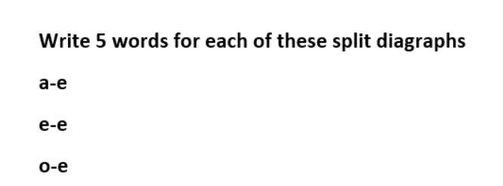
In your light shall we see light
Which rock is formed from magma or lava?
Name 2 example of sedimentary rocks
What does the word natural mean?
Homework
-

Year 3

Given: 7.11.2025 Due: 14.11.2025

English

SPAG:

READING COMPREHENSION:

