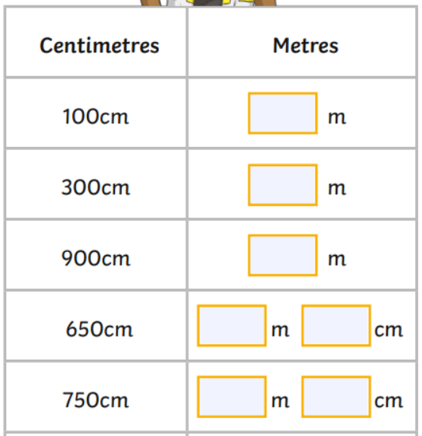
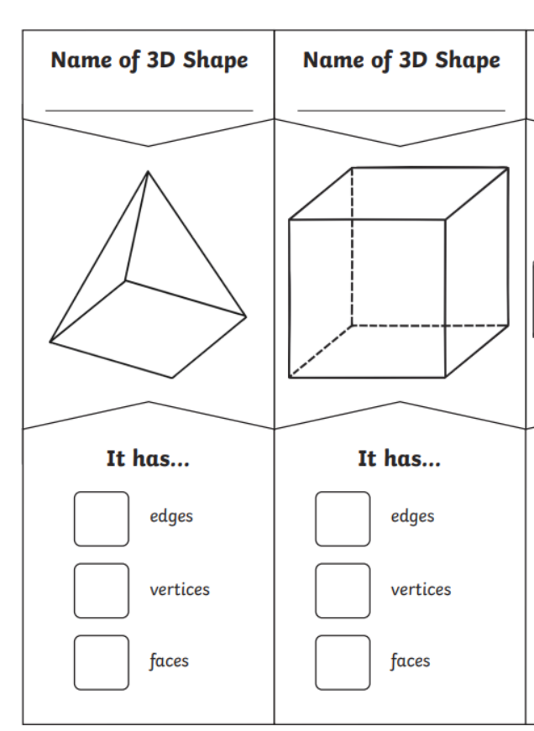
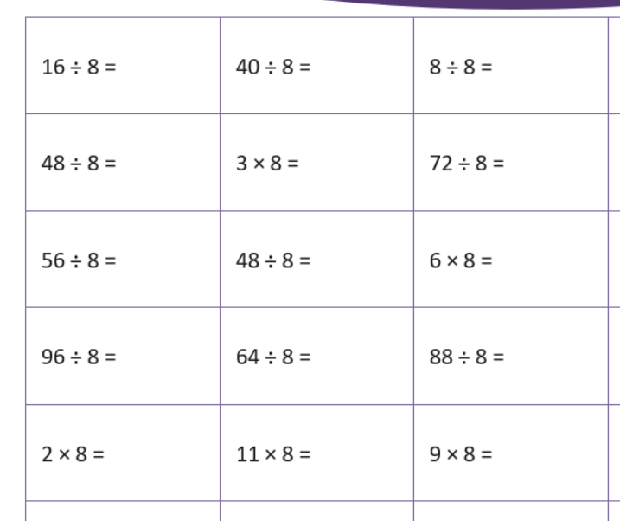
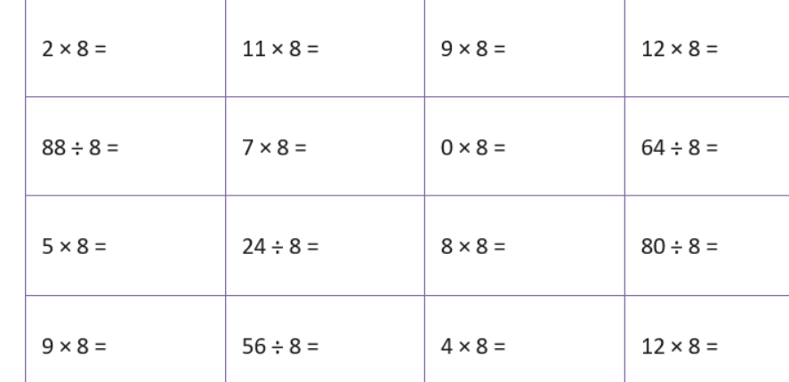

Homework
-

Year 3

Maths
Given: 6.03.2026 Due: 13.03.26

Arithmetic:

This week
’
s learning:

Practise makes perfect:

In your light shall we see light
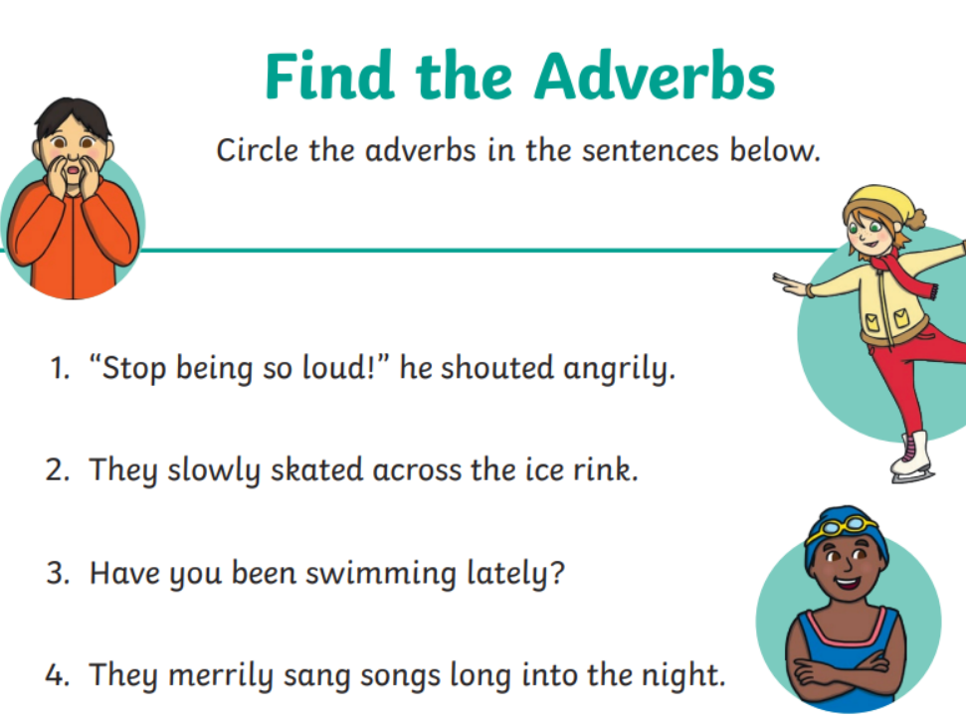
____________________________________________________________________
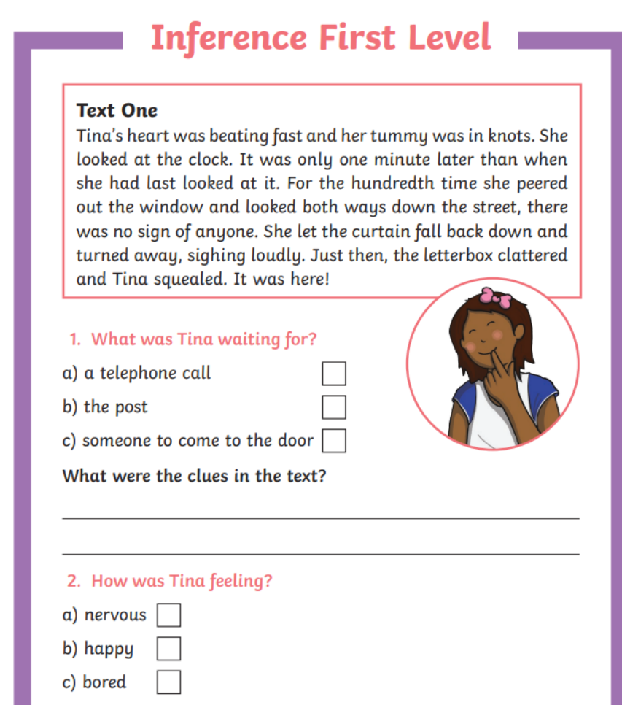
Homework
-

Year 3

Given: 30.01.26 Due: 6.02.26

English

SPAG:

READING COMPREHENSION:

In your light shall we see light

