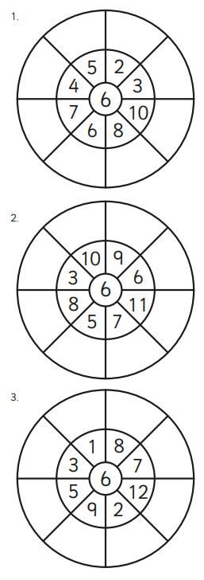

Homework
-

Year 3

Maths
Given: 7.11.25 Due: 14.11.25

Arithmetic:

This week
’
s learning:

Practise makes perfect:

In your light shall we see light
In your light shall we see light
Homework
-

Year 3

Given: 7.11.25 Due: 14.11.25

English

SPAG:

READING COMPREHENSION:

