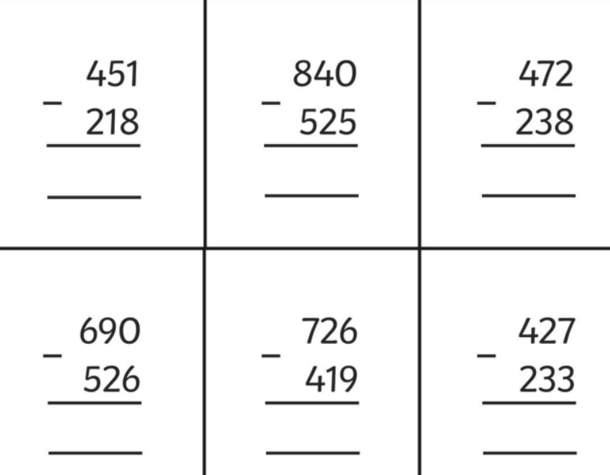
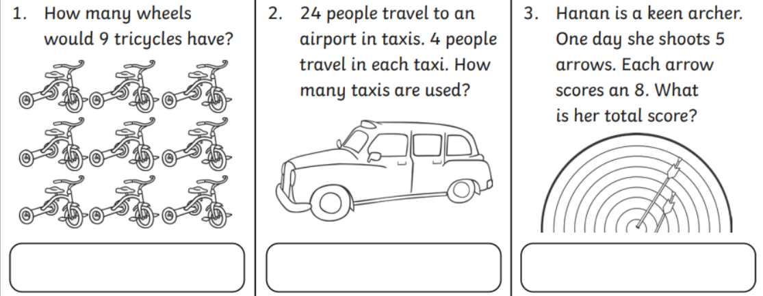
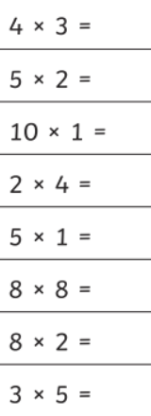

Homework
-

Year 3

Maths
Given: 16.01.26 Due: 23.01.26

Arithmetic:

This week
’
s learning:

Practise makes perfect:

In your light shall we see light
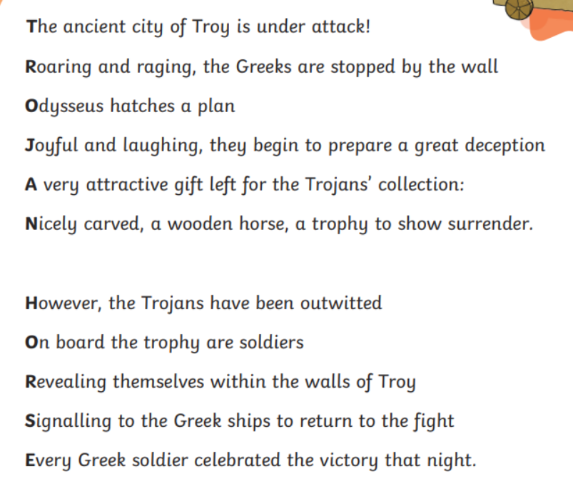
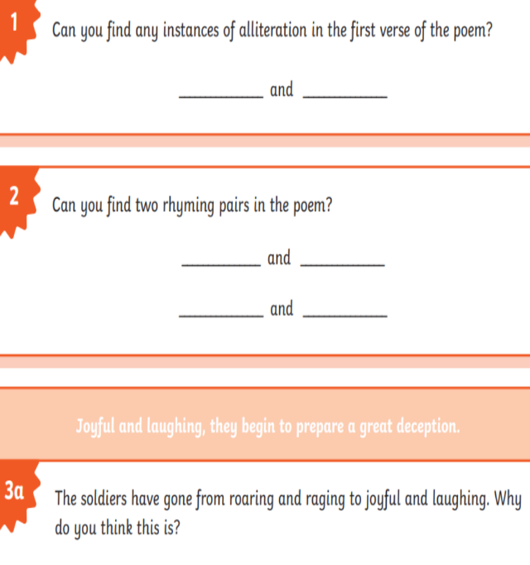
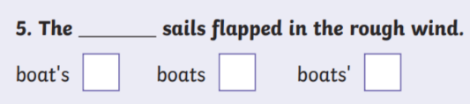
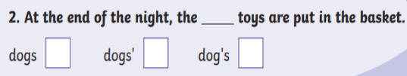
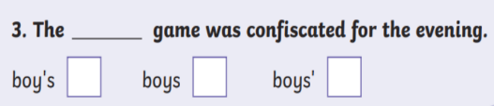
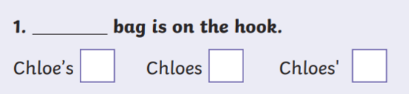
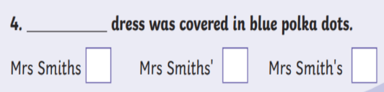
In your light shall we see light
Homework
-

Year 3

Given: 16.01.26 Due:23.01.26

English

SPAG:

READING COMPREHENSION:

