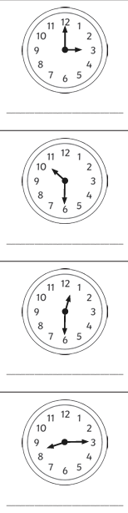
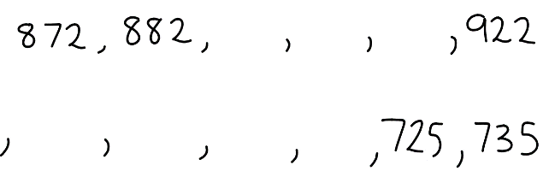
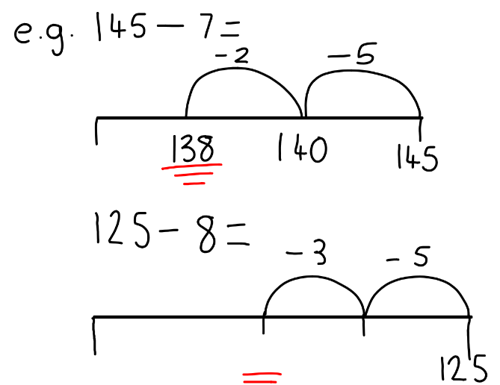
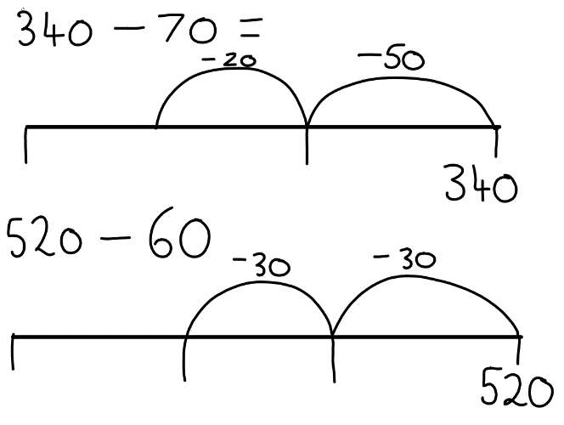
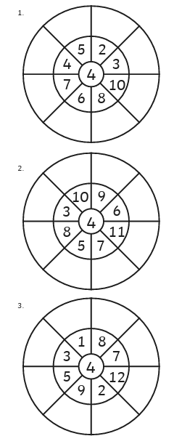

Homework
-

Year 3

Maths
Given: 17.10.25 Due: 24.10.25

Arithmetic:

This week
’
s learning:

Practise makes perfect:

In your light shall we see light

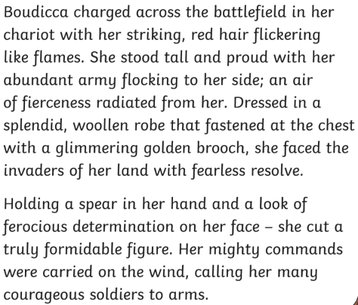
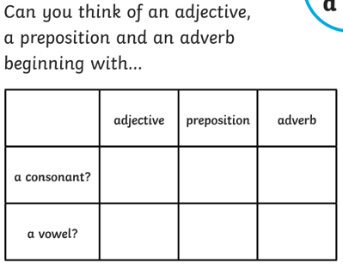
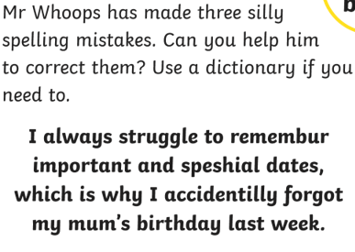
In your light shall we see light

- Find and copy one simile from the text.

- Find one piece of jewellery Boudicca was wearing?

- What is your impression of Boudicca?

- Why has the author described Boudicca as a formidable figure?

Homework
-

Year 3

Given: 17.10.25 Due: 24.10.25

English

SPAG:

READING COMPREHENSION:

