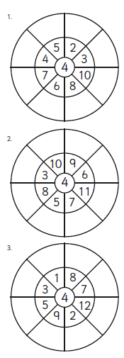
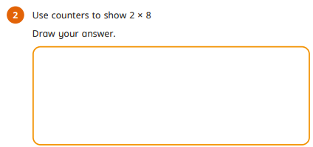
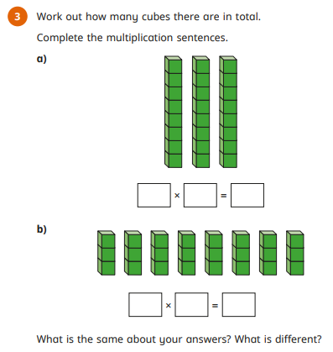
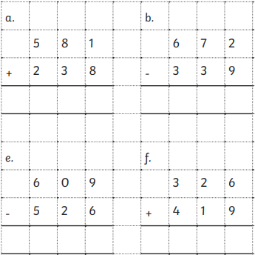

Homework
-

Year 3

Maths
Given: 23.1.26 Due: 30.1.26

Arithmetic:

This week
’
s learning:

Practise makes perfect:

In your light shall we see light
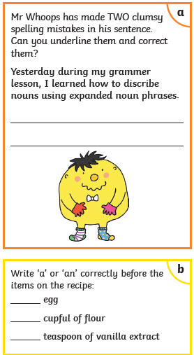
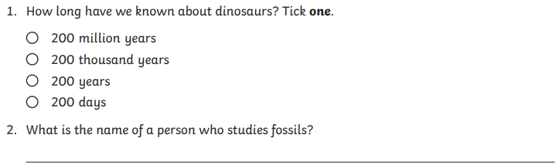
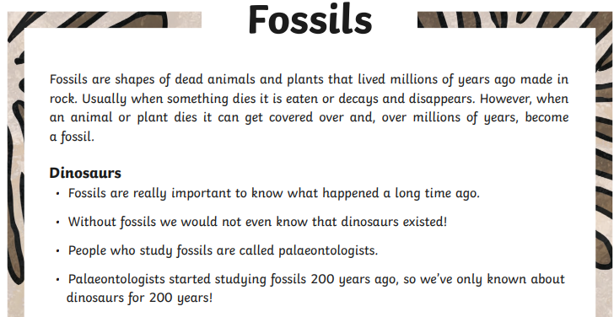
In your light shall we see light
Homework
-

Year 3

Given: 23.1.26 Due: 30.1.26

English

SPAG:

READING COMPREHENSION:

