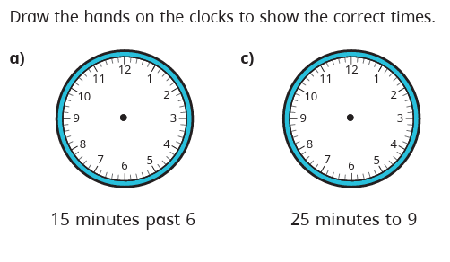
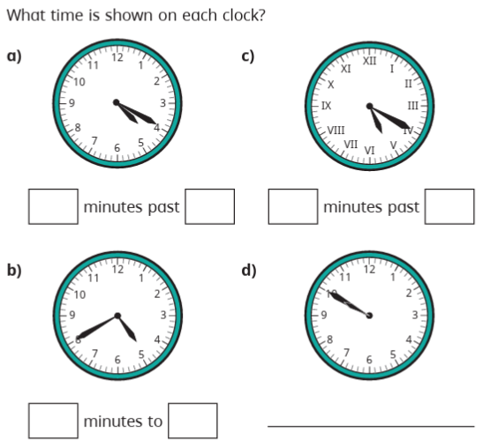
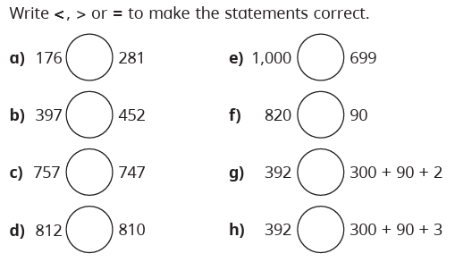
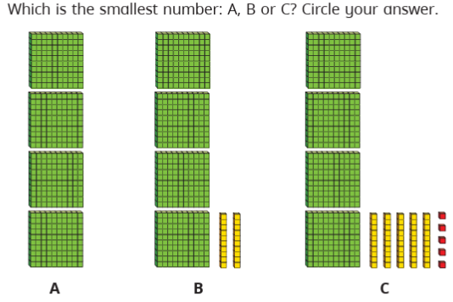
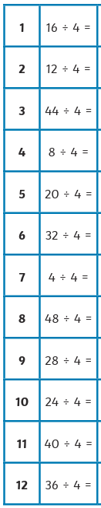
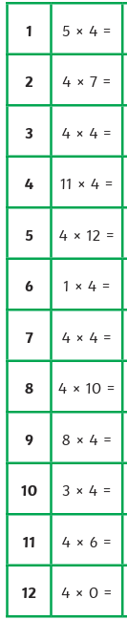

Homework
-

Year 3

Maths
Given: 26.09.25 Due: 03.10.25

Arithmetic:

This week
’
s learning:

Practise makes perfect:

In your light shall we see light
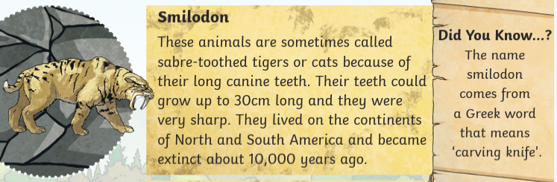
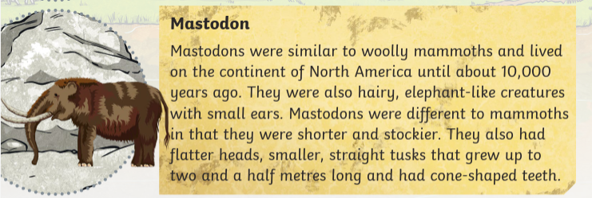
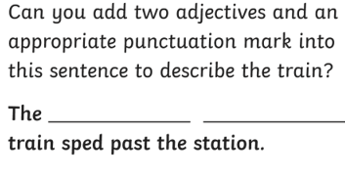
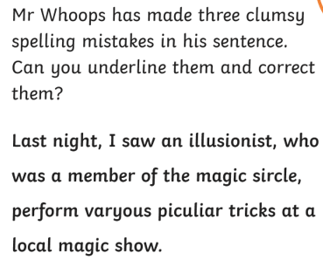
In your light shall we see light
- How long could a mastodon’s tusks grow?

- Where did smilodons live?

- Look at the section called ‘Smilodon.’ Find and copy one word that means the same as ‘not always.’

- What were mastodons similar to? Why do you think this was?

- Why are smilodons often referred to as cats?

Homework
-

Year 3

Given: 26.09.25 Due: 03.10.25

English

SPAG:

READING COMPREHENSION:

