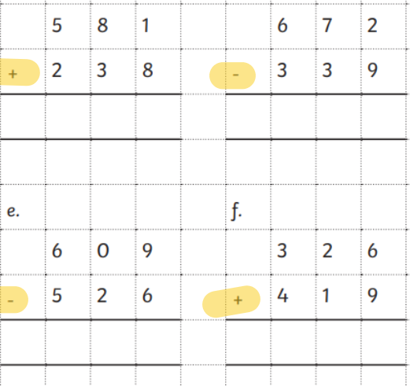
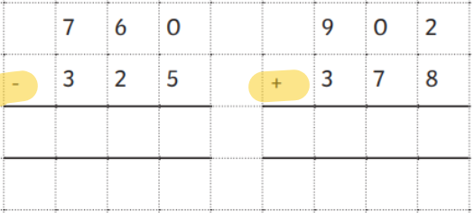
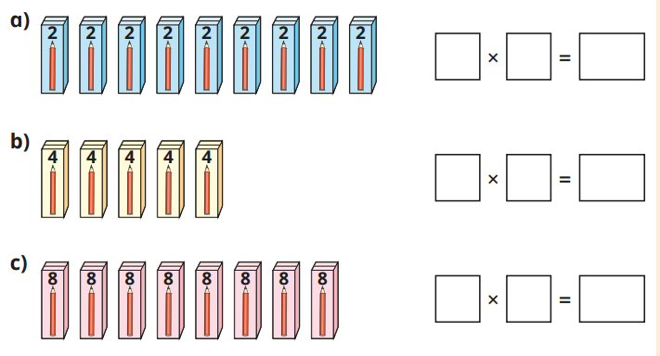
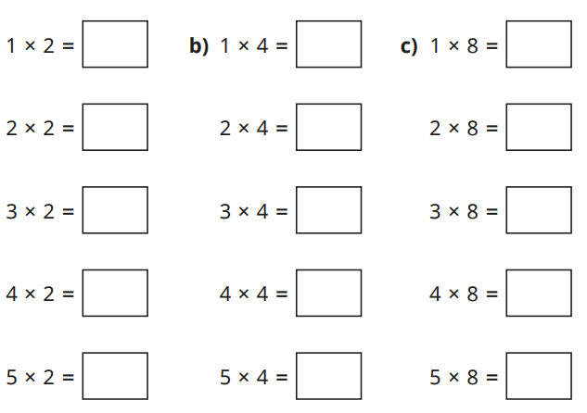
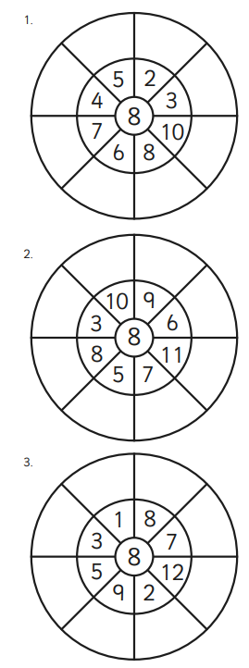

Homework
-

Year 3

Maths
Given: 30.01.26 Due: 6.02.26

Arithmetic:

This week
’
s learning:

Practise makes perfect:

In your light shall we see light
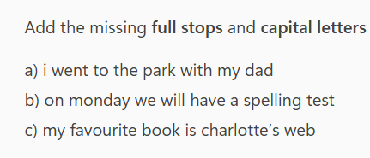
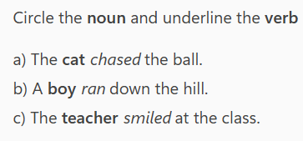
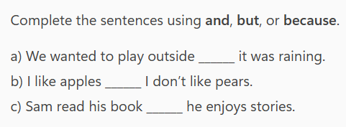

The Surprise at the Garden Shed
On Saturday morning, Leo went into the garden to look for his football. As he walked past the shed, he heard a rustling noise coming from inside. Curious, he opened the door slowly. To his surprise, he saw a small hedgehog curled up in a cardboard box. It must have wandered in during the night. Leo called his dad, and together they carefully placed the box in a quiet corner of the garden so the hedgehog could rest safely. Leo felt proud that he had helped a wild animal.
- Why did Leo go into the garden?

_____________________________________________________________________
- What did Leo find inside the shed?

_____________________________________________________________________

- How did Leo and his dad help the hedgehog?

_____________________________________________________________________
- Why did Leo feel proud at the end? (Use evidence
from the text.

____________________________________________________________________

Homework
-

Year 3

Given: 30.01.26 Due: 6.02.26

English

SPAG:

READING COMPREHENSION:

In your light shall we see light

