What’s happening this half term: |  | Year 5  Spring 2:English |  |  |  | Year 5 National Curriculum content
Renewable energy.  - To use casual conjunctions to link ideas within paragraphs.  - To add the prefixes ‘over-‘, ‘de-‘ and ‘re-‘ to words.  Email to a friend.  - To use brackets, dashes or commas to indicate parenthesis.  - To use their knowledge of grammar and vocabulary to write in an informal style. |  | 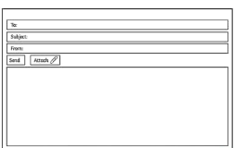   |  |  |  | Word | - Converting nouns or adjectives into verbs using suffixes e.g. –ate, -ise, -ify  - Verb prefixes e.g. dis-, de-, mis-, over-, re-
 |  |  |  |  |  | Sentence | - Relative clauses beginning with who, which, where, when whose, that, or an omitted relative pronoun.  - Indicating degrees of possibility using adverbs e.g. perhaps, surely, or modal verbs e.g. might, should, will, must.
 |  |  |  |  |  | Text | - Devices to build cohesion within a paragraph e.g. then, after that, this, firstly  - Linking ideas across paragraphs using adverbials of time, place and number, or tense choices e.g. he had seen her before.
 |  | Some words to learn to spell this half term: |  |  |  | Punctuation | - Brackets, dashes or commas to indicate parenthesis  - Use of commas to clarify meaning or avoid ambiguity.
 |  | Frequently | Existence |  | Hydro power | Punctuation
 |  | Sufficient | Environment |  | Ozone | Punctuation
 |  | Apologise | Government |  | Wind power | Punctuation
 |  | Apology | Campaign |  | Solar power | Punctuation
 |  | Deep | Convert |  | Greenhouse gas | Key vocabulary: Tier 2 and 3
 |  | Deepen | Decompose |  | Sustainable | Suffix |  | An ending that is added to the end of root word to change its meaning
 |  | Note | Climate |  | Pollutant
 |  | Notify | Emission |  | Replenish | Present perfect tense |  | A recent past-tense verb form using has/have and the past participle
Ideas for reading this half-term: |  | 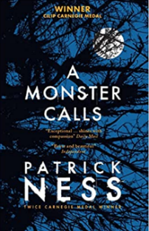 |  | 
 |  |  |  |  |  | Root word |  | A basic word that prefixes and suffixes are added.
You may like to read the following books from our Year 5 suggested reading list.

You can find more suggested books on our class page on the school website.
 |  |  |  |  |  | Relative clause |  | A word that is used to introduce a relative clause e.g. which, who, whose, that
 |  |  |  |  |  | Prefix |  | Adding a letter or word before a root word to change the meaning.
Examples of sentences taught this half-term, including ‘Alan Peat’ sentences: | 1st Sentence type: | Noun, which/where/who (relative clause). Mr Tims, who is my favourite teacher, is leaving school soon.
 | 2nd Sentence type: | The more, the more. The more upset she was, the more her tears flowed.
 | 3rd Sentence type: | An ing, ed sentence. Driving to town, he stopped to watch the UFO land.

