What’s happening this half term: |  | Year 5  Summer 2:English |  |  |  | Year 5 National Curriculum content
Water cycle Haiku:  Plan, write and edit a water cycle poem based on the model text.  Read poem aloud.  Explore figurative language choices used by writers – personification.  Lifecycle of a frog:  Write an explanation text of a lifecycle of another animals.  Revisit causal conjunctions and parenthesis.  The Beatles – changes to British culture and music:  Research and write a questions and answer article about a different musician or group.  To precis longer passages of writing. |  | 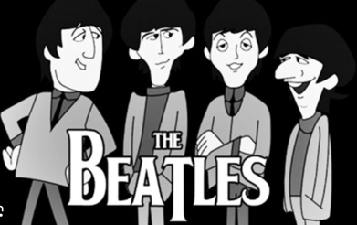  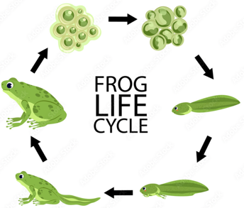 |  |  |  | Word | - Converting nouns or adjectives into verbs using suffixes e.g. –ate, -ise, -ify  - Verb prefixes e.g. dis-, de-, mis-, over-, re-
 |  |  |  |  |  | Sentence | - Relative clauses beginning with who, which, where, when whose, that, or an omitted relative pronoun.  - Indicating degrees of possibility using adverbs e.g. perhaps, surely, or modal verbs e.g. might, should, will, must.
 |  |  |  |  |  | Text | - Devices to build cohesion within a paragraph e.g. then, after that, this, firstly  - Linking ideas across paragraphs using adverbials of time, place and number, or tense choices e.g. he had seen her before.
 |  | Some words to learn to spell this half term: |  |  |  | Punctuation | - Brackets, dashes or commas to indicate parenthesis  - Use of commas to clarify meaning or avoid ambiguity.
 |  | Bond | Absorb |  | Cultures | Punctuation
 |  | Drift | Emerge |  | Docked | Punctuation
 |  | Droplet | External |  | Equality | Punctuation
 |  | Poised | Secrete |  | Generation | Punctuation
 |  | Cloud | Amphibian |  | Influenced | Key vocabulary: Tier 2 and 3
 |  | Condensation | Exothermic |  | Inspired | Brackets |  | Are used to tell the reader additional information about a sentence
 |  | Evaporate | Hibernate |  | Musicians
 |  | Liquid | Metamorphosis |  | Vinyl records | Parenthesis |  | A word, phrase or sentence that is used as extra information when using brackets, dashes or commas.
Ideas for reading this half-term: |  | 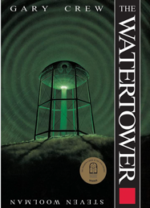 |  | 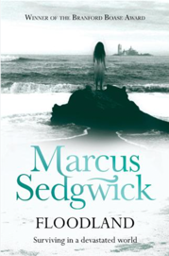
 |  |  |  |  |  | Modal Verb |  | Verbs that indicate likelihood, ability, permission or obligation.
You may like to read the following books from our Year 5 suggested reading list.

You can find more suggested books on our class page on the school website.
 |  |  |  |  |  | Informal |  | A writing style that is used to speak more freely, chatty, relaxed or friendly.
 |  |  |  |  |  | Dashes |  | A punctuation technique to indicate a parenthesis within a sentence, it is normally used to connect to independent clauses.
Examples of sentences taught this half-term, including ‘Alan Peat’ sentences: | 1st Sentence type: | Noun,which/where/who.
 | 2nd Sentence type: | Short sentences (for tension)

