EYFS Long Term English Plan
Literacy is one of the Specific Areas in Reception. It is developed through focused, small group sessions and our continuous provision and is embedded in everything we do. We are encouraged to write, read, comprehend and explore as part of our child centred learning and have continual access to reading materials and writing equipment, both indoor and out, to ignite and inspire our interests. Our Literacy focus is text driven and closely linked to our phonics provision, where we follow the Supersonic Phonics Friends scheme. We learn how to link sounds to letters as we begin our reading and writing journey.

Autumn 1 | All About Me  Children listen to a range of stories and join in with traditional nursery rhymes, talking about their favourites and learning to explain why they like certain books.
Autumn 2 | Celebrations  Stories about bonfire night and then the Nativity feature heavily in this unit. Children continue to develop their oracy skills as they take part in a Christmas Performance.
Spring 1 | Castles, Knights and Dragons  One of the stories that the children focus upon this half-term is Zog, which continues to delight children and to introduce some basic spelling strategies with its rhyming words.  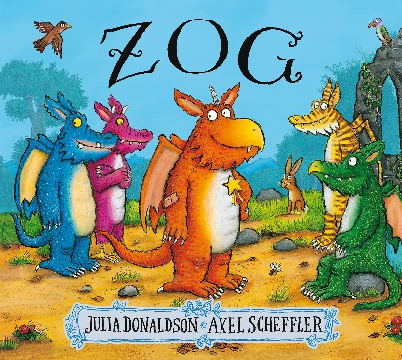
Spring 2 | Spring  Immersed in Percy the Park Keeper, some children start to write simple sentences with capital letters and full stops. They notice that names start with capital letters too.

Summer 1 | Traditional Tales  Children choose their favourite traditional tales and learning stems from these. Jack and the Beanstalk is always popular and children talk about their own beans, planted in pots, describing which is taller and shorter, for example.
Summer 2 | Pirates  The children continue to enjoy role-playing, dressing up as pirates on one special day. They continues to develop their letter formation, basic spelling and simple sentence-writing skills with stories including Pirates Love Underpants for inspiration.  

