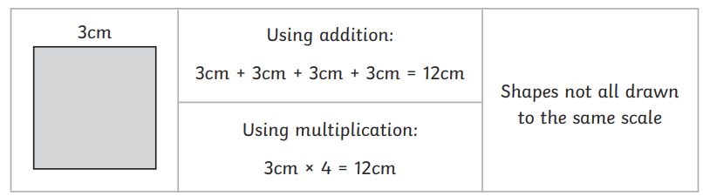
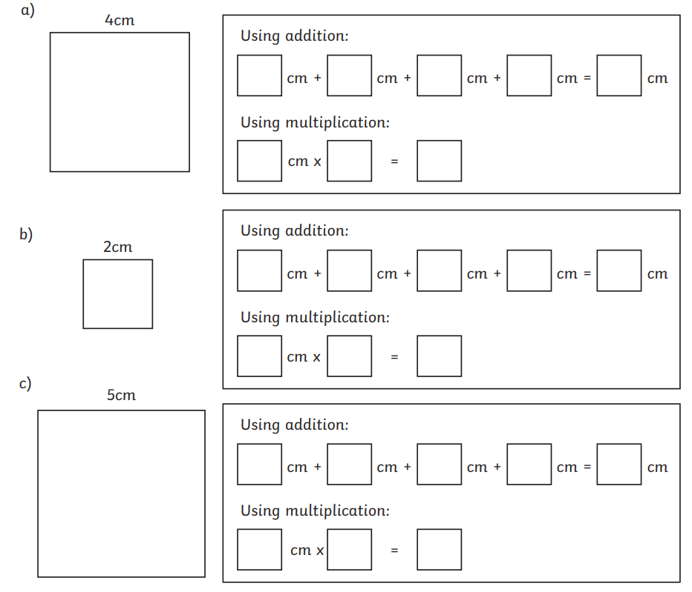
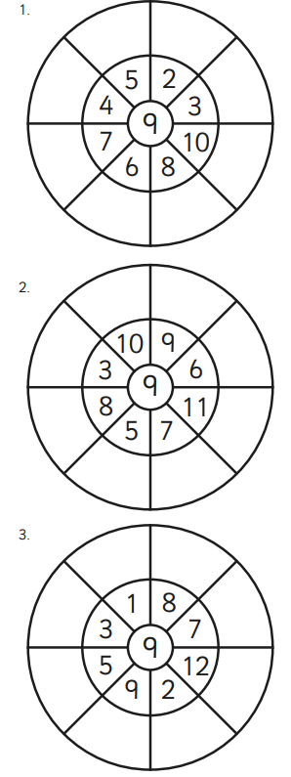

Measure these lines in CM and MM.
What do you notice?

________

____________________

__________________________
Homework
-

Year 3

Maths
Given: 20.03.26 Due: 27.03.26

Arithmetic:

This week’s learning

Practise makes perfect:

In your light shall we see light
The Lost Puppy
Sam was walking home from school when he heard a quiet whimper. He stopped and looked around. Behind a bush, he found a small brown puppy. It was shivering and looked scared.
Sam gently picked up the puppy and checked its collar, but there was no name on it. “Don’t worry,” he said softly. “I’ll help you.” He took the puppy home and gave it some water. The puppy wagged its tail and followed Sam everywhere. Sam made a cosy bed for it using an old blanket. The next day, Sam and his mum made posters to find the puppy’s owner. Later that afternoon, a lady knocked on the door. She looked worried but smiled when she saw the puppy. “Thank you for finding him!” she said. Sam felt happy that the puppy was going back home.
- Find and copy one word from the first paragraph that shows the puppy was making a sad sound.

- Put these events in the correct order by numbering them 1–4:
The lady knocked on the door
Sam made a cosy bed
Sam found the puppy
Sam and his mum made posters

- Why do you think the lady looked worried when she knocked on the door?
Use evidence from the text to support your answer.

- How can you tell that Sam is a kind person?
Give two pieces of evidence from the text.

Capital Letters

Add capital letters where needed:
a) i went to london with my mum.
b) my teacher is called miss jones.
c) we saw the river thames.

2. Commas in a List

Add commas to these sentences:
- I packed apples bananas oranges and grapes.
b) She has a dog a cat and a hamster.

4. Nouns, Verbs, Adjectives

Underline the adjective in each sentence:
a) The small dog barked loudly.
b) I wore a red jumper.
c) The tall tree swayed in the wind.

Homework
-

Year 3

Given: 20.03.26 Due: 27.03.26

English

SPAG:

READING COMPREHENSION:

In your light shall we see light

