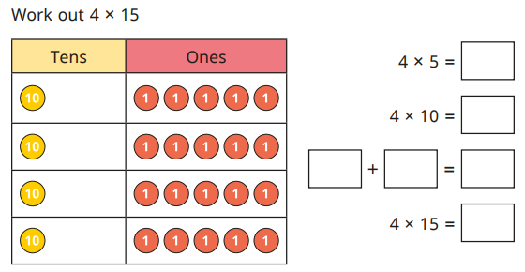
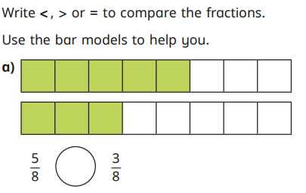
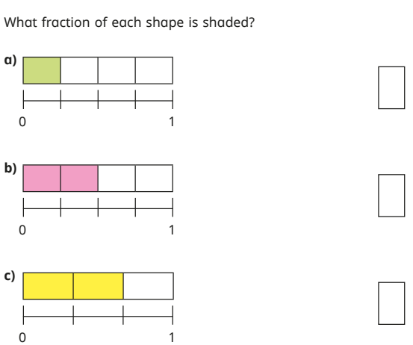
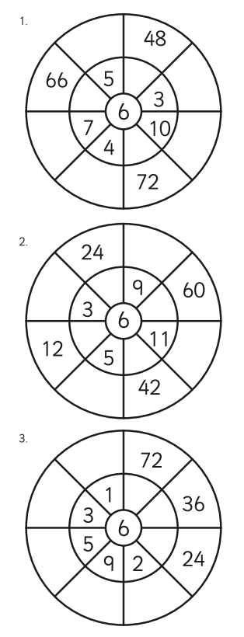

Homework
-

Year 3

Maths
Given: 17.04.26 Due: 24.04.26

Arithmetic:

This week’s learning

Practise makes perfect:

In your light shall we see light
Lila loved visiting her grandmother’s house at the edge of the village. Every Saturday morning, she would walk along the narrow path, listening to the birds singing in the trees. One day, as she reached the garden gate, she noticed it was slightly open. This was unusual. Her grandmother always kept it shut. Lila pushed the gate gently and stepped inside. The garden looked different. Flowerpots were knocked over, and the watering can lay on its side. Lila felt a little worried.
“Grandma?” she called.
From behind the shed, a small, muddy dog ran towards her, wagging its tail. Lila sighed with relief and began to laugh
- Where does Lila’s grandmother live?
______________________________________________________
- Do you think the dog belongs to Lila’s grandmother? Explain your answer.
________________________________________________________
- What was unusual about the gate?
________________________________________________________
- How did Lila feel when she saw the garden? How do you know?
________________________________________________________

Add commas:
- I packed apples oranges bananas and grapes.

Is the verb past or present?
- She played in the garden.

Add a fronted adverbial:
- ______, she opened the door quietly.

Rewrite the sentence correctly:
- on saturday, lucy went to manchester with her brother tom

Homework
-

Year 3

Given: 17.04.26 Due: 24.04.26

English

SPAG:

READING COMPREHENSION:

