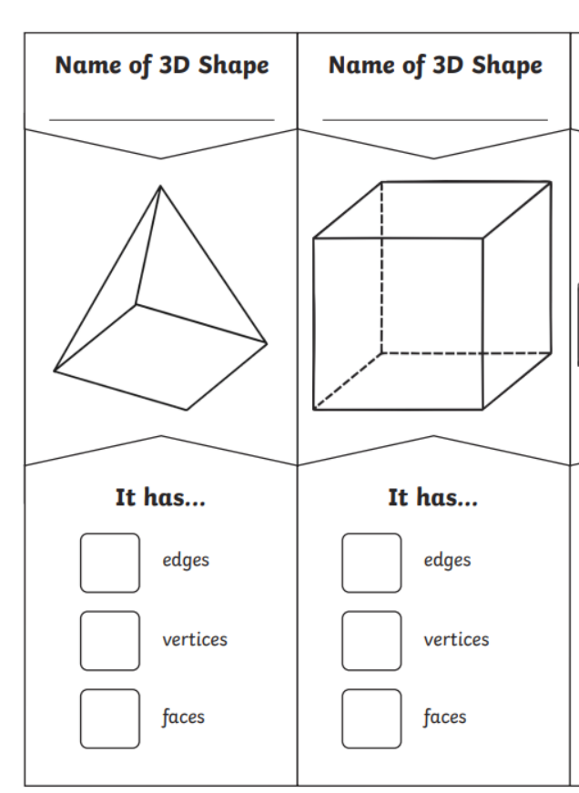
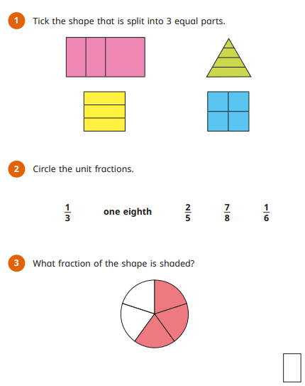

Warm-up
5 x 2 =
9 x 2 =
3 x 5 =
11 x 5 =
2 x 10 =
Step-up
3 x 7 =
9 x 4 =
12 x 3 =
8 x 6 =
4 x 12 =

Homework
-

Year 3

Maths
Given: 24.4.2026 Due: 1.5.26

Arithmetic:

8

This week
’
s learning:

Practise makes perfect:

In your light shall we see light
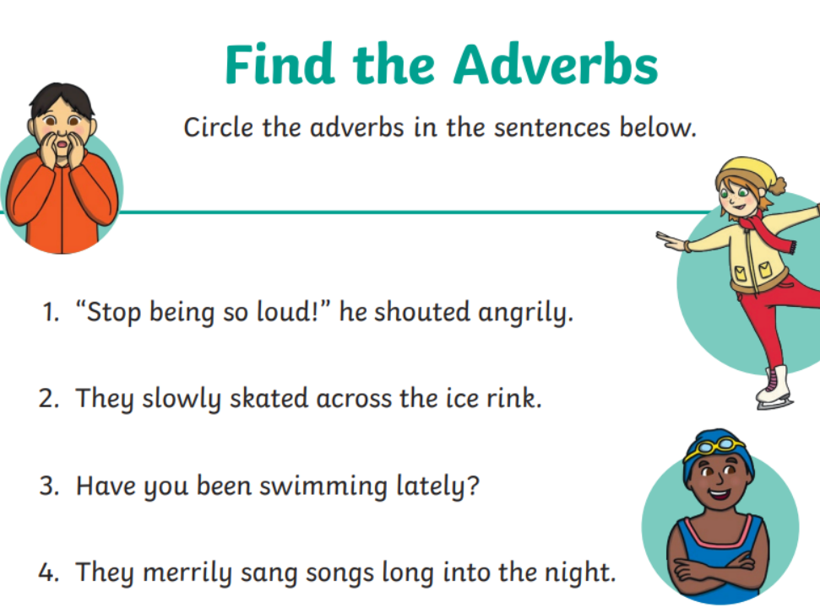
____________________________________________________________________
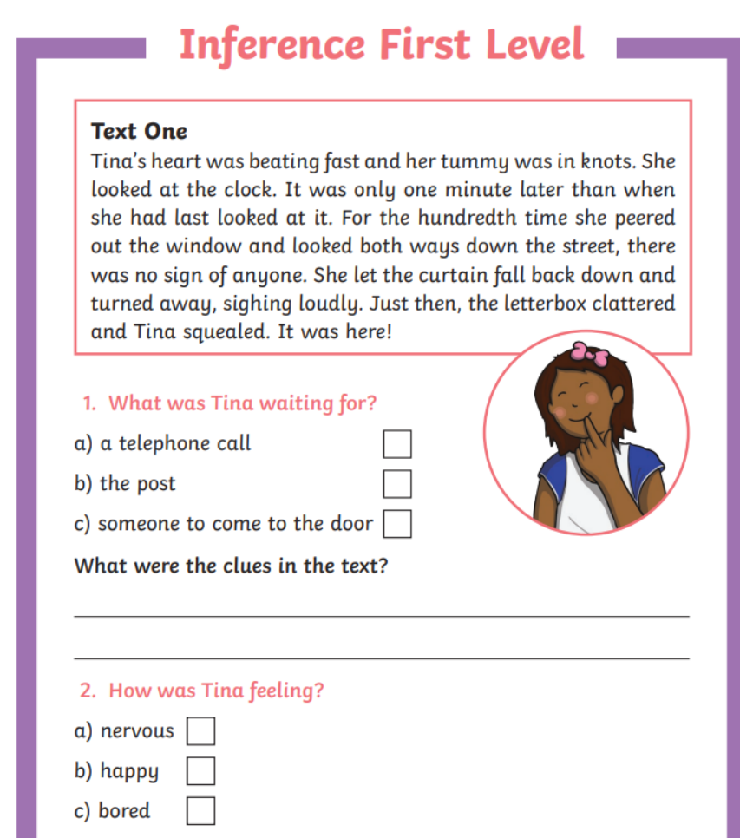
Homework
-

Year 3

Given: 24.4.26 Due: 1.5.26

English

SPAG:

READING COMPREHENSION:

In your light shall we see light

