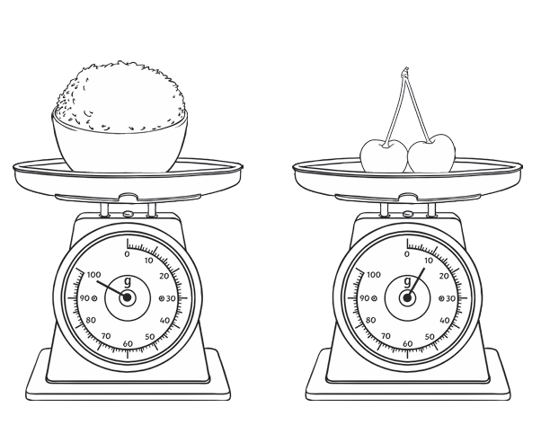
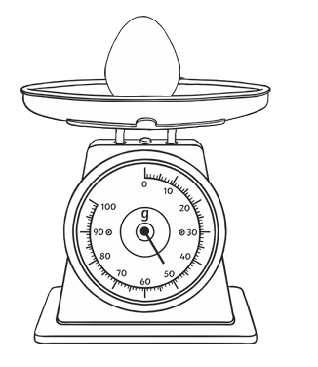
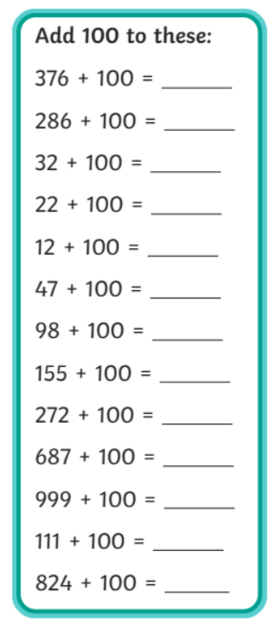
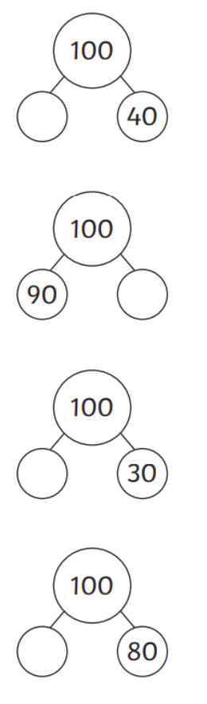

Homework
-

Year 3

Maths
Given: 1.05.2026 Due: 8.05.2026

Arithmetic:

This week
’
s learning:

Practise makes perfect:

In your light shall we see light
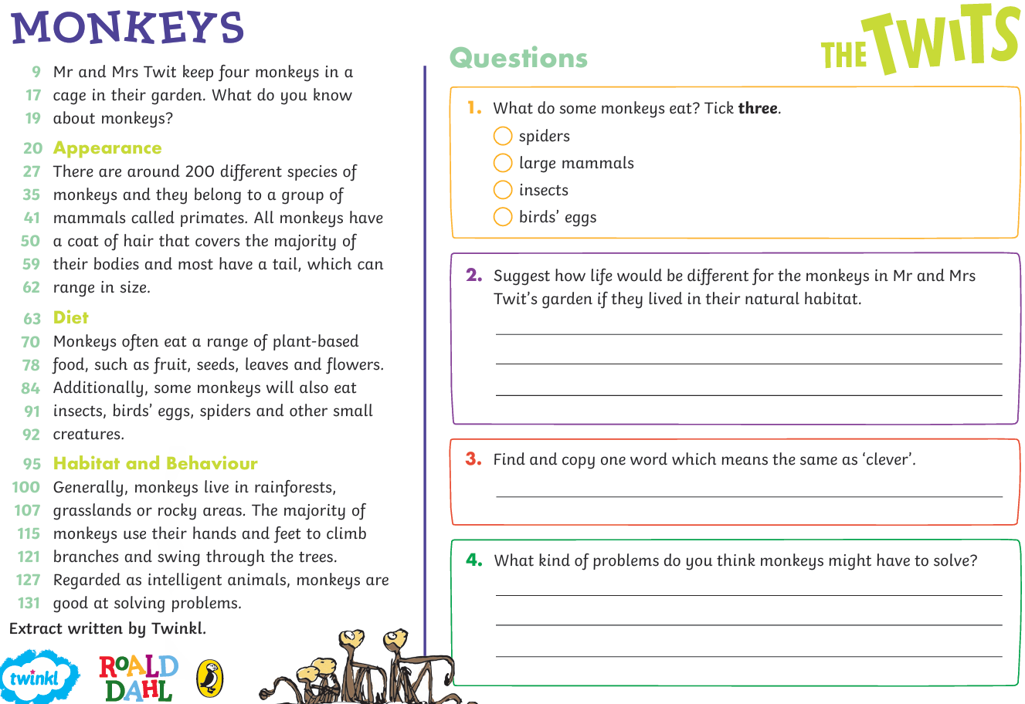
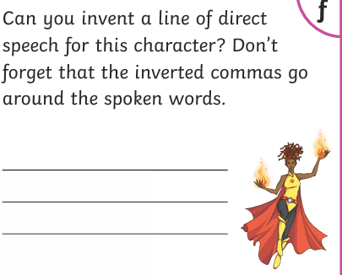
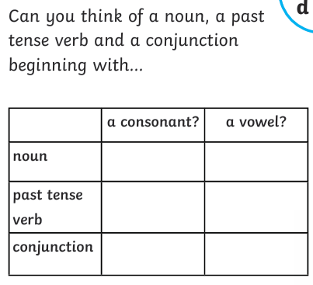
In your light shall we see light

Homework
-

Year 3

Given: 1.05.2026 Due: 8.05.2026

English

SPAG:

READING COMPREHENSION:

